CNC cylindrical grinder by Fermat Machine Tool – Automated by B&R
High precision, flexibility and intuitive operation coming to EMO 2013
Integrated HMI, CNC and servo technology from B&R combined with high-performance POWERLINK communication – all of these things have helped Fermat Machine Tool boost the performance of its machines. Not only that, but they have given developers at Fermat the freedom and power to fully utilize their hard-earned grinding expertise. These characteristics will be on display in September at EMO 2013, the world’s leading exhibition for metalworking taking place in Hanover, Germany, when Fermat Machine Tool, s.r.o. introduces its new CNC cylindrical grinder.
Intuitive, flexible and low-maintenance
"The open CNC control allowed us to implement our own processing cycles, supported by graphical visualizations. As a result, the operator doesn’t need any knowledge of CNC programming," says Ondřej Zoubek, director of R&D at Fermat Machine Tool. "The B&R control system allows us to offer our customers a grinder as flexible as it is reliable – with maximum performance and minimum maintenance."
High precision and smooth migration
Fermat has been able to achieve an extremely high surface grinding precision of 1 µm. These high-quality results were made possible by ACOPOSmulti drives from B&R equipped with an external linear measurement system from Heidenhain. An open NC program interpreter ensures extremely smooth migration from the previous system.
Designed for high-precision axial and surface grinding with a fixed or oscillating table, the BUB E 40/1000 CNC grinder is suitable for the production of workpieces in both small and medium size batches.

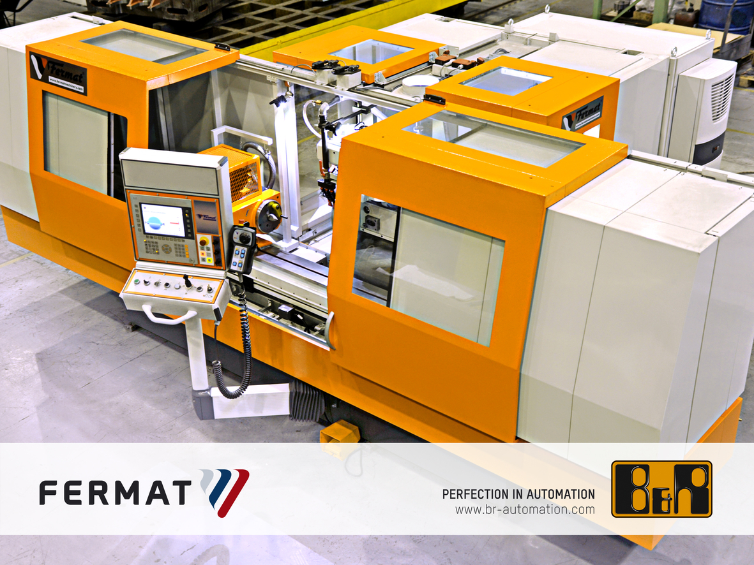
Fermat Machine Tool developed its BUB E 40/1000 CNC grinder for high-precision universal grinding applications – with automation technology from B&R.

B&R Hakkında
ABB Grubunun bir bölümü olan B&R, merkezi Avusturya'da bulunan endüstriyel otomasyon alanında global bir liderdir. B&R, neredeyse her sektördeki müşterilere makine ve fabrika otomasyonu, hareket kontrolü, HMI ve entegre güvenlik teknolojisi için eksiksiz çözümler sunmak üzere en son teknolojiyi ileri mühendislikle birleştiriyor. OPC UA, POWERLINK ve openSAFETY gibi Endüstriyel IoT iletişim standartlarının yanı sıra Automation Studio yazılımıyla B&R, otomasyon mühendisliğinin geleceğini sürekli olarak yeniden tanımlıyor. B&R'ı endüstriyel otomasyonun ön saflarında tutan yenilikçi ruh, süreçleri basitleştirme ve müşteri beklentilerini aşma taahhüdünden kaynaklanmaktadır.
Daha fazla bilgi için www.br-automation.com adresini ziyaret edin.

