B&R at 2013 Motek
Innovations for production and assembly automation
This year's Motek 2013 trade fair starts on Oct 7th and will run until Oct 10th. In hall 7, booth 7101, B&R will be presenting the latest automation solutions. Five current topics will be highlighted: Energy monitoring, efficient engineering, a virtual safety solution, added safety for robotics applications and redundancy using standard components.
Optimized energy management
As a solution for energy data management, APROL EnMon helps users improve their energy efficiency. This ready-to-use solution, which runs on B&R's Automation PC 910, is a simple way to implement the requirements specified in ISO 50001. The solution helps considerably reduce energy consumption, with the resulting financial savings strengthening users' competitive edge.
Automation Studio delivers "Smart Engineering"
Automation Studio fulfills three important goals at once: Keeping quality high, engineering costs low and time to market short. B&R has elevated software design efficiency to an unparalleled new level, allowing engineering processes to be implemented efficiently and effectively.
Virtual safety controller – SafeLOGIC-X
For safe automation applications, B&R presents a software-based safety controller whose safety functionality is distributed across safe I/O modules, a standard controller and the HMI application. This solution, called SafeLOGIC-X, allows even smaller, cost-sensitive safety applications to enjoy the benefits of an integrated safety solution with full-fledged support for all safe motion functions.
Advanced robot safety for complex kinematics
B&R has extended the safety function "Safely Limited Speed at Tool Center Point" (SLS at TCP): It is now possible to monitor the full spectrum of serial robot types in the safety application. With the extended functionality, B&R now offers a parameter block for generalized serial robots. This makes it possible to configure any type of kinematic chain.
Controller redundancy with standard components
The redundancy solution for X20 control systems is a breakthrough that now allows the advantages of high availability to be enjoyed by smaller applications at much less cost. Failsafe features can be configured in Automation Studio at a later time. This eliminates the need for specialized redundancy controllers, which are generally very expensive due the small quantities produced.

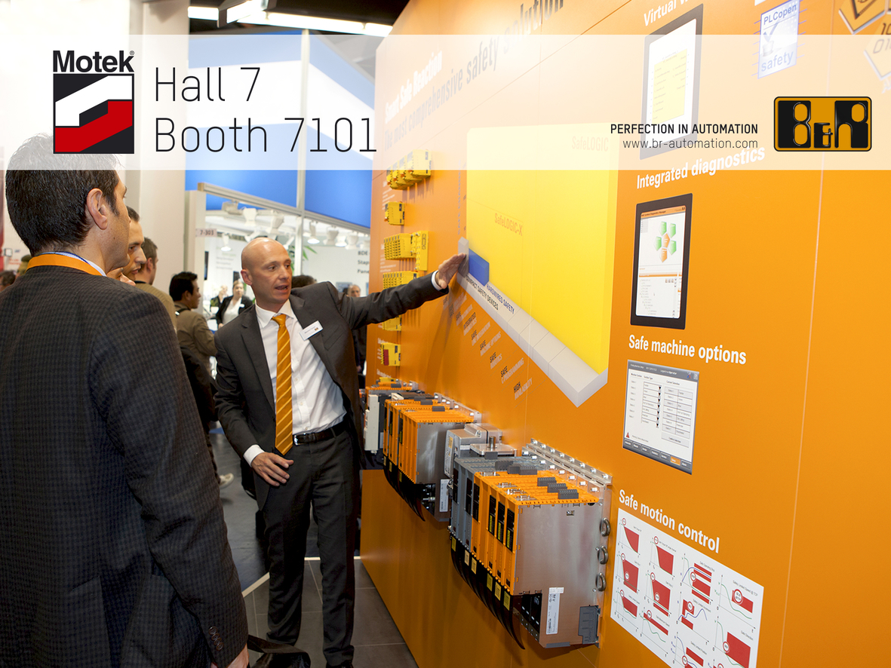
At the Motek trade fair for production and assembly automation (hall 7, booth 7101), B&R will highlight current automation topics.

B&R Hakkında
ABB Grubunun bir bölümü olan B&R, merkezi Avusturya'da bulunan endüstriyel otomasyon alanında global bir liderdir. B&R, neredeyse her sektördeki müşterilere makine ve fabrika otomasyonu, hareket kontrolü, HMI ve entegre güvenlik teknolojisi için eksiksiz çözümler sunmak üzere en son teknolojiyi ileri mühendislikle birleştiriyor. OPC UA, POWERLINK ve openSAFETY gibi Endüstriyel IoT iletişim standartlarının yanı sıra Automation Studio yazılımıyla B&R, otomasyon mühendisliğinin geleceğini sürekli olarak yeniden tanımlıyor. B&R'ı endüstriyel otomasyonun ön saflarında tutan yenilikçi ruh, süreçleri basitleştirme ve müşteri beklentilerini aşma taahhüdünden kaynaklanmaktadır.
Daha fazla bilgi için www.br-automation.com adresini ziyaret edin.

