B&R supports OMAC at UCIMA's Packology fair
Demo impresses at packaging show in Italy
OMAC, the Organization for Machine Automation and Control, continues to gain supporters not only in Europe, but also in key developing markets such as India, where Nestlé's well-traveled OMAC demo will be appearing at no fewer than three trade fairs this year. The organization has its roots among U.S. multinationals.
So what does this have to do with B&R? And why did B&R send key packaging machinery business managers from Italy, Germany and North America to the Packology fair organized by UCIMA (the Italian Packaging Machinery Manufacturers Association) in Rimini, Italy, to support the OMAC demo's presence there?
One reason is most definitely the global environment in which consumer packaged manufacturers (CPGs) operate as well as the packaging machinery and automation suppliers who must provide international support. Global CPGs are the core customers for European machinery builders, making them extremely important to B&R as well. This is why the company has set up a Global Packaging Solutions team that offers support in Europe, the Americas, the Asia/Pacific region, China and India.
The stakes are higher than ever for multinationals, who need to bring their international standards with them to emerging markets – or face chaos in terms of packaging line operation and maintenance. "OMAC is the best thing that could happen to European machine builders," explains Maurizio Tarozzi, global technology manager for B&R's packaging group and representative to UCIMA's membership committee. "We like to say that sharing is winning, and by supporting global adoption of key IEC and ISA standards, along with the best practices being developed by OMAC working groups, we all share common ways to communicate in the machinery world."
"We embrace the opportunity to help establish these standards and show our customers the benefits of adopting them," continues Tarozzi. "It gives them more freedom of choice while also meeting the needs of the Nestlés of the world." OMAC-affiliated companies include the SESAM consortium in Scandinavia, with members such as Arla Foods, as well as Bosch Packaging Technologies, MillerCoors, PepsiCo, Procter & Gamble, Pro Mach, and of course – B&R.
In June, OMAC brought its interoperability demonstration unit to the Packology trade show in Rimini, Italy. UCIMA invited the standards group to bring the demo unit, which was introduced to the public by Nestlé at PACK EXPO 2012. Visitors to Packology were given a guided tour by OMAC chairman Dr. Bryan Griffen of Nestlé, who explained how four automation suppliers including B&R implemented PackML to coordinate four machine modules via Ethernet. The demo has a storage and feeding module, a vision module, a presentation module and an orientation module with a robot controlled by B&R.
The booth attracted a number of machine builders and packagers interested in the organization and the full range of international standards being aggregated by the PackSpec committee into a universal User Requirement Specification (uURS) to be completed later this year. Instead of inconsistent specifications naming individual components that tend to become obsolete in just a short time, PackSpec will provide a functionality- and standards-based URS that will save everybody time and money.
For membership information or to learn more about OMAC activities, please visit:
- www.omac.org

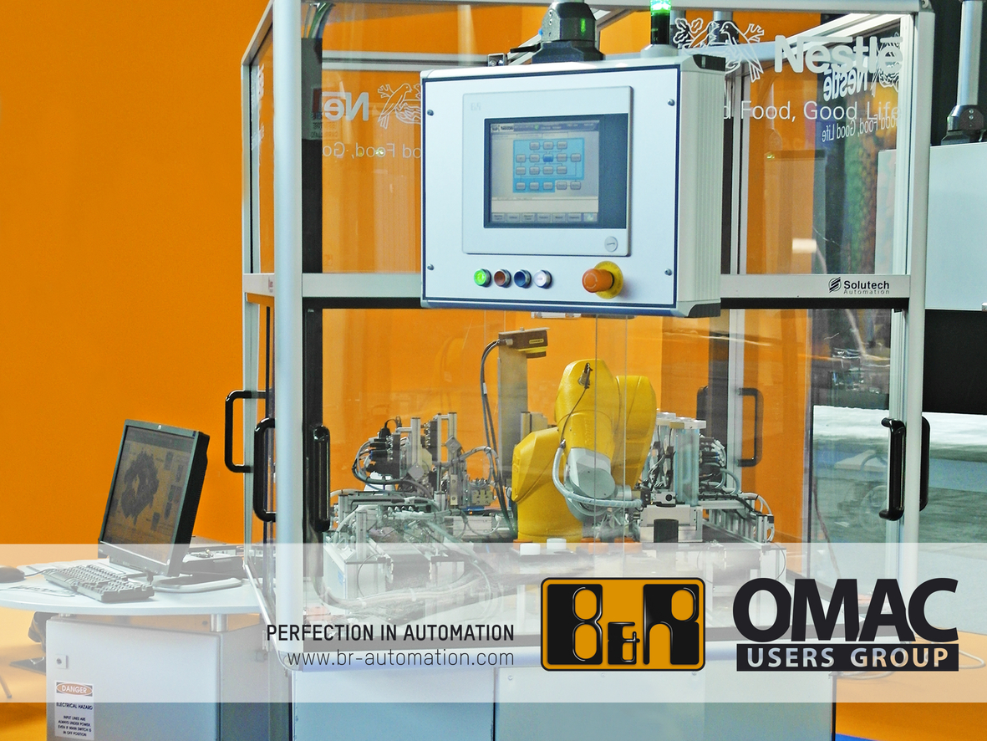
Nestlé's well-traveled OMAC demo will be appearing at numerous exhibitions this year, including the Packology fair in Rimini.

About B&R
B&R, a division of ABB Group, is a global leader in industrial automation headquartered in Austria. B&R combines state-of-the-art technology with advanced engineering to provide customers in virtually every industry with complete solutions for machine and factory automation, motion control, HMI and integrated safety technology. With Industrial IoT communication standards including OPC UA, POWERLINK and openSAFETY as well as its Automation Studio software, B&R is constantly redefining the future of automation engineering. The innovative spirit that keeps B&R at the forefront of industrial automation is driven by a commitment to simplifying processes and exceeding customer expectations.
For more information, visit www.br-automation.com.

