New dimensions in scalability and response time
B&R at the 2013 SPS IPC Drives trade fair in Nuremberg
This year's SPS IPC Drives trade fair in Nuremberg will be taking place November 26–28, 2013. B&R will be taking advantage of the opportunity offered by the world's premier trade fair for industrial automation systems and components to present their entire product range in hall 7, booths 110 and 206. Two main topics are on the B&R agenda this year: maximizing scalability and minimizing response time.
Unprecedented scalability
With Scalability+, B&R is establishing a new philosophy for scalability. This new approach opens up entirely new dimensions for machine builders, making it possible to perfectly tailor an automation solution directly to the needs of a specific machine. It allows you to select a hardware and software solution that best fits your automation needs – all without being forced to enter into any kind of commitment. If it becomes obvious during development that the components or solutions need to be scaled up or down, this can be done at any time without losing a single bit of the work that has already been done. All of this makes it possible for machine manufacturers to perfectly adapt automation systems directly to the needs of the machine without having to make compromises along the way.
A new series of compact controllers
B&R has developed a whole new series of hardware components that further enhances the interoperability and scalability of automation systems. New compact controllers with integrated I/O have been added to the extremely successful X20 series of controllers. The proven Power Panel product series is also being upgraded to include several new touch screen systems – with and without controller functionality – that will also be introduced in Nuremberg.
Groundbreaking cycle times using standard technologies
This year's SPS IPC Drives trade show is also the perfect venue for B&R to unveil reACTION – innovative technology that reduces cycle times to unprecedented levels. This new approach allows extremely time-critical subprocesses to be implemented using standard hardware – all within the requirements of IEC 61131 – while reducing not just the load on the controller, but overall costs as well.
New version of the APROL process control system
B&R will also be introducing Nuremberg and the world to the latest version of its process control system – APROL R 4.0 – in addition to its many new features. Sharing the spotlight will be EnMon energy monitoring and ConMon condition monitoring solution packages from APROL, both of which are the perfect choice for use in factory automation. With APROL, machine manufacturers not only can expand their core competencies, but also offer factory owners and operators the resulting added value. Another solution package, APROL APC (Advanced Process Control), includes various components such as a 10x10x10 model predictive controller for providing simple solutions to complex control tasks.
These and other amazing innovations from all areas of automation – from simulation-based mechatronic software development and high-end PC-based systems to drive technology and mobile automation – will be on display at the B&R booth.

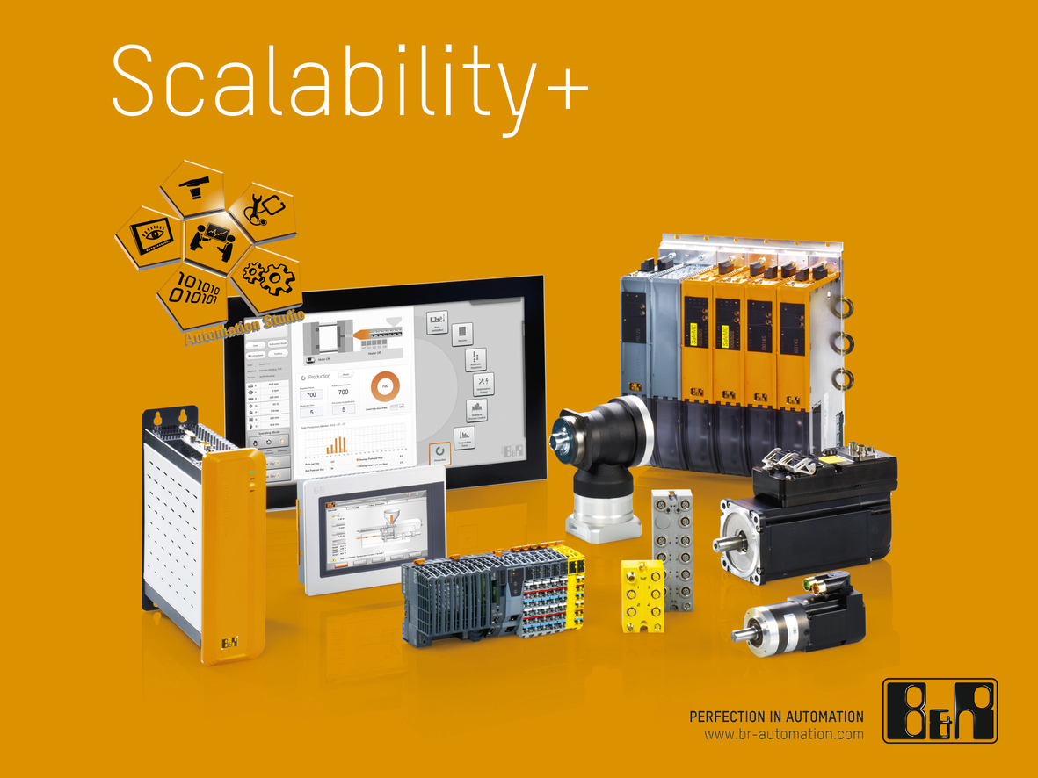
B&R continues to redefine integrated automation with the new Scalability+ series of products, opening up endless possibilities for machine configuration along the way.

B&R Hakkında
ABB Grubunun bir bölümü olan B&R, merkezi Avusturya'da bulunan endüstriyel otomasyon alanında global bir liderdir. B&R, neredeyse her sektördeki müşterilere makine ve fabrika otomasyonu, hareket kontrolü, HMI ve entegre güvenlik teknolojisi için eksiksiz çözümler sunmak üzere en son teknolojiyi ileri mühendislikle birleştiriyor. OPC UA, POWERLINK ve openSAFETY gibi Endüstriyel IoT iletişim standartlarının yanı sıra Automation Studio yazılımıyla B&R, otomasyon mühendisliğinin geleceğini sürekli olarak yeniden tanımlıyor. B&R'ı endüstriyel otomasyonun ön saflarında tutan yenilikçi ruh, süreçleri basitleştirme ve müşteri beklentilerini aşma taahhüdünden kaynaklanmaktadır.
Daha fazla bilgi için www.br-automation.com adresini ziyaret edin.

