B&R adds HART modules to the X20 I/O series
Data transmission, configuration and diagnostics of field devices
B&R now includes an analog HART input module and a HART output module in their successful series of X20 communication modules. These new modules are equipped with two inputs and outputs and use real-time Ethernet POWERLINK to transfer HART data supplied by sensors and actuators directly to the controller. To evaluate the data, the controller forwards information via the process bus to maintenance stations with FDT containers, for example B&R Automation Studio, PACTware or FieldCare.
Controller handles asset monitoring
In the other direction, this type of communication makes it possible to configure the HART devices. This is done with B&R's TCP/IP communication DTM, which scans the network and detects the entire hardware tree, including field devices. The DTM server on the controller operates as a gateway that provides read/write access to all detailed information regarding HART field devices for asset monitoring. Read/Write function blocks support this access during logic processing as well.
One modem per channel ensures more than enough bandwidth
Each channel on B&R HART modules has its own HART modem in order to optimally utilize POWERLINK's high transmission bandwidth. In addition, the comparatively slow HART channels are not encumbered further by multiplexing, as is common in many other systems. HART modules in the X20 series also provide burst mode support, include multidrop functionality and can directly supply up to five devices per channel.

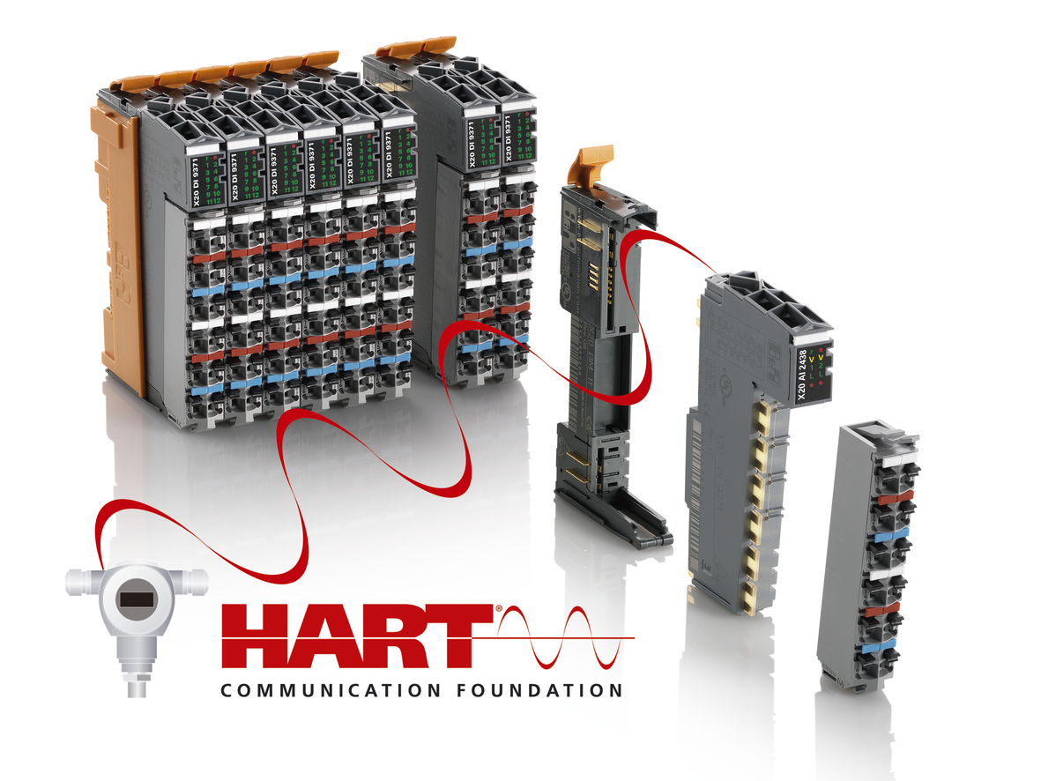
HART modules in B&R's X20 series offer reliable protocol support for data transmission, configuration and diagnostics of HART field devices.

About B&R
B&R, a division of ABB Group, is a global leader in industrial automation headquartered in Austria. B&R combines state-of-the-art technology with advanced engineering to provide customers in virtually every industry with complete solutions for machine and factory automation, motion control, HMI and integrated safety technology. With Industrial IoT communication standards including OPC UA, POWERLINK and openSAFETY as well as its Automation Studio software, B&R is constantly redefining the future of automation engineering. The innovative spirit that keeps B&R at the forefront of industrial automation is driven by a commitment to simplifying processes and exceeding customer expectations.
For more information, visit www.br-automation.com.

