B&R expanding the successful Power Panel HMI family
Terminal and controller designs with touch screen
B&R is adding two new series to its successful Power Panel HMI family: Power Panel T-Series terminals and Power Panel C-Series controllers – both featuring touch screens. Equipped with an embedded browser, the Power Panel T30 terminal is fully web-compatible and can even be used as a VNC client. The terminal series is being offered with four TFT display sizes ranging from 4.3" to 10.1" and comes with two Ethernet interfaces, two USB interfaces and an extensive array of configuration options.
High-performance HMI with a wide range of connection options
The Power Panel C70 controller is equipped with a 333 MHz Intel® AtomTM CPU, 256 MB DDRAM, 16 kB FRAM and 2 GB onboard flash EEPROM memory. This controller provides a built-in touch screen and is being offered in three display sizes ranging from 5.7" to 10.1". In addition to achieving cycle times as low as 1 ms, the Power Panel C70 also features POWERLINK and standard Ethernet, 2x USB 2.0 and X2X Link technology as well as optional RS232, RS485 and CAN connections to offer a wide range of possibilities for peripheral devices.
Both of these device series have an extremely compact design, minimal installation depth and an intelligent cable outlet arrangement, making these panels easy-to-mount space savers. And because these two new series do not have hard disks, fans or batteries, they are completely maintenance-free. The panel front provides IP65 protection, which makes these systems extremely suitable for hygienic applications.

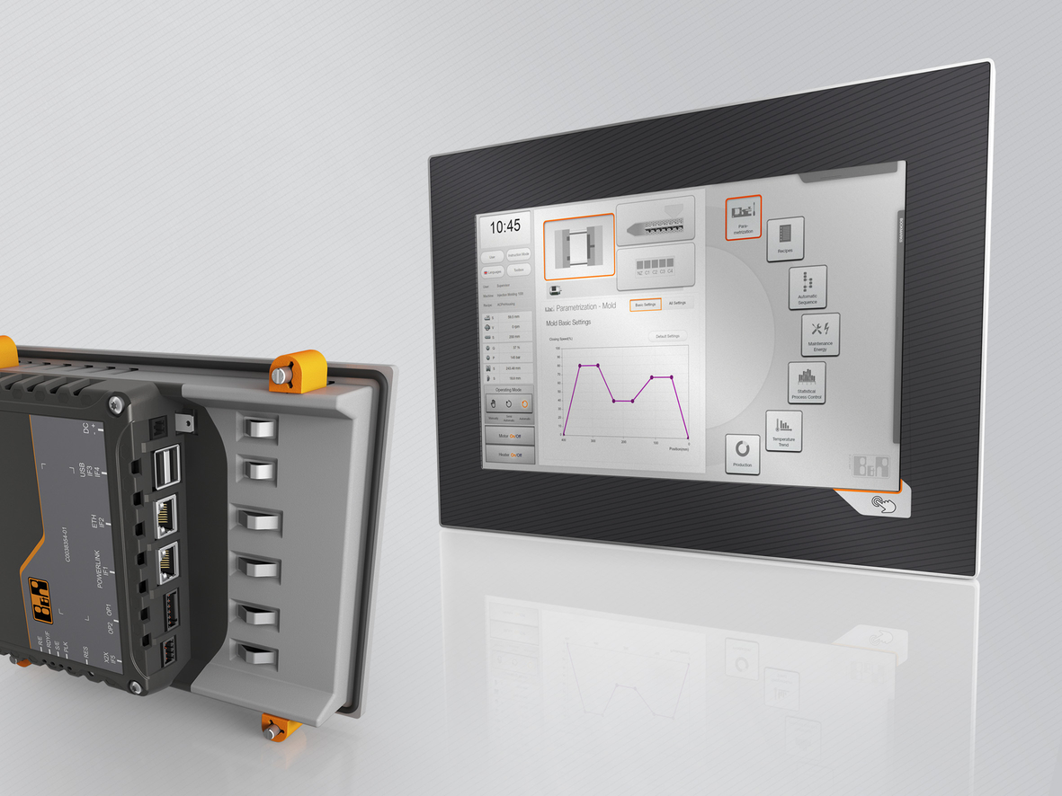
Two new HMI series from B&R – Power Panel T-Series terminals and Power Panel C-Series controllers – are available in a wide variety of display sizes.

About B&R
B&R, a division of ABB Group, is a global leader in industrial automation headquartered in Austria. B&R combines state-of-the-art technology with advanced engineering to provide customers in virtually every industry with complete solutions for machine and factory automation, motion control, HMI and integrated safety technology. With Industrial IoT communication standards including OPC UA, POWERLINK and openSAFETY as well as its Automation Studio software, B&R is constantly redefining the future of automation engineering. The innovative spirit that keeps B&R at the forefront of industrial automation is driven by a commitment to simplifying processes and exceeding customer expectations.
For more information, visit www.br-automation.com.

