B&R expanding the successful Power Panel HMI family
Terminal and controller designs with touch screen
B&R is adding two new series to its successful Power Panel HMI family: Power Panel T-Series terminals and Power Panel C-Series controllers – both featuring touch screens. Equipped with an embedded browser, the Power Panel T30 terminal is fully web-compatible and can even be used as a VNC client. The terminal series is being offered with four TFT display sizes ranging from 4.3" to 10.1" and comes with two Ethernet interfaces, two USB interfaces and an extensive array of configuration options.
High-performance HMI with a wide range of connection options
This controller provides a built-in touch screen and is being offered in three display sizes ranging from 5.7" to 10.1". In addition to achieving cycle times as low as 1 ms, the Power Panel C70 also features POWERLINK and standard Ethernet, 2x USB 2.0 and X2X Link technology as well as optional RS232, RS485 and CAN connections to offer a wide range of possibilities for peripheral devices.
Both of these device series have an extremely compact design, minimal installation depth and an intelligent cable outlet arrangement, making these panels easy-to-mount space savers. And because these two new series do not have hard disks, fans or batteries, they are completely maintenance-free. The panel front provides IP65 protection, which makes these systems extremely suitable for hygienic applications.

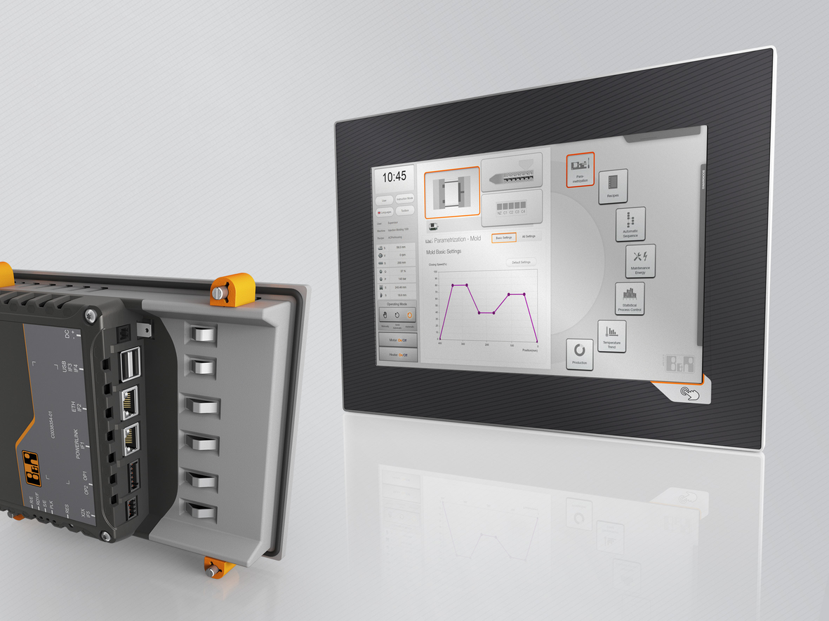
Two new HMI series from B&R – Power Panel T-Series terminals and Power Panel C-Series controllers – are available in a wide variety of display sizes.

B&R Hakkında
ABB Grubunun bir bölümü olan B&R, merkezi Avusturya'da bulunan endüstriyel otomasyon alanında global bir liderdir. B&R, neredeyse her sektördeki müşterilere makine ve fabrika otomasyonu, hareket kontrolü, HMI ve entegre güvenlik teknolojisi için eksiksiz çözümler sunmak üzere en son teknolojiyi ileri mühendislikle birleştiriyor. OPC UA, POWERLINK ve openSAFETY gibi Endüstriyel IoT iletişim standartlarının yanı sıra Automation Studio yazılımıyla B&R, otomasyon mühendisliğinin geleceğini sürekli olarak yeniden tanımlıyor. B&R'ı endüstriyel otomasyonun ön saflarında tutan yenilikçi ruh, süreçleri basitleştirme ve müşteri beklentilerini aşma taahhüdünden kaynaklanmaktadır.
Daha fazla bilgi için www.br-automation.com adresini ziyaret edin.

