Modular automation solutions for agricultural machinery
B&R innovations at the 2013 Agritechnica in Hanover
Agricultural machine manufacturers are under the same pressure as industrial machine manufacturers when it comes to implementing automated solutions and guaranteeing the safety of their machinery. Moreover, outdoor use presents its own unique challenges for mobile machines. In addition to presenting optimal solutions for meeting these challenges, B&R will also be showcasing its entire range of modular control, I/O and drive systems for mobile applications November 12-16, 2013, at the Agritechnica exhibition (Hall 01, Booth A219).
Efficient development, fast installation
In line with the exhibition theme "Systems & Components", B&R will be presenting its modular systems for automating agricultural vehicles – systems that allow machines and devices to be installed and maintained with an absolute minimum of effort. With B&R's Automation Studio software, developers can create modular, distributed programs for all control, motion control, visualization and safety tasks using a single development environment.
A new dimension in data communication
The Ethernet POWERLINK Standardization Group (EPSG) will also be represented at the B&R booth as a user organization for the real-time POWERLINK communication system. This fast and flexible Ethernet-based protocol provides superior data transfer capacity, helping to master new challenges such as the exponential increase in data traffic that results, for example, from the increased use of data generated by camera systems.
POWERLINK is available as open source technology and thus guarantees total vendor independence. The real-time network standard has multi-master capabilities, is well-suited for two-wire connections and simplifies the structure of interoperable autonomous systems.
The highest level of safety for modular technology
The open and fieldbus-independent safety protocol openSAFETY makes it easy to implement safety functionality and satisfy the requirements set forth in EU machinery directives. With safety-related signals routed through regular communication pathways on the network, separate wiring becomes unnecessary – opening up the highest safety standards, fast reaction times and advanced diagnostics for modular system architectures as well.

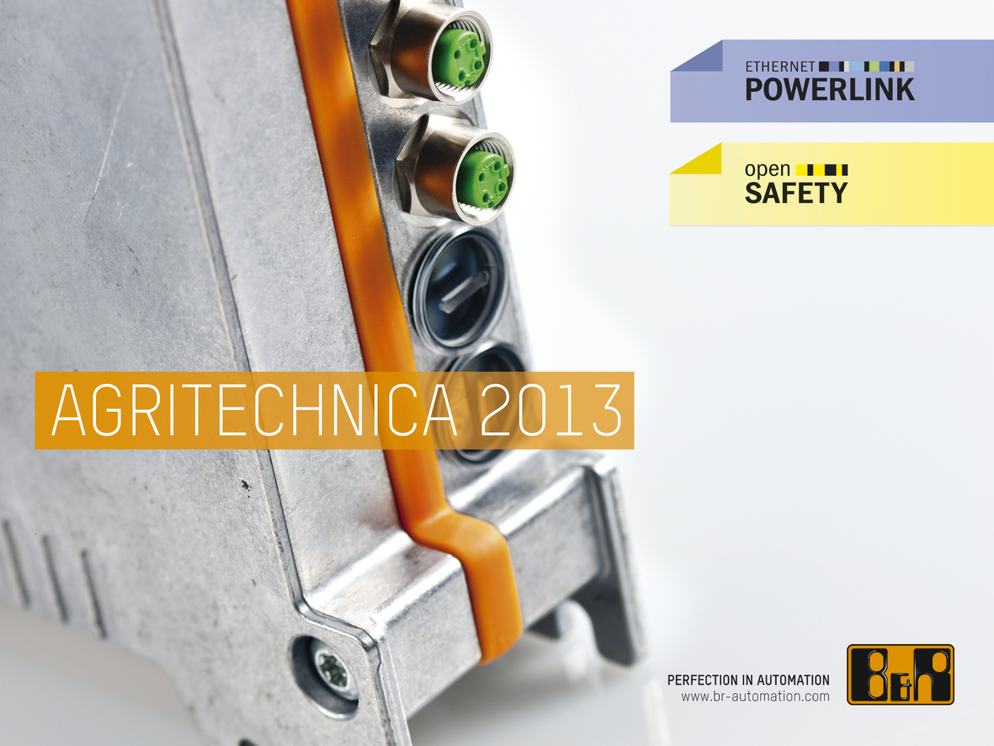
B&R will be presenting its entire range of modular control, I/O and drive systems for mobile applications at the Agritechnica (hall 01, booth A219).


About B&R
B&R, a division of ABB Group, is a global leader in industrial automation headquartered in Austria. B&R combines state-of-the-art technology with advanced engineering to provide customers in virtually every industry with complete solutions for machine and factory automation, motion control, HMI and integrated safety technology. With Industrial IoT communication standards including OPC UA, POWERLINK and openSAFETY as well as its Automation Studio software, B&R is constantly redefining the future of automation engineering. The innovative spirit that keeps B&R at the forefront of industrial automation is driven by a commitment to simplifying processes and exceeding customer expectations.
For more information, visit www.br-automation.com.

