Covering distances up to 100 meters with Smart Display Link 3
B&R presents the new generation of display data transmission technology
B&R is excited to introduce Smart Display Link 3, the newest generation of its proven technology for digital display data transmission. This new version allows a maximum distance of 100 meters between the PC and panel, providing clear benefits for modular machine and system manufacturing in particular. Smart Display Link technology was first introduced in 2004 and made it possible for B&R customers to operate HMI devices at distances up to 40 meters.
Decentralization made easy
With Smart Display Link 3, all communication channels are transferred over a standard Ethernet cable. In addition to reducing cable costs, the thin cable and RJ45 connector are a perfect fit in tight spaces such as feed-through openings and swing arm systems. Smart Display Link 3 offers high-end graphics performance as well. Graphics data is transferred directly from the PC system to the panel without having to be processed by additional PC architecture in the panel. This technology can also be used regardless of operating system.
With its modular design, Smart Display Link 3 can be used on all Automation Panels – not only new product generations, but all previous generations as well. As a result, Smart Display Link 3 is compatible with all Automation Panels currently in the field.

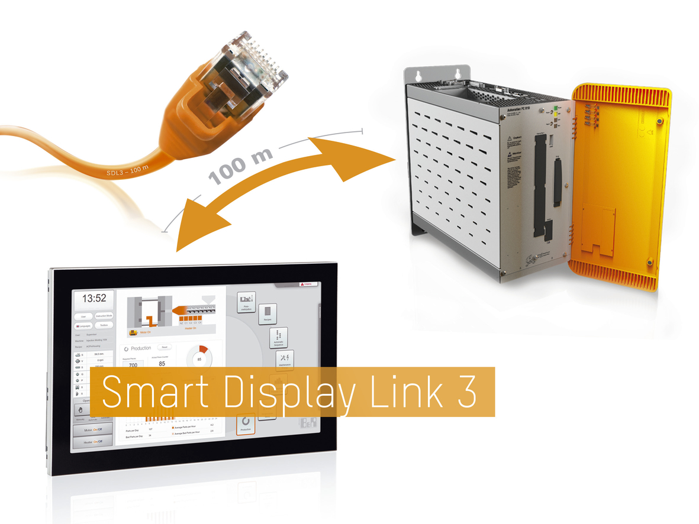
Smart Display Link 3 allows Automation PCs and panels to be placed at optimal locations along the machine – even in extensive systems spanning up to 100 meters.

About B&R
B&R, a division of ABB Group, is a global leader in industrial automation headquartered in Austria. B&R combines state-of-the-art technology with advanced engineering to provide customers in virtually every industry with complete solutions for machine and factory automation, motion control, HMI and integrated safety technology. With Industrial IoT communication standards including OPC UA, POWERLINK and openSAFETY as well as its Automation Studio software, B&R is constantly redefining the future of automation engineering. The innovative spirit that keeps B&R at the forefront of industrial automation is driven by a commitment to simplifying processes and exceeding customer expectations.
For more information, visit www.br-automation.com.

