Compact X20 controllers with integrated I/O
Real-time Ethernet onboard – Unlimited expansion possibilities
B&R has expanded the X20 system to include a new series of compact controllers with integrated I/O. As with all X20 CPUs, additional I/O modules can be connected either locally or remotely using cables. These new compact controllers are being offered in a wide range of variants with different levels of performance and features. Each of theses systems comes equipped with 32 built-in digital and analog I/O channels and an x86 processor as standard features. Integrated POWERLINK, standard Ethernet, CAN, RS232 and USB interfaces are also available.
Complete functionality in two performance classes
The compact controllers are available with two different CPU frequencies: 200 MHz and 400 MHz. Depending on the variant, up to 256 MB RAM and 16 kB nonvolatile onboard RAM is available. A built-in flash drive is available to store up to 4 GB of application and other data. All CPUs come equipped with Ethernet, USB and one RS232 interface. In both performance classes, integrated POWERLINK and CAN interfaces are also available. If additional fieldbus connections are needed, all CPUs can be upgraded with an interface module from the standard X20 product range. These CPUs do not require fans or batteries and are therefore maintenance-free.
30 different digital inputs and outputs and 2 analog inputs are integrated in the devices. The new CPU product range is perfectly complemented by 2 variants with innovative, ultrafast reACTION technology. With this technology, the integrated I/O channels can be controlled with response times down to 1 μs using a function block library. Programming using the standard FBD editor in the B&R Automation Studio development environment is completely compliant with IEC 61131.

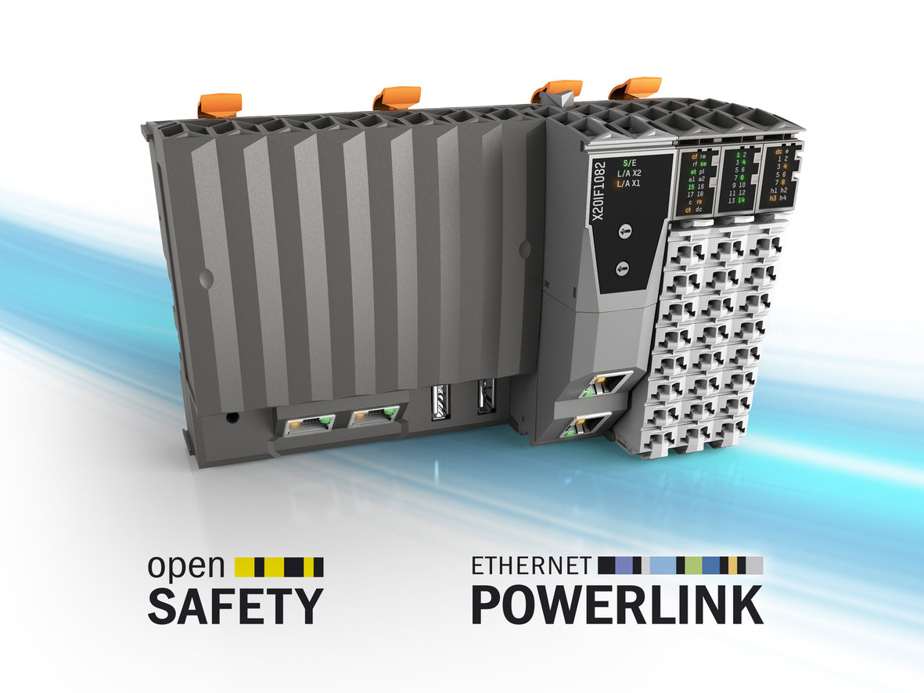
The new compact X20 controllers feature 32 built-in digital and analog I/O channels.

About B&R
B&R, a division of ABB Group, is a global leader in industrial automation headquartered in Austria. B&R combines state-of-the-art technology with advanced engineering to provide customers in virtually every industry with complete solutions for machine and factory automation, motion control, HMI and integrated safety technology. With Industrial IoT communication standards including OPC UA, POWERLINK and openSAFETY as well as its Automation Studio software, B&R is constantly redefining the future of automation engineering. The innovative spirit that keeps B&R at the forefront of industrial automation is driven by a commitment to simplifying processes and exceeding customer expectations.
For more information, visit www.br-automation.com.

