Support for rehabilitation kindergarten
Bernecker + Rainer donates €5,000 to Braunau facility
B&R has donated €5000 to the Braunau rehabilitation kindergarten. The money shall be used to buy outdoor play equipment for the children's therapy facility.
"We were very happy when we got the call to say we were receiving this gift", said the chairwoman of the Braunau counseling kindergarten, Brigitte Swoboda, at the check presentation. It is so nice when a company engages with the community.
B&R HQ in Eggelsberg and the rehabilitation service have worked together for years. The center’s workshops always receive orders for mailings or for packaging trade fair gifts.
Relief for parents
Eight children, aged from three years to school starting age, are looked after at the Braunau children's therapy center. "The majority of the children need a lot of attention", explained head of the kindergarten, Maria Rehatschek. The great advantage of the institution is that necessary therapies can be offered under one roof. The parents do not have to travel far so their child can receive specific therapies.
If a child needs special therapy equipment, the kindergarten often relies upon donations. Likewise for other large purchases. So, we are really pleased to be able to buy new outdoor play equipment with the €5,000, says Ms Rehatschek.

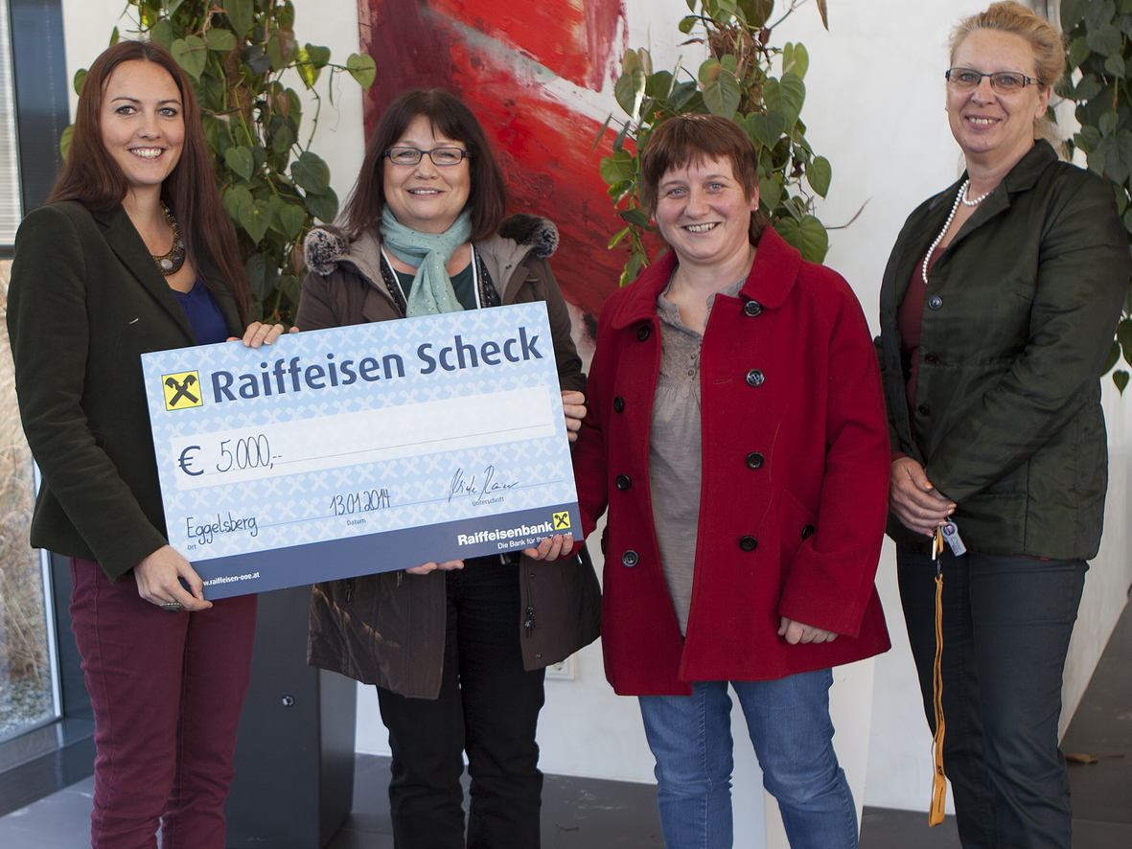
With the €5000 donation from B&R, the special-care kindergarten in Braunau will purchase outdoor playground equipment. Handing over the donation (from left): Mag. Nicole Rainer (B&R staff manager), Brigitte Swoboda (Braunau counseling center chairlady), Maria Rehatscheck (kindergarten manager) and Gaby Nagl-Güthler (B&R human resources department)
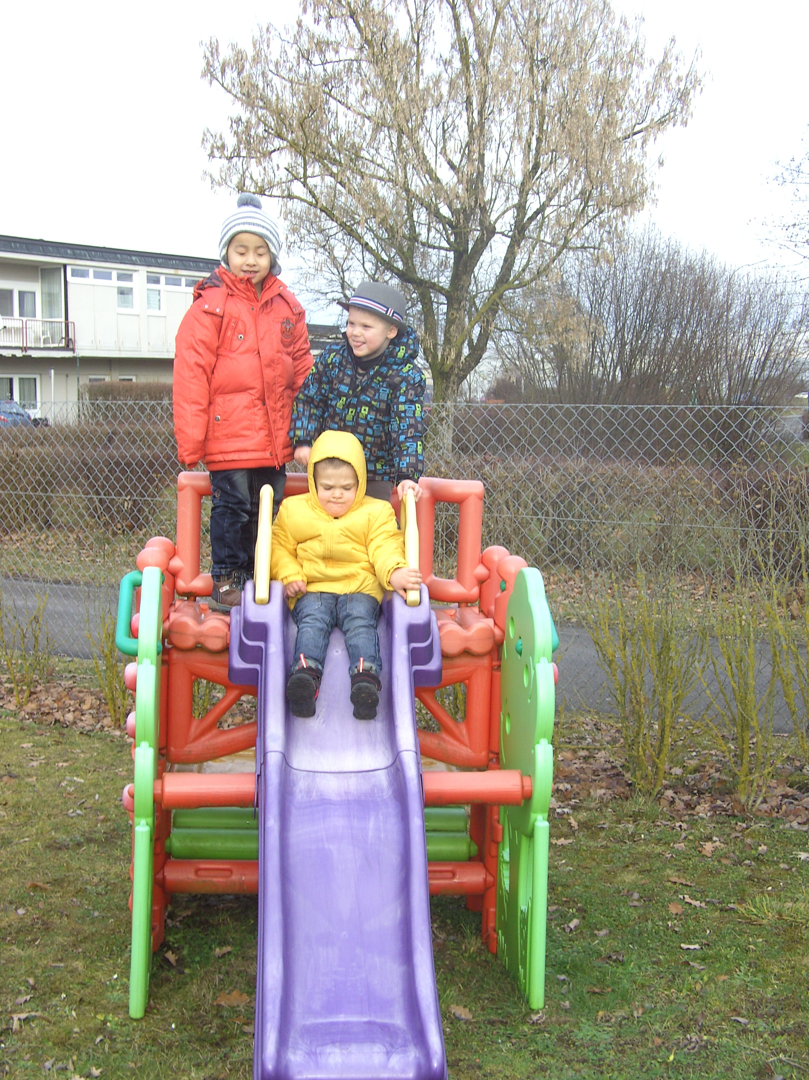
The children are overjoyed to receive a new slide. (Photo: Kindergarten)

About B&R
B&R, a division of ABB Group, is a global leader in industrial automation headquartered in Austria. B&R combines state-of-the-art technology with advanced engineering to provide customers in virtually every industry with complete solutions for machine and factory automation, motion control, HMI and integrated safety technology. With Industrial IoT communication standards including OPC UA, POWERLINK and openSAFETY as well as its Automation Studio software, B&R is constantly redefining the future of automation engineering. The innovative spirit that keeps B&R at the forefront of industrial automation is driven by a commitment to simplifying processes and exceeding customer expectations.
For more information, visit www.br-automation.com.

