B&R innovations at the 2014 EWEA in Barcelona
State-of-the-art technology for the wind power industry
Today's wind turbines require a high-performance automation solution and place high demands on safety and system availability, especially when located offshore. Harsh operating conditions are a real challenge for the components themselves as well. "B&R offers the perfect technology and automation solutions for these special demands," explains Mikel Imaz, manager of the B&R office in Spain's Basque region. On March 10-13, B&R will be showcasing a wide range of trend-setting products at the EWEA 2014 exhibition in Barcelona (Hall 7, Booth 42).
openSAFETY for tomorrow's wind turbines
As an open-source safety protocol, openSAFETY is the perfect technology for powering tomorrow's wind turbines. This protocol enables intelligent and safe communication between different safety components via any fieldbus systems, opening up completely new possibilities for safe closed-loop control, error response and system service. Full compliance with the GL 2010 and GL 2012 standards is also provided. And because the certified communication stack is open source, the development of safety components has become easier than ever before.
As the only open-source network with hard real-time characteristics, POWERLINK provides complete support for solutions involving ultrafast communication between inverters, I/O points, safety technology and entire wind farms. The advantages of open source technology and easy integration into nearly any conventional operating system have allowed this standard to flourish, with over 900,000 machines and systems currently in the field as proof of its ruggedness and reliability.
reACTION technology – ultrafast 1 µs cycle times
With reACTION technology, B&R is able to reduce cycle times in industrial automation down to 1 µs. This new approach allows extremely time-critical subprocesses to be managed using standard hardware – all within the requirements of IEC 61131 – while cutting costs by reducing the load on the controller and optimizing performance to match demands. The result is an immense increase in performance without the downside of additional costs.

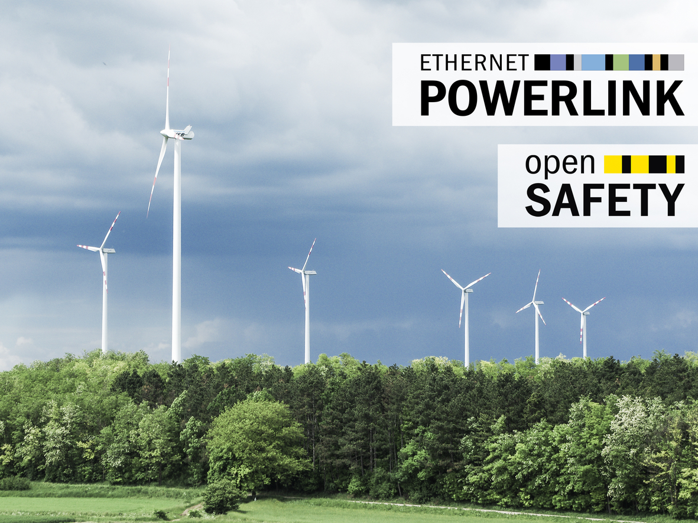
For wind turbine automation, B&R relies on the open-source technologies POWERLINK and openSAFETY.

B&R Hakkında
ABB Grubunun bir bölümü olan B&R, merkezi Avusturya'da bulunan endüstriyel otomasyon alanında global bir liderdir. B&R, neredeyse her sektördeki müşterilere makine ve fabrika otomasyonu, hareket kontrolü, HMI ve entegre güvenlik teknolojisi için eksiksiz çözümler sunmak üzere en son teknolojiyi ileri mühendislikle birleştiriyor. OPC UA, POWERLINK ve openSAFETY gibi Endüstriyel IoT iletişim standartlarının yanı sıra Automation Studio yazılımıyla B&R, otomasyon mühendisliğinin geleceğini sürekli olarak yeniden tanımlıyor. B&R'ı endüstriyel otomasyonun ön saflarında tutan yenilikçi ruh, süreçleri basitleştirme ve müşteri beklentilerini aşma taahhüdünden kaynaklanmaktadır.
Daha fazla bilgi için www.br-automation.com adresini ziyaret edin.

