Budding engineers gain experience at B&R
180 students from HTBLA Braunau got to know numerous technical professions at the B&R HQ in Eggelsberg, Upper Austria. During a two-day open house, the budding engineers learned firsthand how their professional futures could possibly turn out.
A close look at real jobs
"The basic idea for the event is that students actually see how the work is done and are not just receiving theoretical information," explains Thomas Dicker, who coordinates cooperation between B&R and various educational institutes. In small groups, the visitors went off to learn about twelve different jobs. At the individual stations, staff explained to the students how B&R's wide range of products are used to automate industrial machines and systems. These systems can be used to manufacturer many different products, such as plastic bottles, pastries or carbon fiber components for automobiles.
Opportunities for development within the company
At the workstations, the students also learned what technical qualification future employees must have and what development opportunities are available at the company. The student's teacher Maximilien Mayr was enthusiastic about the event: "This open house wasn't a company or product presentation, it provides our students an overview of the job opportunities available to them after HTL training."
Longstanding partnership
The partnership between B&R and HTBLA Braunau has existed for over 15 years. In addition to offering an overview of career opportunities in the field of automation, B&R also provides assistance with thesis projects.

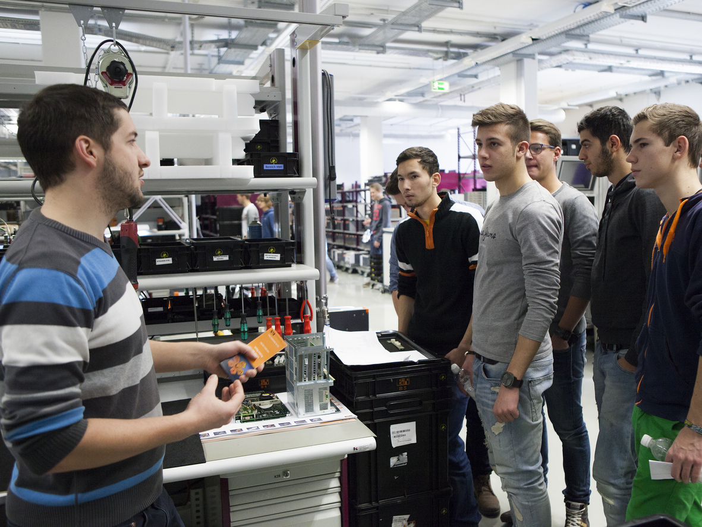
Team leader Martin Schmollngruber (left) explains to a group of students how efficient logistics for Industrial PCs works at B&R.

About B&R
B&R, a division of ABB Group, is a global leader in industrial automation headquartered in Austria. B&R combines state-of-the-art technology with advanced engineering to provide customers in virtually every industry with complete solutions for machine and factory automation, motion control, HMI and integrated safety technology. With Industrial IoT communication standards including OPC UA, POWERLINK and openSAFETY as well as its Automation Studio software, B&R is constantly redefining the future of automation engineering. The innovative spirit that keeps B&R at the forefront of industrial automation is driven by a commitment to simplifying processes and exceeding customer expectations.
For more information, visit www.br-automation.com.

