Budding engineers gain experience at B&R
180 students from HTBLA Braunau got to know numerous technical professions at the B&R HQ in Eggelsberg, Upper Austria. During a two-day open house, the budding engineers learned firsthand how their professional futures could possibly turn out.
A close look at real jobs
"The basic idea for the event is that students actually see how the work is done and are not just receiving theoretical information," explains Thomas Dicker, who coordinates cooperation between B&R and various educational institutes. In small groups, the visitors went off to learn about twelve different jobs. At the individual stations, staff explained to the students how B&R's wide range of products are used to automate industrial machines and systems. These systems can be used to manufacturer many different products, such as plastic bottles, pastries or carbon fiber components for automobiles.
Opportunities for development within the company
At the workstations, the students also learned what technical qualification future employees must have and what development opportunities are available at the company. The student's teacher Maximilien Mayr was enthusiastic about the event: "This open house wasn't a company or product presentation, it provides our students an overview of the job opportunities available to them after HTL training."
Longstanding partnership
The partnership between B&R and HTBLA Braunau has existed for over 15 years. In addition to offering an overview of career opportunities in the field of automation, B&R also provides assistance with thesis projects.

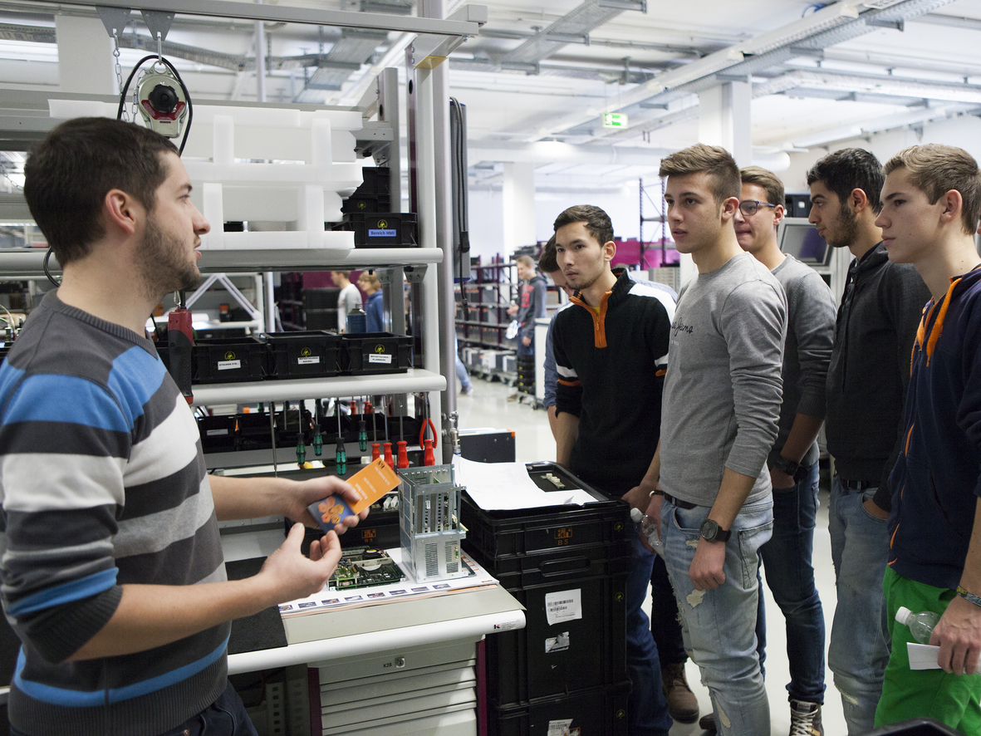
Team leader Martin Schmollngruber (left) explains to a group of students how efficient logistics for Industrial PCs works at B&R.

Acerca de B&R
B&R, empresa perteneciente al Grupo ABB y con sede en Austria, es líder mundial en automatización industrial. B&R combina tecnología de vanguardia con ingeniería avanzada para proporcionar a usuarios de todos los sectores soluciones completas para la automatización de máquinas y fábricas, Motion Control, HMI y tecnología de seguridad integrada. El catálogo de productos se completa con estándares de comunicación de IoT industrial que incluyen OPC UA, POWERLINK y openSAFETY. Gracias a su única herramienta de software Automation Studio, B&R redefine constantemente el futuro de la ingeniería de automatización. El espíritu innovador que mantiene a B&R a la vanguardia de la automatización industrial está impulsado por el compromiso de simplificar los procesos y superar las expectativas de los clientes.Para más información, visite www.br-automation.com.
Para más información, visite www.br-automation.com.

