Panel PC 900 multi-touch: The new flagship system from B&R
Fast, fanless and flexible
By taking advantage of state-of-the-art processors – up to and including Intel® Core™ i7 – the new Panel PC 900 with multi-touch functionality offers the absolute highest level of total computing power. Combining new display sizes with multi-touch operation, B&R's new flagship system is more versatile than ever, even offering full compatibility with the previous device generation.
The Panel PC 900 takes full advantage of the state-of-the-art projected capacitive touch screen also used in the Automation Panel widescreen display series. With an edge-to-edge, anti-glare glass surface and high-resolution monitors, maximum functionality and an advanced design have been integrated into a single operator panel. Displays ranging from 15.6" to 24" with Full HD resolution ensure that every possible requirement is covered.
Safe with multi-touch
These multi-touch displays allow new and innovative user interactions, such as zooming with two fingers or quickly paging forward with swipe gestures. At the same time, two-hand gestures for critical or potentially dangerous operations provide an effective way of preventing unintentional operator errors.
Compatible
Systems in the Panel PC 900 series are available as widescreen displays in addition to the traditional 4:3 format. Equipped with an analog resistive touch screen and display sizes ranging from 12.1" to 19", Panel PC 900 single-touch systems provide full compatibility with the previous device generation with respect to screen resolution and dimensions.
Fanless
Many Panel PC 900 variants can be operated without fans. Used together with SSD drives and/or CFast cards, these systems completely eliminate rotating components, making maintenance work such as regularly replacing the air filter a thing of the past.

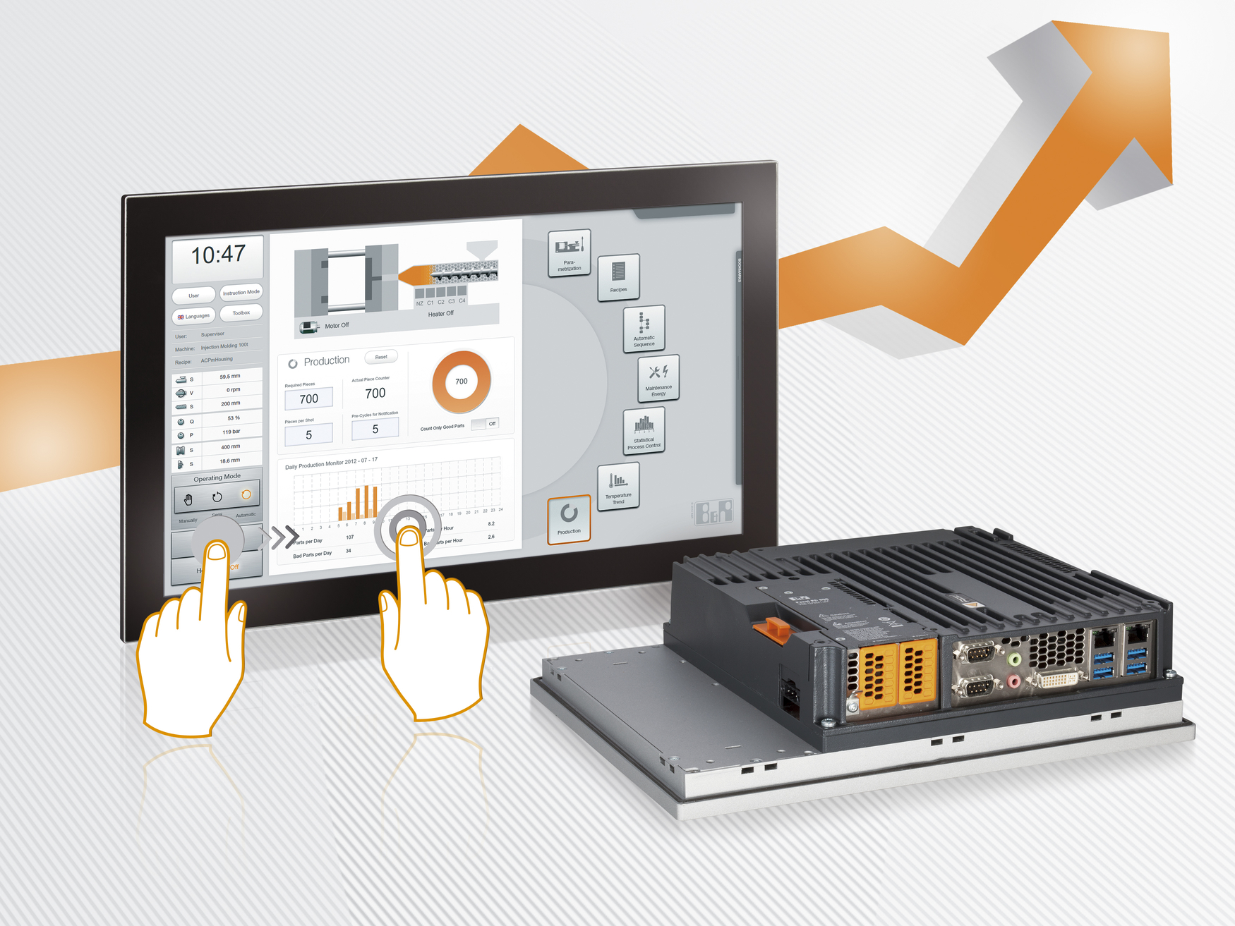
The Panel PC 900 is available in a wide range of sizes and configurations.

About B&R
B&R, a division of ABB Group, is a global leader in industrial automation headquartered in Austria. B&R combines state-of-the-art technology with advanced engineering to provide customers in virtually every industry with complete solutions for machine and factory automation, motion control, HMI and integrated safety technology. With Industrial IoT communication standards including OPC UA, POWERLINK and openSAFETY as well as its Automation Studio software, B&R is constantly redefining the future of automation engineering. The innovative spirit that keeps B&R at the forefront of industrial automation is driven by a commitment to simplifying processes and exceeding customer expectations.
For more information, visit www.br-automation.com.

