B&R Germany under new leadership
Markus Sandhöfner takes over as general manager
Markus Sandhöfner became the new general manager of B&R Germany at the beginning of this year. Sandhöfner – a specialist in the field of automation engineering – took over from Frank Winter (66), who led the company in Germany with great success since its founding in 1983. Winter will continue to assist the company in an advisory capacity.
Sandhöfner has held various positions at B&R over the past 13 years and been part of the B&R Germany management team since 2010. He is a native of Baden-Württemberg and has 20 years of experience in the area of machine manufacturing.
After studying machine manufacturing and mechanical engineering, he began his career at B&R headquarters in Eggelsberg and played an important role in establishing the subsidiary company in the USA. B&R USA now has 25 offices and has become very successful in the American market.
Focusing on customers
"Together with our customers, we want to further increase our strength in the market," says Sandhöfner, defining B&R Germany's primary goal for the coming years. Working closely with customers and offering an extensive range of services will also remain central elements. "With many new products and innovations, we will be able to further increase our customers' competitive edge."

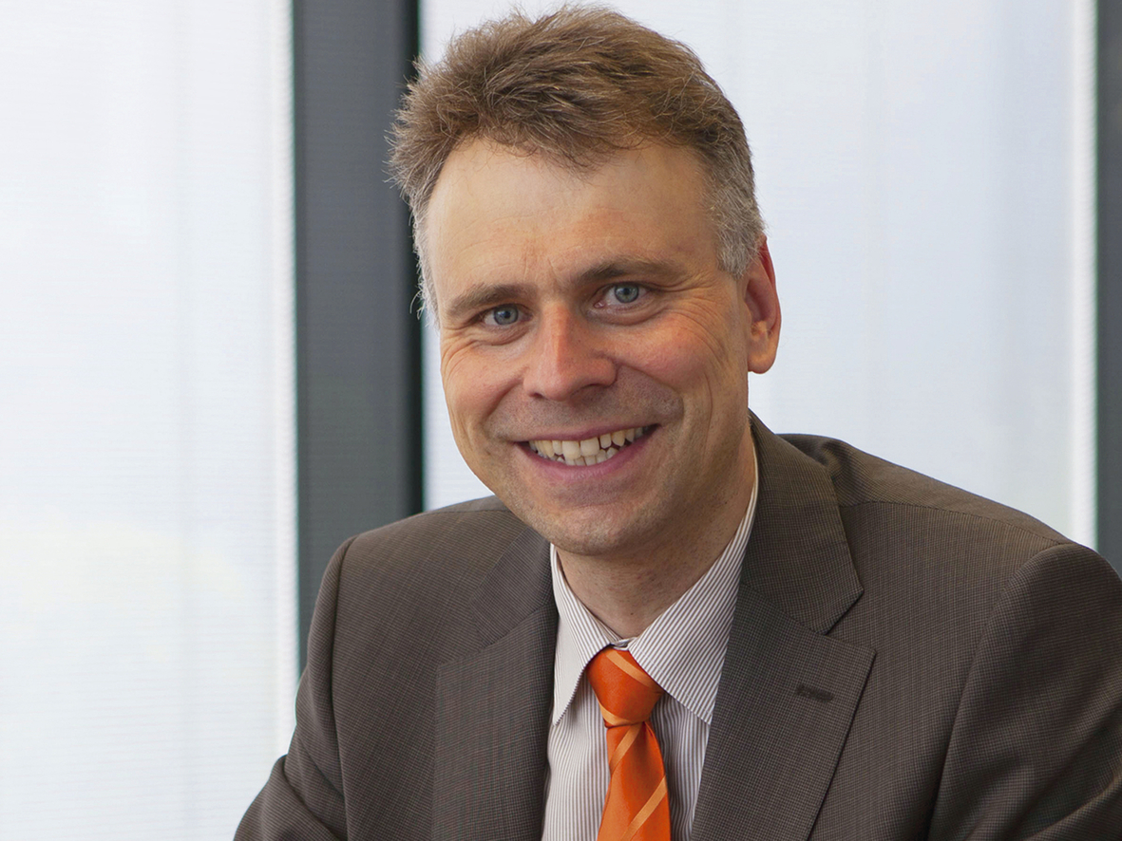
Markus Sandhöfner has been in charge of B&R Germany since January 2014.

About B&R
B&R, a division of ABB Group, is a global leader in industrial automation headquartered in Austria. B&R combines state-of-the-art technology with advanced engineering to provide customers in virtually every industry with complete solutions for machine and factory automation, motion control, HMI and integrated safety technology. With Industrial IoT communication standards including OPC UA, POWERLINK and openSAFETY as well as its Automation Studio software, B&R is constantly redefining the future of automation engineering. The innovative spirit that keeps B&R at the forefront of industrial automation is driven by a commitment to simplifying processes and exceeding customer expectations.
For more information, visit www.br-automation.com.

