30 Years B&R Germany – A success story
From a 10-man business to a full-service automation supplier
This year, B&R Germany is celebrating its 30th anniversary. Since being founded in the summer of 1983, the company has become one of the leading suppliers of automation technology. In addition to the headquarters in Bad Homburg, B&R Germany now also has 16 local offices.
Frank Winter (66) is inextricably linked to the history of the company. He was in charge of business between 1983 and handing over management of the company to Markus Sandhofner (47) at the end of 2013.
Frank Winter set out in 1983, together with 10 industrial control specialists, to conquer the world of automation. With B&R's extremely innovative family of PLCs, the young team was quickly able to achieve success at world-renowned companies.
In the late 80s, parallel computing on the controller was the next innovation for B&R. "High-level language programming, Ethernet networks and processing CNC algorithms on the PLC were unique on the market at that time," says Frank Winter.
A decentralized structure was consistently pursued, which is still in use today. "The skill of our employees and close proximity to our customers are vital to our success," says Frank Winter. This allows product developers to receive important feedback so that subsequent innovations better meet customer needs.
Immediately after the German reunification, the first office in the new states was opened in Leipzig. Additional offices all over German followed.
In 1992, B&R surprised the industry with what was at that time a technological sensation: the 2000-series PLCs, which included multitasking, symbolic variable names, dedicated axis processors and modern fieldbus technology, and industrial PCs represented a further milestone in the successful product strategy.
With the development of our own servo drive technology and the POWERLINK real-time Ethernet network, B&R became a full-service supplier in the field of industrial automation. B&R has now also become a technological leader for safety applications.
With a portfolio that includes integrated robot controllers and the powerful APROL process control system, B&R is well-prepared for the demands of Industry 4.0.

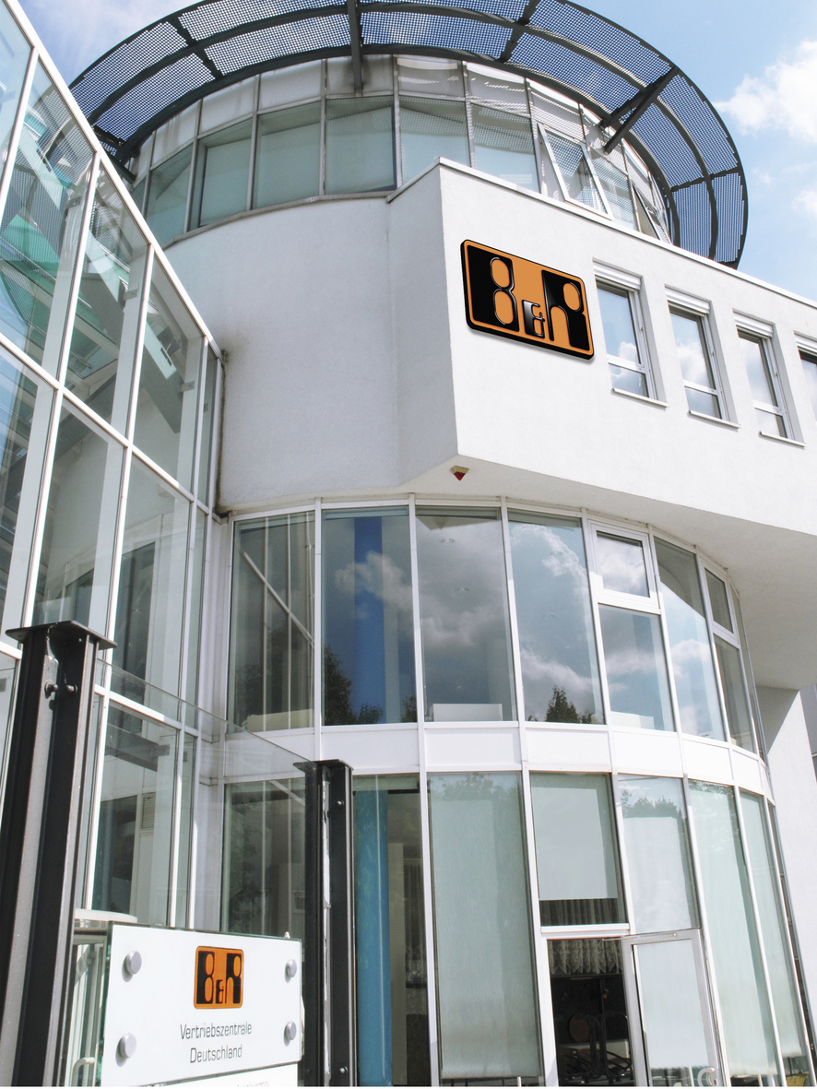
B&R Germany headquarters is in Bad Homburg.
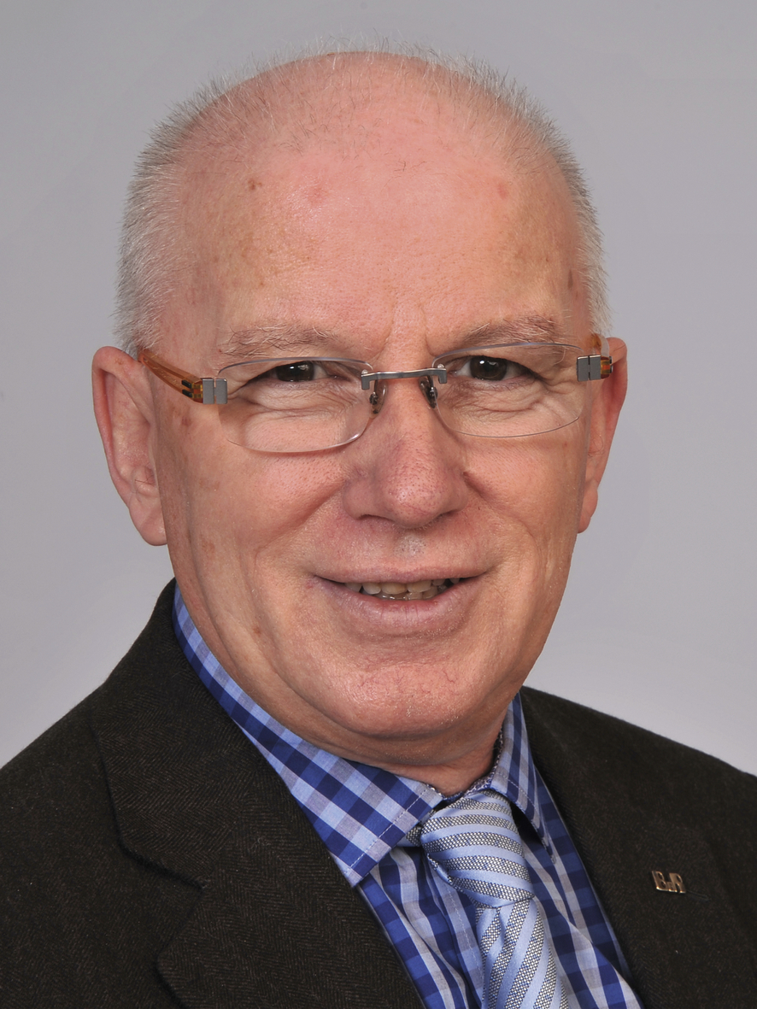
Frank Winter has been in charge of B&R Germany for the last 30 years.

B&R Hakkında
ABB Grubunun bir bölümü olan B&R, merkezi Avusturya'da bulunan endüstriyel otomasyon alanında global bir liderdir. B&R, neredeyse her sektördeki müşterilere makine ve fabrika otomasyonu, hareket kontrolü, HMI ve entegre güvenlik teknolojisi için eksiksiz çözümler sunmak üzere en son teknolojiyi ileri mühendislikle birleştiriyor. OPC UA, POWERLINK ve openSAFETY gibi Endüstriyel IoT iletişim standartlarının yanı sıra Automation Studio yazılımıyla B&R, otomasyon mühendisliğinin geleceğini sürekli olarak yeniden tanımlıyor. B&R'ı endüstriyel otomasyonun ön saflarında tutan yenilikçi ruh, süreçleri basitleştirme ve müşteri beklentilerini aşma taahhüdünden kaynaklanmaktadır.
Daha fazla bilgi için www.br-automation.com adresini ziyaret edin.

