B&R to showcase modular automation systems for off-highway vehicles at IFPE 2014

From March 4-8, 2014, B&R will exhibit its innovative technology solutions for mobile automation at booth 83550 in the South hall of IFPE, the leading international exposition for the integration of fluid power with other technologies for power transmission and motion control applications. The show is co-located with CONEXPO-CON/AGG, where an additional 100,000 industry professionals from for every major construction industry including asphalt, aggregates, concrete, earthmoving, lifting, mining, utilities will come together.
Mobile automation highlights
B&R offers modular systems for off-highway vehicle architectures and will showcase its new MA170 control and I/O system. This device series has been specially developed for use in harsh conditions. An IP65 housing and coated circuit board allow these modules to withstand extreme temperatures from -40°C to +85°C without difficulties. These new B&R modules are also shock and vibration resistant. The MA330 mobile automation keypad system with intuitive handling, robust design and flexible functionality will also be featured.
Real-time deterministic controls network for mobile equipment
Mobile devices from B&R are equipped with CAN bus, and the option to use POWERLINK, the deterministic real-time protocol for standard Ethernet. This open source Ethernet protocol can address both data and control needs on a single wire, while reducing design costs, minimizing system jitter, and achieving maximum system performance and will be an area of focus at the B&R booth. On Wednesday, March 5, IFPE and CONEXPO-CON/AGG attendees can hear Technology Marketing Manager of the Ethernet POWERLINK Standardization Group, Sari Germanos, present at the IFPE Technical conference session “High Speed Real-Time Industrial Ethernet Technology Revolutionizes Off-Highway Vehicle Automation Architectures.”

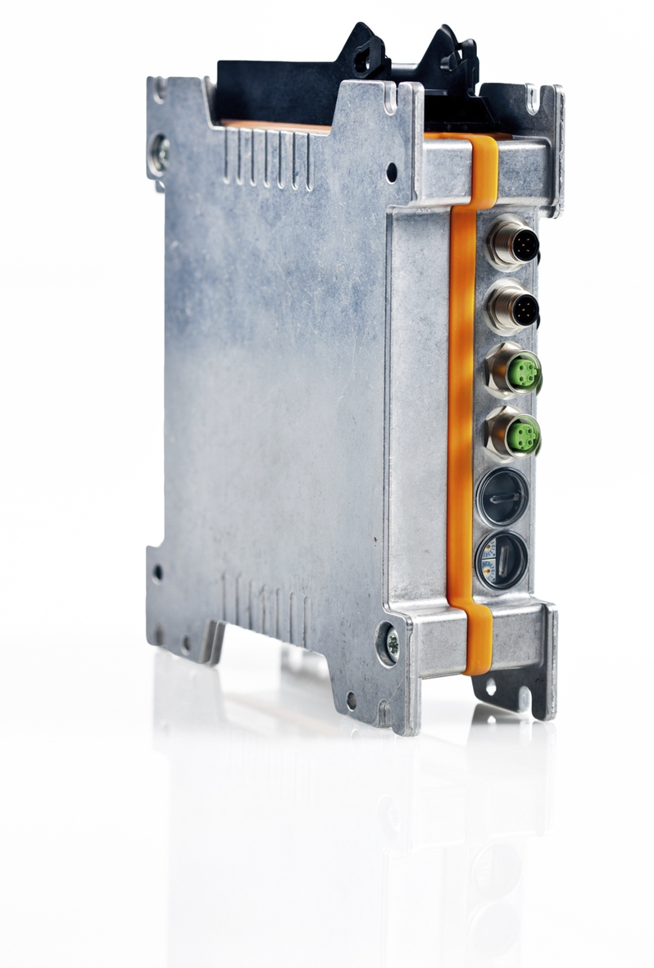
B&R’s MA170 control and I/O systems, which are shock and vibration resistant and ideal for harsh conditions will be on display at IFPE booth S-83550.

About B&R
B&R, a division of ABB Group, is a global leader in industrial automation headquartered in Austria. B&R combines state-of-the-art technology with advanced engineering to provide customers in virtually every industry with complete solutions for machine and factory automation, motion control, HMI and integrated safety technology. With Industrial IoT communication standards including OPC UA, POWERLINK and openSAFETY as well as its Automation Studio software, B&R is constantly redefining the future of automation engineering. The innovative spirit that keeps B&R at the forefront of industrial automation is driven by a commitment to simplifying processes and exceeding customer expectations.
For more information, visit www.br-automation.com.

