Structured work within a team
Automation Studio 4 integrated with Team Foundation Server
The integration of the Team Foundation Server platform into B&R's Automation Studio software development environment makes it easier than ever to versionize individual software components and ensure adherence to defined sequences. Essential for structured development within a team, a source control system is the only way to guarantee clearly defined development versions while helping to prevent errors such as unintended overwriting or the use of outdated modules.
Uniform workflows
Manually saving different versions and writing up change logs for each is an extremely time-consuming and error-prone process. The TFS adapter for Automation Studio provides software developers a way of leaving tedious version management tasks up to the system – with synchronization a breeze thanks to the software's integrated comparison mechanisms. Uniform, user-defined workflows also ensure that real-time information is available for everyone involved and prevent the distribution of unreleased versions. The development process itself can be traced through history logs, helping developers retain an overview of their current tasks. In addition to TFS, Automation Studio can also be integrated with the open-source Subversion versioning and revision control system.
Always a step ahead
Along with the integration of version management software, the openness of Automation Studio also means that it supports continuous integration – a process that compiles the application, performs unit testing and creates reports each time a check-in procedure takes place. This not only allows potential errors to be identified and corrected immediately, but also guarantees the highest level of software quality beginning directly in the development process itself.

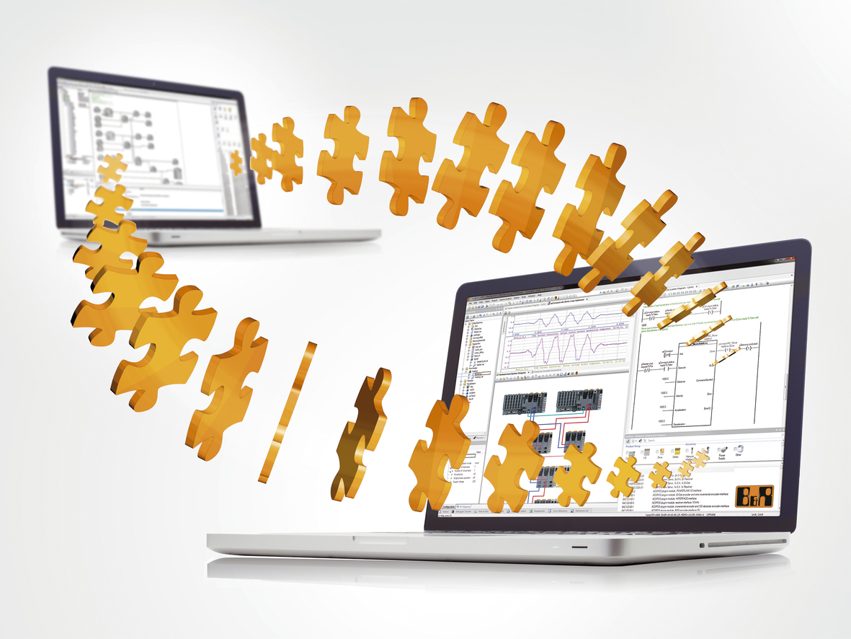
Software development in teams has become considerably easier with automated source code management provided by Team Foundation Server.

About B&R
B&R, a division of ABB Group, is a global leader in industrial automation headquartered in Austria. B&R combines state-of-the-art technology with advanced engineering to provide customers in virtually every industry with complete solutions for machine and factory automation, motion control, HMI and integrated safety technology. With Industrial IoT communication standards including OPC UA, POWERLINK and openSAFETY as well as its Automation Studio software, B&R is constantly redefining the future of automation engineering. The innovative spirit that keeps B&R at the forefront of industrial automation is driven by a commitment to simplifying processes and exceeding customer expectations.
For more information, visit www.br-automation.com.

