Geared up for Industry 4.0
B&R presenting solutions for tomorrow's machines in Hanover
According to the Industry 4.0 working group, Smart Factories and the Internet of Things will be reality by 2025. B&R customers will not have to wait nearly that long, however. This innovative specialist in the field of automation offers technologies and solutions that make it possible to implement tomorrow's machines and systems today. B&R will be presenting their innovative range of products at the Hannover Messe in Hall 9, Booth D28.
"The concepts of the future will thrive on the use of open technologies," explains Markus Sandhöfner, managing director of B&R Germany. This requirement is already being met by B&R's Automation Studio software and the open-source POWERLINK and openSAFETY standards. The APROL process control system allows machinery to be quickly and safely interconnected in order to optimize maintenance intervals, overall energy efficiency and the load on individual machines. "This is Industry 4.0 – up close and personal," says Sandhöfner.
Scalability+ is a decisive step into the future, offering a perfectly orchestrated array of solutions that open up machines and plants to unprecedented levels of modularity and flexibility. Not only are machine builders free to select the precise hardware and software components that best meet their automation needs – this freedom remains open throughout the entire project. "If the development process determines that components or solutions need to be upgraded or scaled down, this can be done at any time," says Sandhöfner. Every bit of development work that had already been completed is retained.
High performance with a compact design
B&Rs modular Panel PC platform is an important component of Scalability+. The newest system in this platform, the Panel PC 2100, will be presented to the public for the first time at the Hannover Messe. All 2nd generation Automation Panels – both the build-in and swing arm variants – can be upgraded to a powerful Panel PC system simply by installing the PC module. Taking advantage of innovative Bay Trail architecture from Intel, the PC module is as compact as a DVI/SDL receiver. At the same time, the computing power is fully scalable, with single-core, dual-core or quad-core processors available depending on the actual requirements of the user.

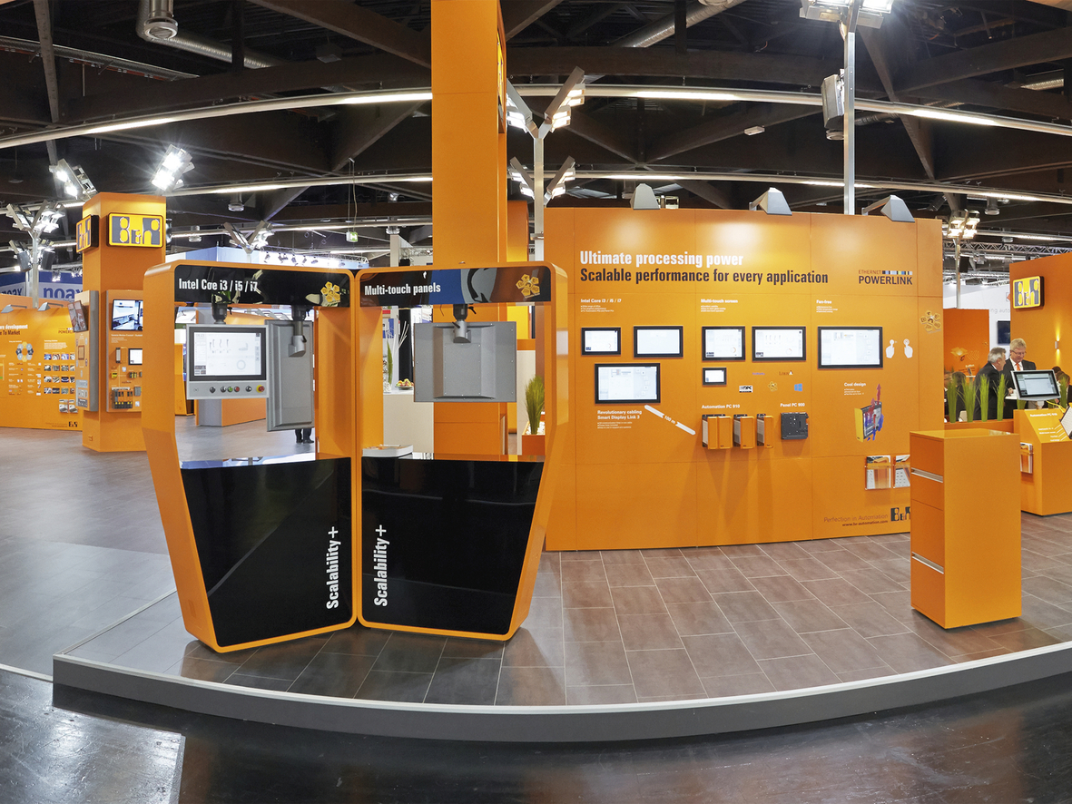
B&R experts will be presenting advanced solutions at the Hannover Messe that are paving the way for Industry 4.0.

About B&R
B&R, a division of ABB Group, is a global leader in industrial automation headquartered in Austria. B&R combines state-of-the-art technology with advanced engineering to provide customers in virtually every industry with complete solutions for machine and factory automation, motion control, HMI and integrated safety technology. With Industrial IoT communication standards including OPC UA, POWERLINK and openSAFETY as well as its Automation Studio software, B&R is constantly redefining the future of automation engineering. The innovative spirit that keeps B&R at the forefront of industrial automation is driven by a commitment to simplifying processes and exceeding customer expectations.
For more information, visit www.br-automation.com.

