Combining proven and state-of-the-art technology
Full compatibility: New Automation Panels in 4:3 format
In addition to widescreen panels, B&R is now offering second generation Automation Panel displays in conventional 4:3 format with single-touch operation. For customers, this means 100% compatibility with existing systems without having to sacrifice modern features such as LED backlighting.
Any distance between the industrial PC and display that needs covering is also not a problem since all Automation Panels can be equipped with a Smart Display Link 3 receiver – allowing displays to be placed up to 100 meters away from the Automation PC. SDL3 then transmits all necessary data over an ordinary Ethernet cable, with sleek and cost-efficient RJ45 connectors perfectly suited for routing through tight openings.
Display sizes from 12.1" to 19"
Existing visualization applications can be displayed using the latest screen technology on Automation Panels in 4:3 format without having to modify the software a single bit. 12.1" and 15" panels with XGA resolution are available for control cabinet installations in addition to a 19" panel with SXGA resolution that rounds off the product line.
These systems not only feature brilliant graphics, but also an extremely slim design; the 12.1" variant can even be used as a replacement for the 10.4" panel if a higher resolution is desired. To top it off, the LED backlight features a wide adjustment range that allows the displays to be dimmed for user comfort in environments with lower light levels.

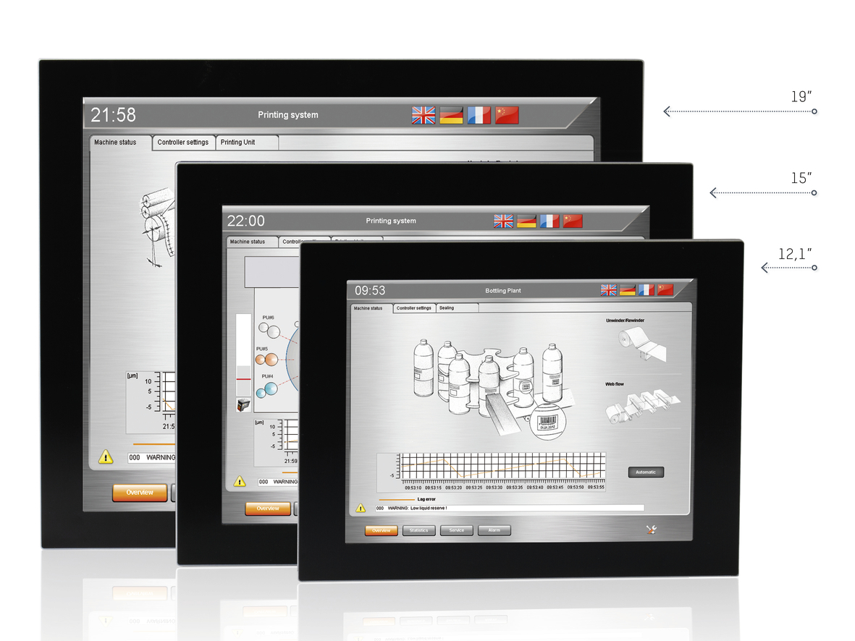
Automation Panels from B&R in 4:3 format are available in three different sizes.

B&R Hakkında
ABB Grubunun bir bölümü olan B&R, merkezi Avusturya'da bulunan endüstriyel otomasyon alanında global bir liderdir. B&R, neredeyse her sektördeki müşterilere makine ve fabrika otomasyonu, hareket kontrolü, HMI ve entegre güvenlik teknolojisi için eksiksiz çözümler sunmak üzere en son teknolojiyi ileri mühendislikle birleştiriyor. OPC UA, POWERLINK ve openSAFETY gibi Endüstriyel IoT iletişim standartlarının yanı sıra Automation Studio yazılımıyla B&R, otomasyon mühendisliğinin geleceğini sürekli olarak yeniden tanımlıyor. B&R'ı endüstriyel otomasyonun ön saflarında tutan yenilikçi ruh, süreçleri basitleştirme ve müşteri beklentilerini aşma taahhüdünden kaynaklanmaktadır.
Daha fazla bilgi için www.br-automation.com adresini ziyaret edin.

