B&R accelerates automation
Smart: reACTION reduces response times to 1 µs
B&R has raised the bar in the field of automation technology with regard to response times. With reACTION technology, the Austrian specialist is able to reduce automation response times in down to 1 µs. B&R will present these and many other innovations at SMART Automation Austria from May 6-8 in Vienna (Hall A, Booth A0223).
Completely scalable
Power Panel T-Series and C-series control panels are new additions to B&R's wide range of products. Whereas the controller version comes equipped with a built-in controller, the T30 terminal is similar in appearance but is purely a visualization device. Both variants are characterized by a small installation depth and maintenance-free operation. The Scalability+ solution allows for numerous models so that machine manufacturers can adjust their automation solution to perfectly match the needs of each individual machine.
Out-of-the-box packages for equipment manufacturers and end users
With APROL EnMon, B&R has a ready-to-use solution that allows users to considerably reduce energy consumption and save money. APROL EnMon makes it easy to meet ISO 50001 requirements. The APROL ConMon condition monitoring module also makes it possible to achieve savings. This solution detects cases when service work might be needed early and can therefore prevent system downtime. APROL EnMon and ConMon are available as complete preconfigured systems.

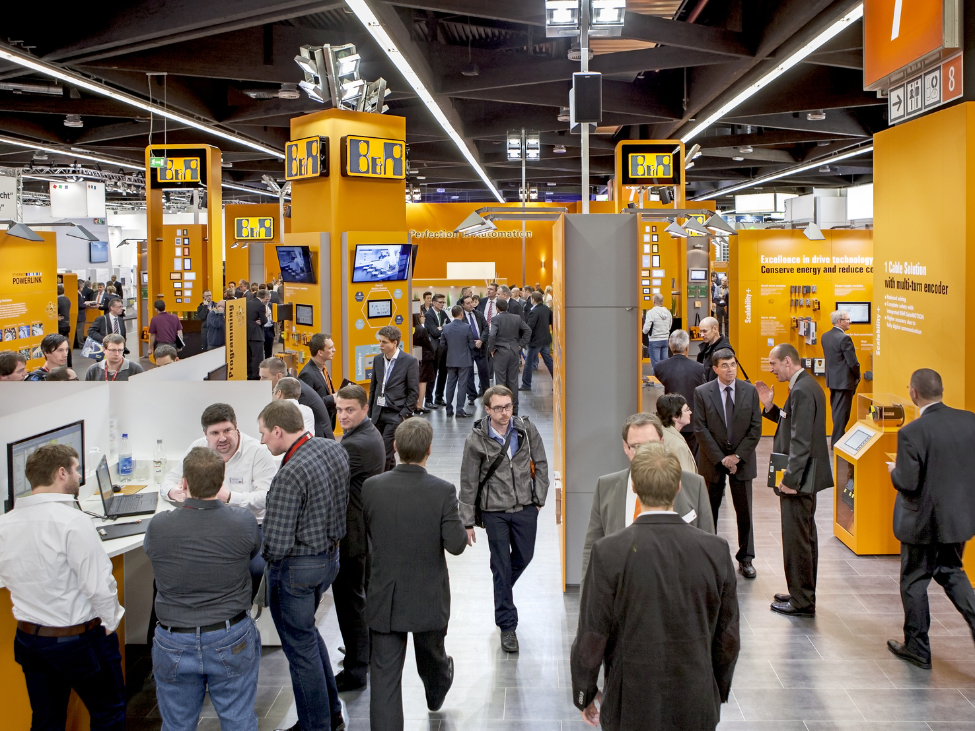
At SMART, B&R will be presenting its latest technologies.

About B&R
B&R, a division of ABB Group, is a global leader in industrial automation headquartered in Austria. B&R combines state-of-the-art technology with advanced engineering to provide customers in virtually every industry with complete solutions for machine and factory automation, motion control, HMI and integrated safety technology. With Industrial IoT communication standards including OPC UA, POWERLINK and openSAFETY as well as its Automation Studio software, B&R is constantly redefining the future of automation engineering. The innovative spirit that keeps B&R at the forefront of industrial automation is driven by a commitment to simplifying processes and exceeding customer expectations.
For more information, visit www.br-automation.com.

