Compensating for errors in advance
B&R servo drives detect and correct lag error automatically
B&R continues to expand the functionality of its ACOPOS line of servo drives. Repetitive control – B&R's latest advancement – considerably improves the accuracy of production processes with stationary disturbances by using predictive lag error compensation. The performance of the machine or system is considerably increased without a great deal of additional effort. Repetitive control is available for all ACOPOS models simply by installing a firmware update.
When using position-controlled drives with constant speed, mechanical conditions can cause stationary disturbing torque fluctuations, which often results in lag error localized to a certain area. Optimizing the drive controller configuration can minimize these lag errors but will not be able to completely prevent the disturbance.
Intelligent algorithm
Embedded in the standard speed control loop for the ACOPOS drive family, repetitive control adjusts the torque setpoint of the drive in a way that drastically reduces the periodic portions in the speed or lag error. The algorithm undergoes a constant learning process so that changes to the load profile – caused by wear, for example – have no effect whatsoever on the drive due to predictive compensation for disturbances.
Available as an add-on to the standard control procedure, active disturbance suppression is easy and intuitive to configure, not even requiring a mathematical model thanks to the extremely adaptive nature of the algorithm.

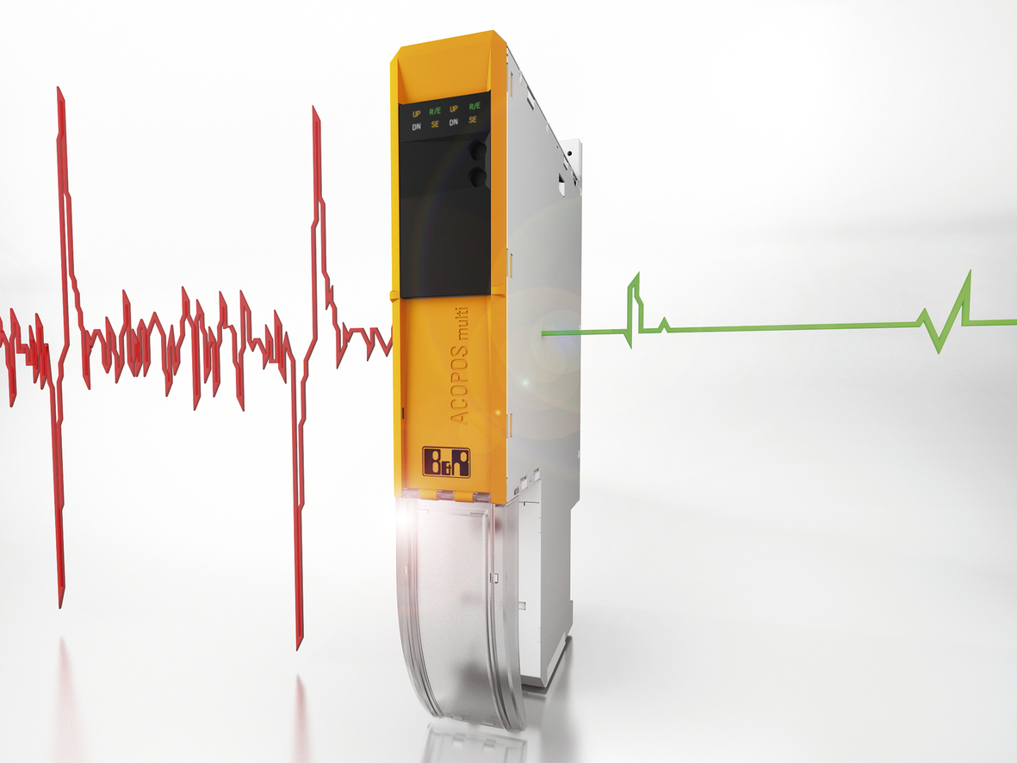
Repetitive control provides lag error compensation for ACOPOS servo drives from B&R to considerably improve the accuracy of production processes with stationary disturbances.

About B&R
B&R, a division of ABB Group, is a global leader in industrial automation headquartered in Austria. B&R combines state-of-the-art technology with advanced engineering to provide customers in virtually every industry with complete solutions for machine and factory automation, motion control, HMI and integrated safety technology. With Industrial IoT communication standards including OPC UA, POWERLINK and openSAFETY as well as its Automation Studio software, B&R is constantly redefining the future of automation engineering. The innovative spirit that keeps B&R at the forefront of industrial automation is driven by a commitment to simplifying processes and exceeding customer expectations.
For more information, visit www.br-automation.com.

