Compensating for errors in advance
B&R servo drives detect and correct lag error automatically
B&R continues to expand the functionality of its ACOPOS line of servo drives. Repetitive control – B&R's latest advancement – considerably improves the accuracy of production processes with stationary disturbances by using predictive lag error compensation. The performance of the machine or system is considerably increased without a great deal of additional effort. Repetitive control is available for all ACOPOS models simply by installing a firmware update.
When using position-controlled drives with constant speed, mechanical conditions can cause stationary disturbing torque fluctuations, which often results in lag error localized to a certain area. Optimizing the drive controller configuration can minimize these lag errors but will not be able to completely prevent the disturbance.
Intelligent algorithm
Embedded in the standard speed control loop for the ACOPOS drive family, repetitive control adjusts the torque setpoint of the drive in a way that drastically reduces the periodic portions in the speed or lag error. The algorithm undergoes a constant learning process so that changes to the load profile – caused by wear, for example – have no effect whatsoever on the drive due to predictive compensation for disturbances.
Available as an add-on to the standard control procedure, active disturbance suppression is easy and intuitive to configure, not even requiring a mathematical model thanks to the extremely adaptive nature of the algorithm.

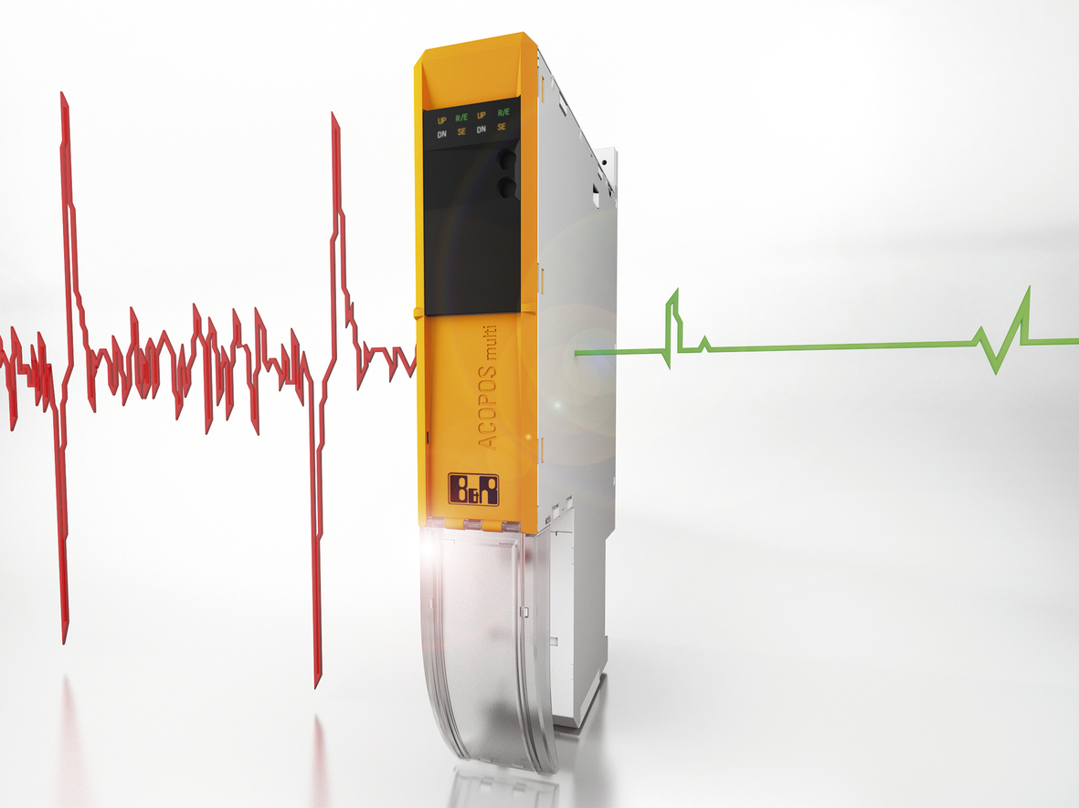
Repetitive control provides lag error compensation for ACOPOS servo drives from B&R to considerably improve the accuracy of production processes with stationary disturbances.

B&R Hakkında
ABB Grubunun bir bölümü olan B&R, merkezi Avusturya'da bulunan endüstriyel otomasyon alanında global bir liderdir. B&R, neredeyse her sektördeki müşterilere makine ve fabrika otomasyonu, hareket kontrolü, HMI ve entegre güvenlik teknolojisi için eksiksiz çözümler sunmak üzere en son teknolojiyi ileri mühendislikle birleştiriyor. OPC UA, POWERLINK ve openSAFETY gibi Endüstriyel IoT iletişim standartlarının yanı sıra Automation Studio yazılımıyla B&R, otomasyon mühendisliğinin geleceğini sürekli olarak yeniden tanımlıyor. B&R'ı endüstriyel otomasyonun ön saflarında tutan yenilikçi ruh, süreçleri basitleştirme ve müşteri beklentilerini aşma taahhüdünden kaynaklanmaktadır.
Daha fazla bilgi için www.br-automation.com adresini ziyaret edin.

