B&R India: Your partner in success
Perfect automation partner
“The strength of B&R Industrial Automation is echoed in the strength of our customers. We are confident that the power of our technical expertise and innovations will maximize your competitive edge..” says PV Sivaram, Managing Director of B&R India.
B&R Industrial Automation Pvt. Ltd. is a wholly owned subsidiary of the Austrian multinational company Bernecker & Rainer Industrie-Elektronik Ges.m.b.H. B&R recognized the strategic importance of the Indian market early on, and became actively involved in 1995. Today, B&R Industrial Automation Pvt. Ltd. is a trusted name amongst Indian manufacturers.
B&R India has its headquarters in Pune, Maharashtra, in a premises exceeding 7,000 sq.ft., as well as a logistics and repair center in nearby Chakan with an additional area of 11,000 sq.ft.. These ultra-modern facilities are equipped to deliver the latest automation products and services. With regional offices in Ahmedabad, Bengaluru, Delhi and Chennai, B&R is well prepared to provide comprehensive support all across the country.
By Indians, for India
Regarding distinctiveness of B&R in Indian market, Sivaram comments “In a time of global competition and disappearing trade barriers, the uniqueness of a solution makes all the difference. For a final product to perform up to its full potential, it must be built on a foundation of outstanding technical expertise. This need is well addressed by our young and dynamic team of application engineers. These highly qualified specialists receive extensive training at the corporate headquarters in Austria. B&R also maintains full-fledged training centers for customers and partners in Pune, Ahmedabad and Bengaluru”.
As an integral part of a global technology leader dedicated to its OEM customers and partners, B&R India can guarantee application confidentiality as well as an extensive support network.
Efficient engineering fuelled by innovations
Our technologically advanced, state-of-the-art products give our customers a decisive edge over their competitors. B&R’s integrated automation solutions for machine and process control cover all aspects of PLC, motion control, HMI, industrial PCs and integrated safety technology for every industry. With high-performance industrial fieldbus communication standards like Ethernet POWERLINK and openSAFETY as well as the versatile Automation Studio software development environment, B&R is constantly redefining the future of automation engineering.

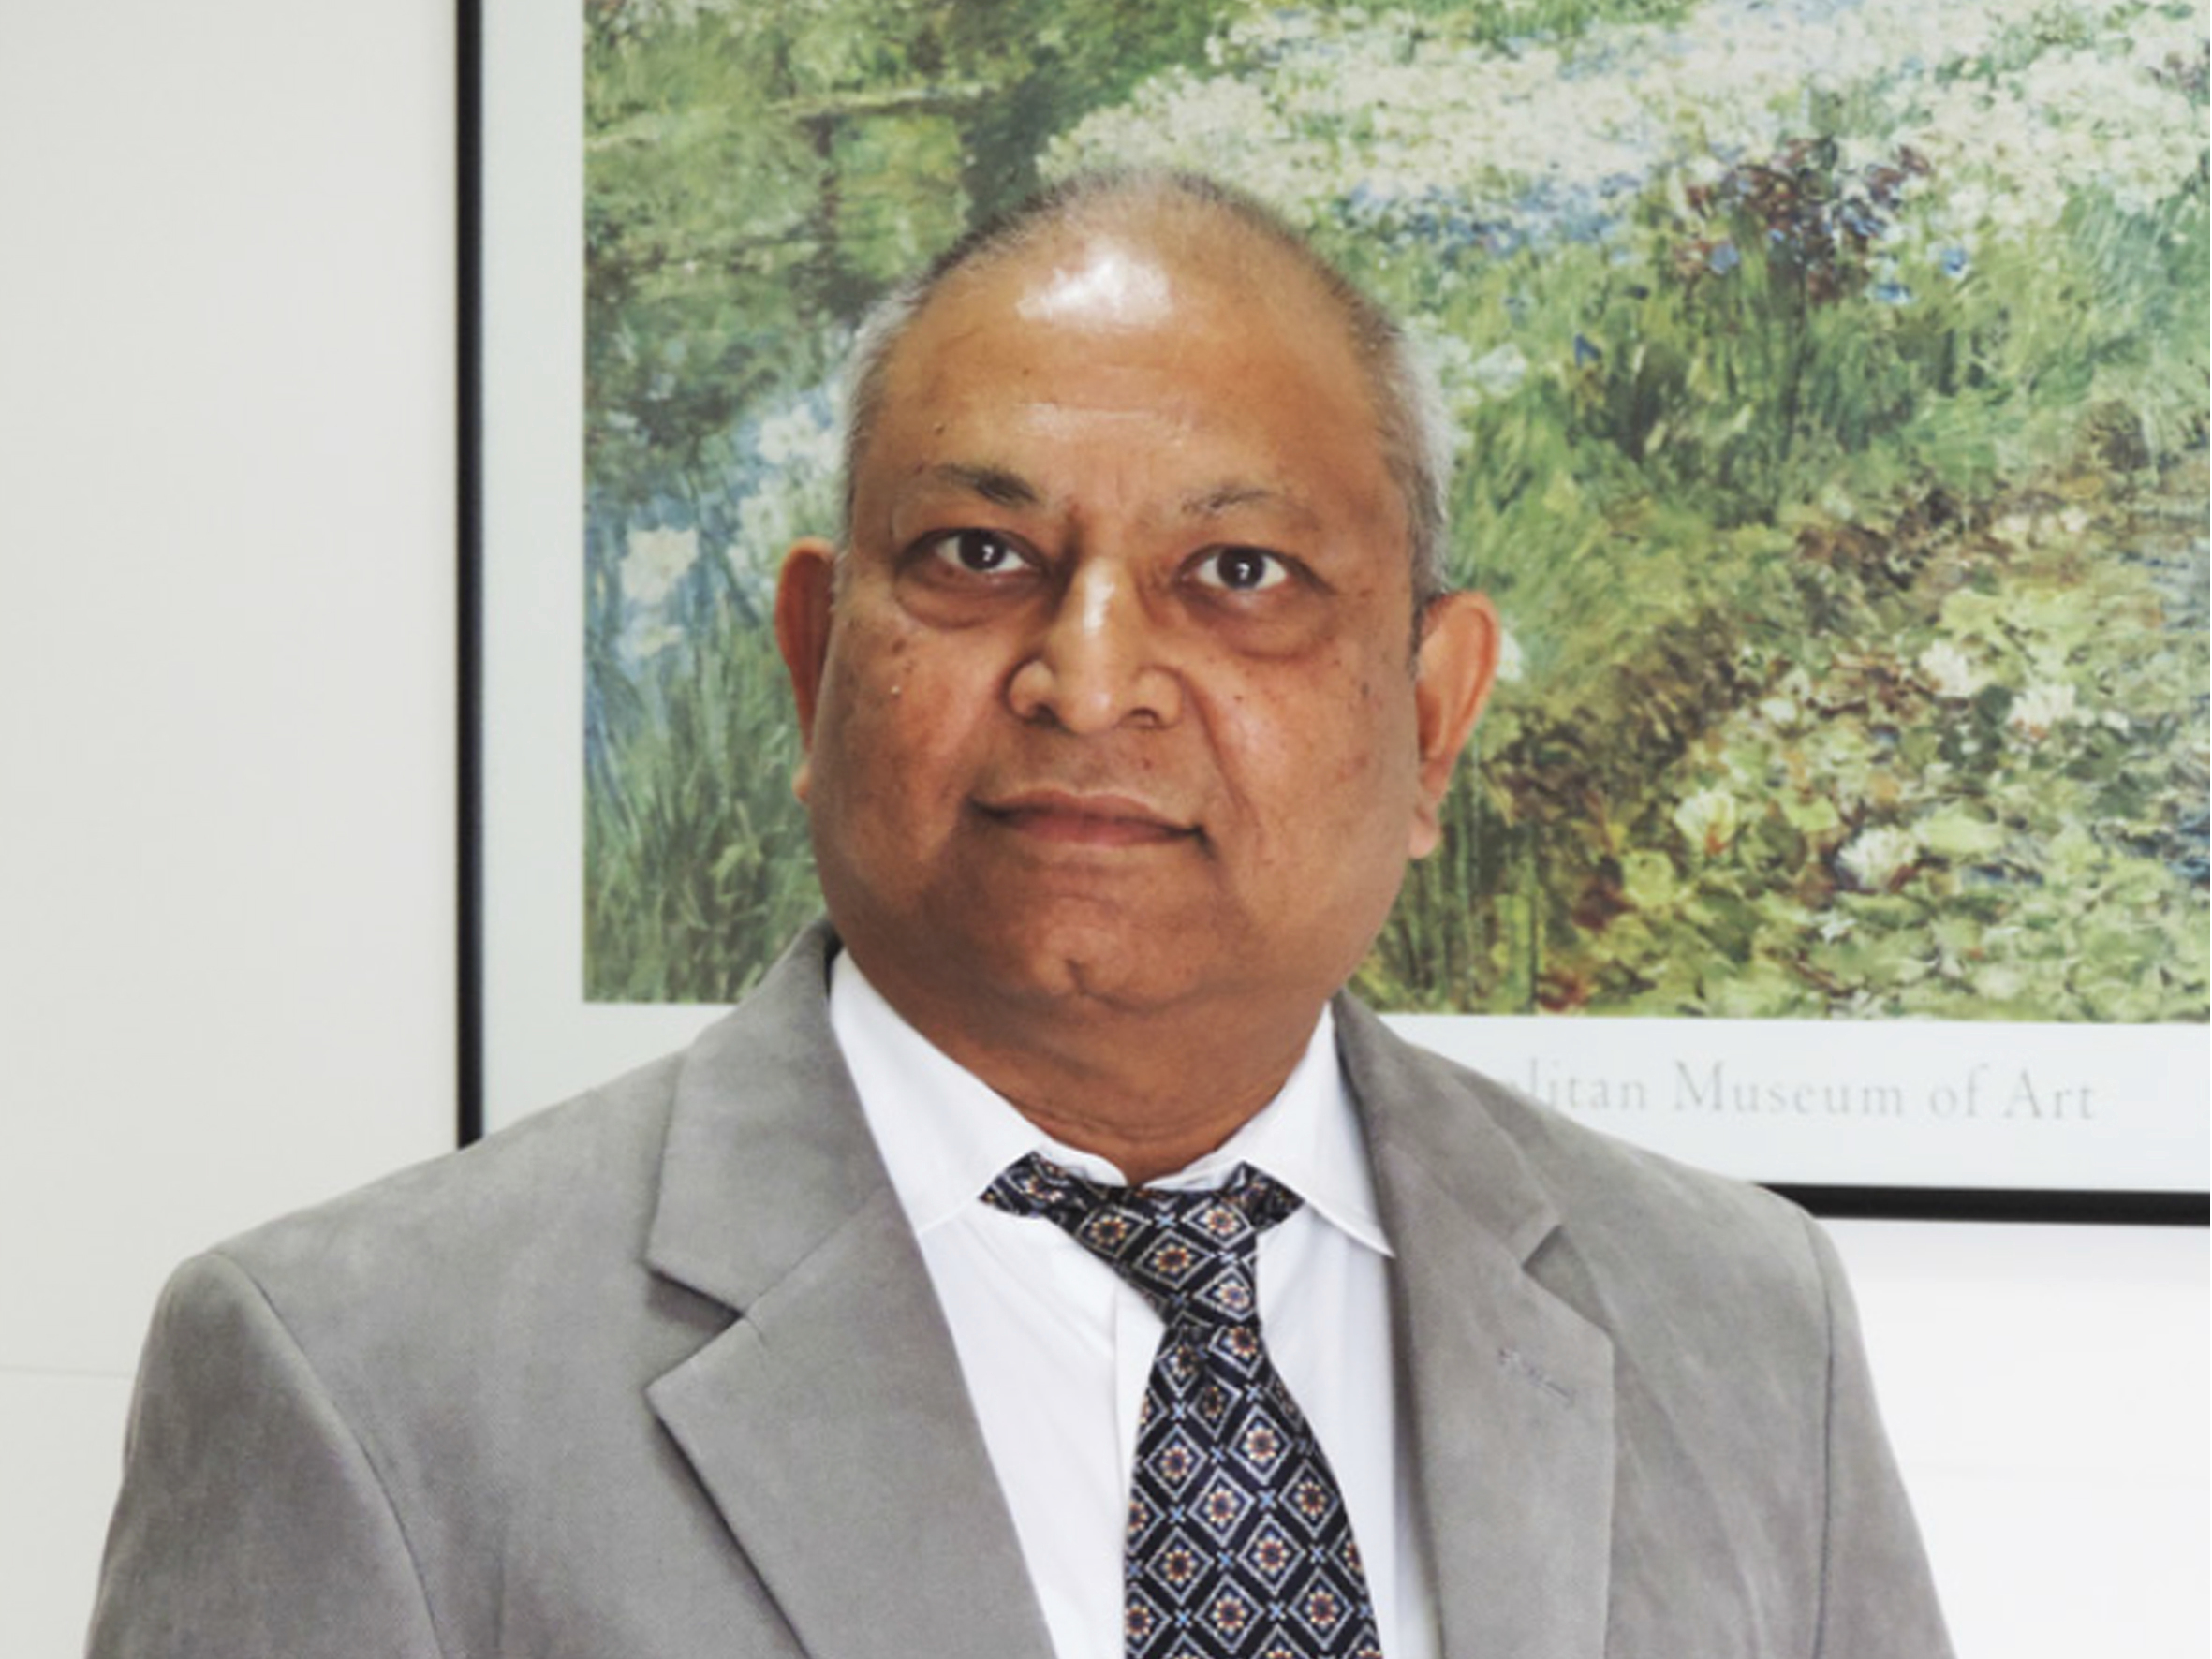
PV Sivaram, Managing Director of B&R India

About B&R
B&R, a division of ABB Group, is a global leader in industrial automation headquartered in Austria. B&R combines state-of-the-art technology with advanced engineering to provide customers in virtually every industry with complete solutions for machine and factory automation, motion control, HMI and integrated safety technology. With Industrial IoT communication standards including OPC UA, POWERLINK and openSAFETY as well as its Automation Studio software, B&R is constantly redefining the future of automation engineering. The innovative spirit that keeps B&R at the forefront of industrial automation is driven by a commitment to simplifying processes and exceeding customer expectations.
For more information, visit www.br-automation.com.

