B&R at interpack 2014 in Düsseldorf
Taking packaging to a whole new level
B&R continues to push packaging machine performance to its physical limits. With reACTION technology, B&R has reduced the response times for industrial automation down to 1 µs. This makes it possible to process extremely time-critical sub-processes in accordance with IEC 61131 requirements using standard hardware. The newest B&R solutions for the packaging industry will be on display on May 8-14 at interpack 2014 in Dusseldorf (Hall A6 / Booth E62).
B&R's innovative automation technologies are opening up entirely new levels of machine and line performance – not to mention increased flexibility and availability. B&R products make it easy to seamlessly integrate a wide range of advanced automation technology into packaging machines, including web services, advanced motion control and robotics, safety, vision systems and IT connectivity. The performance of high-speed machine functions such as product labelling or the rejection of sub-par products has also gained an enormous boost – without added costs – through the use of B&R reACTION and NetTime technologies.
Ultimate Flexibility
Packaging lines demand extreme levels of productivity and flexibility across the board – from the primary and secondary solutions straight through to the end-of-line equipment. This can be achieved through a modular design with control and drive components installed directly on the machine's frame – or even on rotating parts. B&R offers IP65-rated ACOPOSremote and ACOPOSmotor servo drives as well as the X67 series of machine-mountable I/O modules.

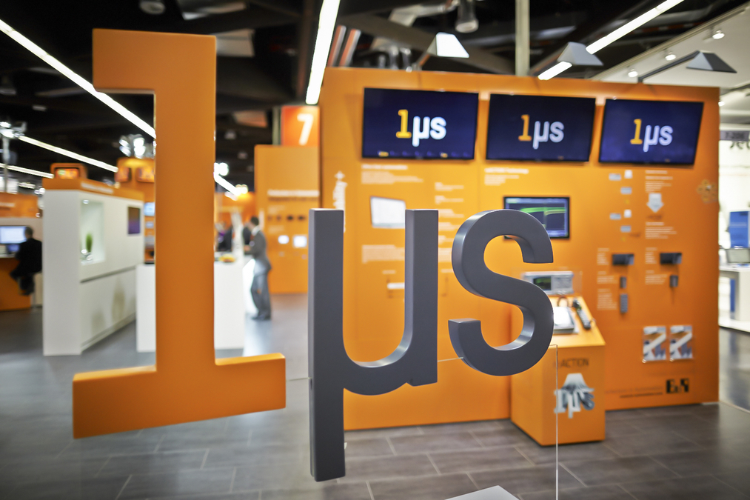
Packaging machines benefit from B&R’s reACTION technology, which reduces response times in industrial automation applications down to 1 µs.

About B&R
B&R, a division of ABB Group, is a global leader in industrial automation headquartered in Austria. B&R combines state-of-the-art technology with advanced engineering to provide customers in virtually every industry with complete solutions for machine and factory automation, motion control, HMI and integrated safety technology. With Industrial IoT communication standards including OPC UA, POWERLINK and openSAFETY as well as its Automation Studio software, B&R is constantly redefining the future of automation engineering. The innovative spirit that keeps B&R at the forefront of industrial automation is driven by a commitment to simplifying processes and exceeding customer expectations.
For more information, visit www.br-automation.com.

