B&R at interpack 2014 in Düsseldorf
Taking packaging to a whole new level
B&R continues to push packaging machine performance to its physical limits. With reACTION technology, B&R has reduced the response times for industrial automation down to 1 µs. This makes it possible to process extremely time-critical sub-processes in accordance with IEC 61131 requirements using standard hardware. The newest B&R solutions for the packaging industry will be on display on May 8-14 at interpack 2014 in Dusseldorf (Hall A6 / Booth E62).
B&R's innovative automation technologies are opening up entirely new levels of machine and line performance – not to mention increased flexibility and availability. B&R products make it easy to seamlessly integrate a wide range of advanced automation technology into packaging machines, including web services, advanced motion control and robotics, safety, vision systems and IT connectivity. The performance of high-speed machine functions such as product labelling or the rejection of sub-par products has also gained an enormous boost – without added costs – through the use of B&R reACTION and NetTime technologies.
Ultimate Flexibility
Packaging lines demand extreme levels of productivity and flexibility across the board – from the primary and secondary solutions straight through to the end-of-line equipment. This can be achieved through a modular design with control and drive components installed directly on the machine's frame – or even on rotating parts. B&R offers IP65-rated ACOPOSremote and ACOPOSmotor servo drives as well as the X67 series of machine-mountable I/O modules.

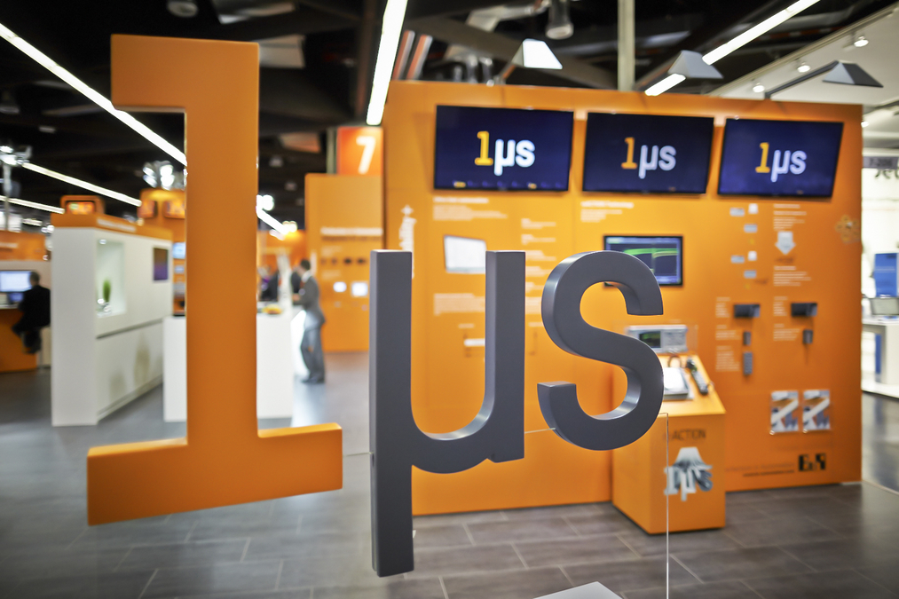
Packaging machines benefit from B&R’s reACTION technology, which reduces response times in industrial automation applications down to 1 µs.

B&R Hakkında
ABB Grubunun bir bölümü olan B&R, merkezi Avusturya'da bulunan endüstriyel otomasyon alanında global bir liderdir. B&R, neredeyse her sektördeki müşterilere makine ve fabrika otomasyonu, hareket kontrolü, HMI ve entegre güvenlik teknolojisi için eksiksiz çözümler sunmak üzere en son teknolojiyi ileri mühendislikle birleştiriyor. OPC UA, POWERLINK ve openSAFETY gibi Endüstriyel IoT iletişim standartlarının yanı sıra Automation Studio yazılımıyla B&R, otomasyon mühendisliğinin geleceğini sürekli olarak yeniden tanımlıyor. B&R'ı endüstriyel otomasyonun ön saflarında tutan yenilikçi ruh, süreçleri basitleştirme ve müşteri beklentilerini aşma taahhüdünden kaynaklanmaktadır.
Daha fazla bilgi için www.br-automation.com adresini ziyaret edin.

