Maximum performance comes in very small packages
B&R presents the Panel PC 2100 – with the latest Intel® Atom technology
The new Panel PC 2100 from B&R is a full-fledged PC system whose deceptively compact housing conceals colossal performance. The innovative design of this new system takes advantage of the latest Intel® Atom technology and represents a decisive advancement in the performance of embedded systems – with a price/performance ratio that can't be beat.
Equipped with a PC module that has the same dimensions as a Smart Display Link or DVI receiver, any second-generation Automation Panel can be transformed into a full-fledged Panel PC – including completely enclosed panels designed for swing arm mounting.
Scalable and maintenance-free
Available with single-, dual- or quad-core processors, the computing power of the Panel PC 2100 is fully scalable. At the upper range of performance, it even exceeds the performance of CoreTM i3 chips. Regardless of the variant, the absence of fans or other rotating components means that no maintenance whatsoever is required. Other standard features include two Gigabit Ethernet interfaces as well as one USB 2.0 and one USB 3.0 interface. Fieldbus connections such as POWERLINK or CAN can be individually configured through the use of interface modules, and compact MLC-based CFast cards with 60 GB or more are available to meet every memory need.
Optimal graphics performance
The graphics engine used by Intel® Atom processors is derived from CoreTM i technology and provides powerful processing all the way up to Full HD. This is also the first time that support for DirectX 11 is provided in this segment, opening up even more possibilities for enhanced graphic capabilities in SCADA and other HMI systems.

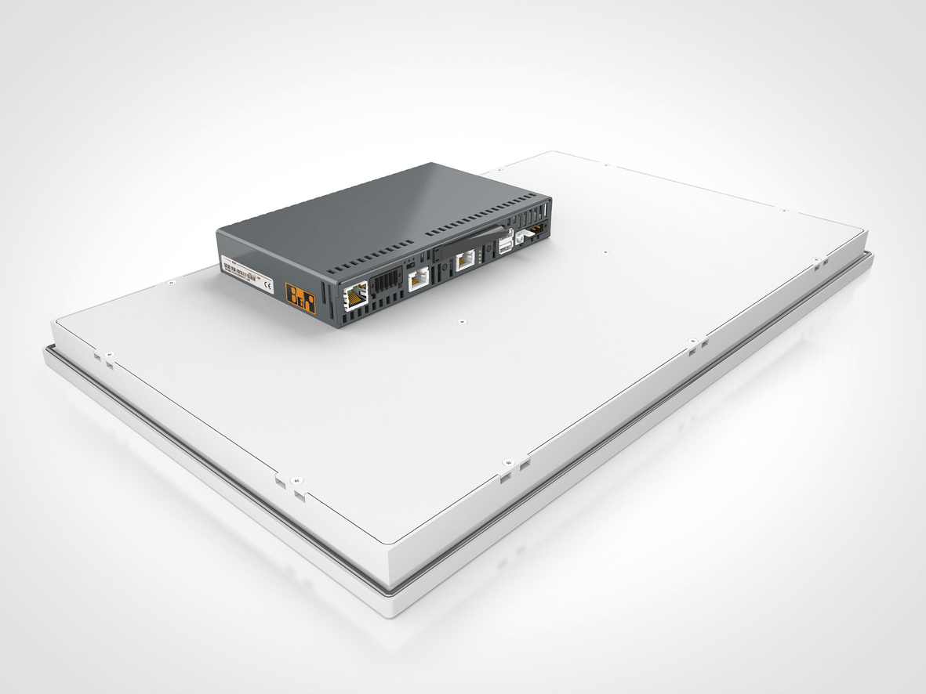
The PC module for the Panel PC 2100 from B&R is much more powerful than its small size suggests.

About B&R
B&R, a division of ABB Group, is a global leader in industrial automation headquartered in Austria. B&R combines state-of-the-art technology with advanced engineering to provide customers in virtually every industry with complete solutions for machine and factory automation, motion control, HMI and integrated safety technology. With Industrial IoT communication standards including OPC UA, POWERLINK and openSAFETY as well as its Automation Studio software, B&R is constantly redefining the future of automation engineering. The innovative spirit that keeps B&R at the forefront of industrial automation is driven by a commitment to simplifying processes and exceeding customer expectations.
For more information, visit www.br-automation.com.

