Maximum performance comes in very small packages

The new Panel PC 2100 from B&R is a full-fledged PC system whose deceptively compact housing conceals colossal performance. The innovative design of this new system takes advantage of the latest Intel® Atom technology and represents a decisive advancement in the performance of embedded systems – with a price/performance ratio that can't be beat.
Equipped with a PC module that has the same dimensions as a Smart Display Link or DVI receiver, any second-generation Automation Panel can be transformed into a full-fledged Panel PC – including completely enclosed panels designed for swing arm mounting.
Scalable and maintenance-free
Available with single-, dual- or quad-core processors, the computing power of the Panel PC 2100 is fully scalable. Regardless of the variant, the absence of fans or other rotating components means that no maintenance whatsoever is required. Other standard features include two Gigabit Ethernet interfaces as well as one USB 2.0 and one USB 3.0 interface. Fieldbus connections such as POWERLINK or CAN can be individually configured through the use of interface modules, and compact MLC-based CFast cards with 60 GB or more are available to meet every memory need.
Optimal graphics performance
This is also the first time that support for DirectX 11 is provided in this segment, opening up even more possibilities for enhanced graphic capabilities in SCADA and other HMI systems.

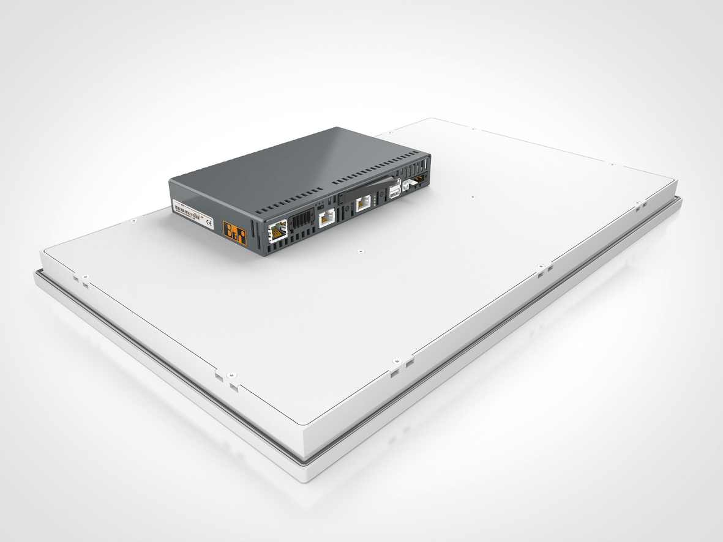
The PC module for the Panel PC 2100 from B&R is much more powerful than its small size suggests.

B&R Hakkında
ABB Grubunun bir bölümü olan B&R, merkezi Avusturya'da bulunan endüstriyel otomasyon alanında global bir liderdir. B&R, neredeyse her sektördeki müşterilere makine ve fabrika otomasyonu, hareket kontrolü, HMI ve entegre güvenlik teknolojisi için eksiksiz çözümler sunmak üzere en son teknolojiyi ileri mühendislikle birleştiriyor. OPC UA, POWERLINK ve openSAFETY gibi Endüstriyel IoT iletişim standartlarının yanı sıra Automation Studio yazılımıyla B&R, otomasyon mühendisliğinin geleceğini sürekli olarak yeniden tanımlıyor. B&R'ı endüstriyel otomasyonun ön saflarında tutan yenilikçi ruh, süreçleri basitleştirme ve müşteri beklentilerini aşma taahhüdünden kaynaklanmaktadır.
Daha fazla bilgi için www.br-automation.com adresini ziyaret edin.

