X20 system from B&R receives ATEX and HazLoc certification
Control for Zone 2
Modules from B&R's X20 controller system are now certified for ATEX Zone 2 and HazLoc Division 2 environments. These modules can now be used in locations where explosive atmospheres may temporarily occur in the event of an error.
This certification is required, for example, in bottling plants for high-proof alcohol, spirits and cleaning agents. Heating and air conditioning equipment may also fall under the ATEX directive in the European Union or the ANSI/ISA 12.12.01-2007 standard in the USA. The same applies to a wide variety of other applications in the chemical and pharmaceutical industries.

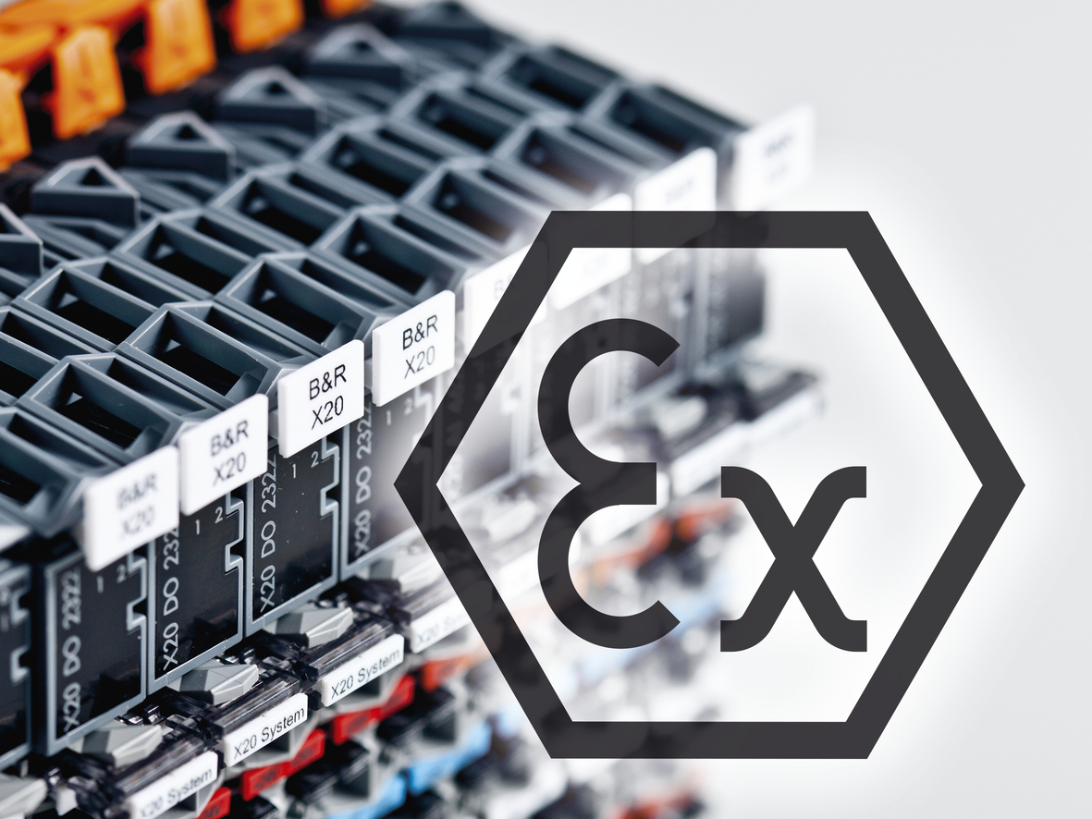
Modules from the X20 system are certified in accordance with the ATEX directive for use in zones where explosive atmospheres may temporarily occur.

About B&R
B&R, a division of ABB Group, is a global leader in industrial automation headquartered in Austria. B&R combines state-of-the-art technology with advanced engineering to provide customers in virtually every industry with complete solutions for machine and factory automation, motion control, HMI and integrated safety technology. With Industrial IoT communication standards including OPC UA, POWERLINK and openSAFETY as well as its Automation Studio software, B&R is constantly redefining the future of automation engineering. The innovative spirit that keeps B&R at the forefront of industrial automation is driven by a commitment to simplifying processes and exceeding customer expectations.
For more information, visit www.br-automation.com.

