B&R introduces premium IP65-rated helical gearboxes
Smoother operation for absolute precision
B&R is adding two new helical members to its premium family of gearboxes: the 8GP70 series with a shaft output and the 8GF70 series with a drive flange. These new products series offer excellent synchronization characteristics and a very low noise level at high speeds.
As with all B&R premium gearboxes, minimal backlash is a defining characteristic – with an option available for reducing it even further (<1 arcminute). The ability of this premium series of gearboxes to handle high axial and radial forces, their high power density and their IP65 rating mean that they can be used in an extremely wide range of applications.
Whenever an application places especially high demands on smooth operation, synchronicity and low excitation frequencies, these helical gearboxes are right at home. Woodworking machines, for example, can produce much smoother surfaces with less chatter, while printing machines can render a more consistent printed image. Since there is less heat build-up, high-speed machines can run even faster.
Scalable and perfectly coordinated
By offering these new gearboxes with either a standard shaft or flange output, B&R not only provides the perfect gearbox to match any application, but also remains faithful to their successful Scalability+ concept. Thanks to compatible designs and connector dimensions, machinery can easily be adapted to changing requirements without having to make changes to the basic machine design. Both of these new gearboxes are available in 5 different sizes with gear ratios ranging from i=3 to i=100.

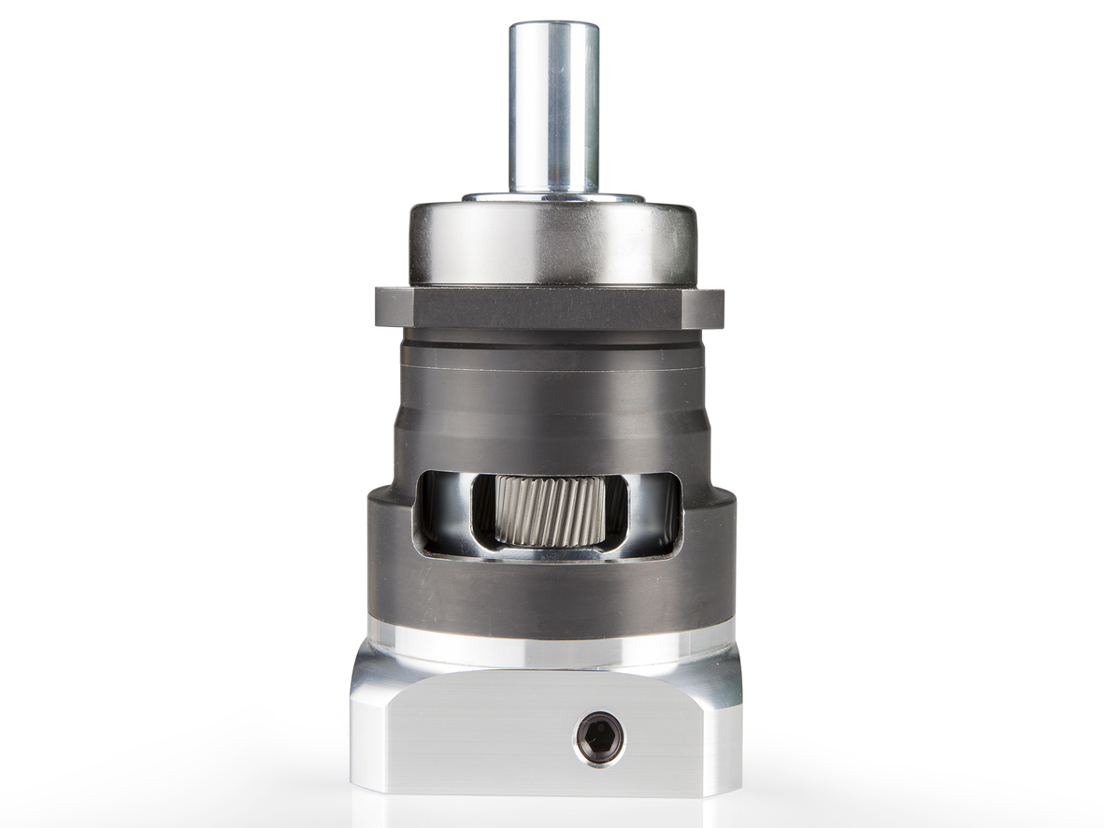
B&R now offers premium helical gearboxes with either a shaft output (8GP70) or drive flange (8GF70).

About B&R
B&R, a division of ABB Group, is a global leader in industrial automation headquartered in Austria. B&R combines state-of-the-art technology with advanced engineering to provide customers in virtually every industry with complete solutions for machine and factory automation, motion control, HMI and integrated safety technology. With Industrial IoT communication standards including OPC UA, POWERLINK and openSAFETY as well as its Automation Studio software, B&R is constantly redefining the future of automation engineering. The innovative spirit that keeps B&R at the forefront of industrial automation is driven by a commitment to simplifying processes and exceeding customer expectations.
For more information, visit www.br-automation.com.

