X20 modules with increased component density
B&R provides functionality for switching up to 2 amps in a compact housing
With two new X20-series modules, B&R continues on the path of miniaturization. The X20DO8323 offers 8 push/pull outputs in the X20 form factor, and the X20DO6639 is a 6x relay module for 30 VDC or 230 VAC.
Up to eight motors
The digital outputs on the DO8323 are electrically isolated and can be wired as high-side, low-side or push/pull variants. Therefore the module allows control of up to 4 DC motors operated as a full-bridge with a nominal voltage of 12 to 24 VDC and a rated current of up to 0.5A. When operated as a half-bridge, up to 8 motors can be controlled.
The DO6639 module has 6 isolated relays with normally open contacts. They can be loaded with 2 amps at either 30 VDC or 230 VAC. In this way, B&R has significantly improved the component density for 230 VAC relays.

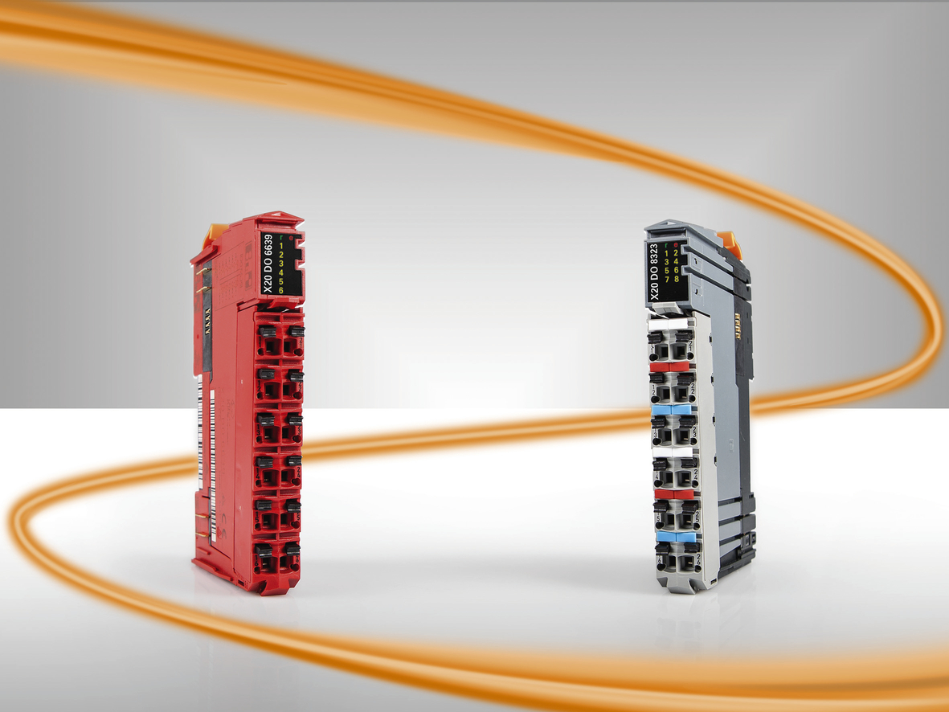
B&R presents two new compact X20 I/O series modules.

About B&R
B&R, a division of ABB Group, is a global leader in industrial automation headquartered in Austria. B&R combines state-of-the-art technology with advanced engineering to provide customers in virtually every industry with complete solutions for machine and factory automation, motion control, HMI and integrated safety technology. With Industrial IoT communication standards including OPC UA, POWERLINK and openSAFETY as well as its Automation Studio software, B&R is constantly redefining the future of automation engineering. The innovative spirit that keeps B&R at the forefront of industrial automation is driven by a commitment to simplifying processes and exceeding customer expectations.
For more information, visit www.br-automation.com.

