Packaging on the fast track
B&R's reACTION technology takes packaging to an entirely new level
With reACTION technology, B&R is able to reduce response times in industrial automation applications down to 1 µs. This new approach allows extremely time-critical subprocesses to be managed using standard hardware – all within the requirements of IEC 61131 – while cutting costs by reducing the load on the controller and optimizing performance to match high-end packaging machines demands.
Absolute precision for packaging machines
Primary packaging is the most challenging task in the packaging industry. In these machines, the packaging material meets the product at the highest possible speed; as a result, the level of precision has a direct influence on both product quality and the usage of raw materials. Gravimetric and volumetric filling processes in liquid filling machines, for example, can take advantage of reACTION technology to operate valves and sensors with an unrivaled precision of 1 µs.
Other high-speed packaging machine functions like code stamping and bad product rejection can combine B&R's reACTION and NetTime technologies to synchronize motion control and distributed I/O to achieve absolute precision.
Digital output patterns can be controlled with a resolution of 125 ns, and fast input edges such as registration marks or product detection can be recorded with a timestamp of 1 µs. reACTION technology fits perfectly into the extensive B&R portfolio of highly integrated, highly scalable automation solutions for achieving unprecedented levels of machine performance.

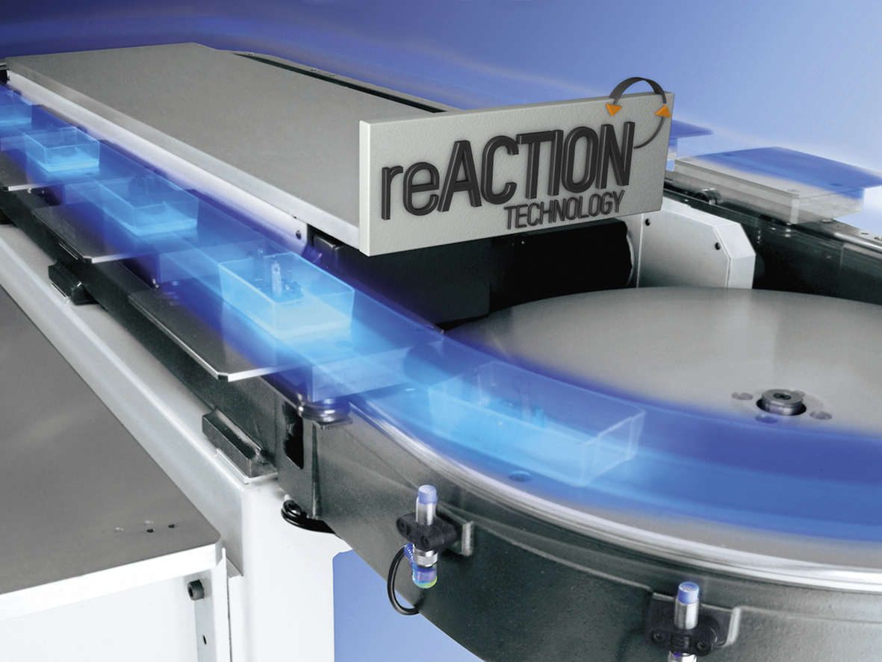
B&R reACTION technology increases the performance of high-speed packaging machines.

About B&R
B&R, a division of ABB Group, is a global leader in industrial automation headquartered in Austria. B&R combines state-of-the-art technology with advanced engineering to provide customers in virtually every industry with complete solutions for machine and factory automation, motion control, HMI and integrated safety technology. With Industrial IoT communication standards including OPC UA, POWERLINK and openSAFETY as well as its Automation Studio software, B&R is constantly redefining the future of automation engineering. The innovative spirit that keeps B&R at the forefront of industrial automation is driven by a commitment to simplifying processes and exceeding customer expectations.
For more information, visit www.br-automation.com.

