Packaging on the fast track
B&R's reACTION technology takes packaging to an entirely new level
With reACTION technology, B&R is able to reduce response times in industrial automation applications down to 1 µs. This new approach allows extremely time-critical subprocesses to be managed using standard hardware – all within the requirements of IEC 61131 – while cutting costs by reducing the load on the controller and optimizing performance to match high-end packaging machines demands.
Absolute precision for packaging machines
Primary packaging is the most challenging task in the packaging industry. In these machines, the packaging material meets the product at the highest possible speed; as a result, the level of precision has a direct influence on both product quality and the usage of raw materials. Gravimetric and volumetric filling processes in liquid filling machines, for example, can take advantage of reACTION technology to operate valves and sensors with an unrivaled precision of 1 µs.
Other high-speed packaging machine functions like code stamping and bad product rejection can combine B&R's reACTION and NetTime technologies to synchronize motion control and distributed I/O to achieve absolute precision.
Digital output patterns can be controlled with a resolution of 125 ns, and fast input edges such as registration marks or product detection can be recorded with a timestamp of 1 µs. reACTION technology fits perfectly into the extensive B&R portfolio of highly integrated, highly scalable automation solutions for achieving unprecedented levels of machine performance.

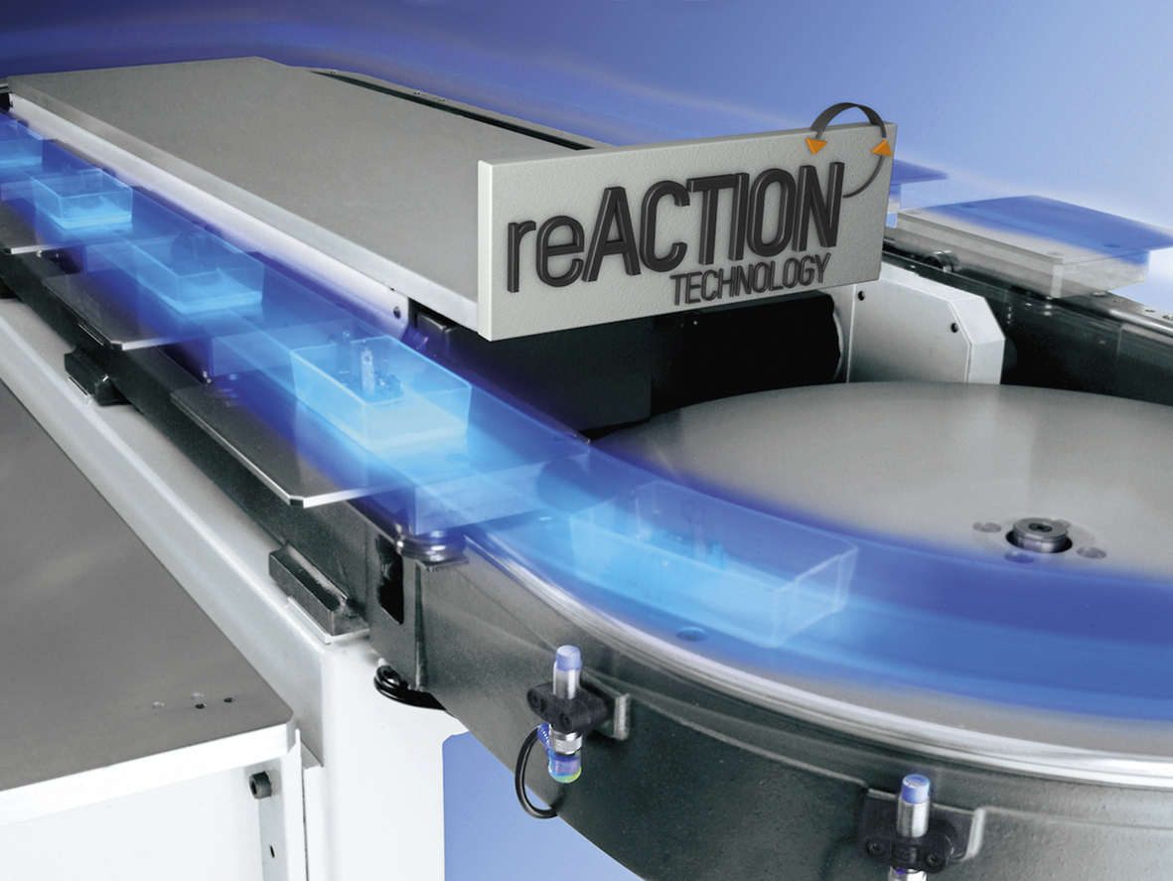
B&R reACTION technology increases the performance of high-speed packaging machines.

A proposito di B&R
B&R, una divisione del Gruppo ABB, è leader globale nell'automazione industriale con sede in Austria. B&R combina tecnologia all'avanguardia con ingegneria avanzata per fornire ai clienti, praticamente di ogni settore, soluzioni complete per l'automazione di macchine e fabbriche, controllo del movimento, HMI e tecnologia di sicurezza integrata. Con gli standard di comunicazione IoT industriale tra cui OPC UA, POWERLINK e openSAFETY, nonché il software Automation Studio, B&R ridefinisce costantemente il futuro dell'ingegneria dell'automazione. Lo spirito innovativo che mantiene B&R all'avanguardia nell'automazione industriale è guidato dall'impegno a semplificare i processi e a superare le aspettative dei clienti.
Per maggiori informazioni, visita www.br-automation.com

