Packaging on the fast track
B&R's reACTION technology takes packaging to an entirely new level
With reACTION technology, B&R is able to reduce response times in industrial automation applications down to 1 µs. This new approach allows extremely time-critical subprocesses to be managed using standard hardware – all within the requirements of IEC 61131 – while cutting costs by reducing the load on the controller and optimizing performance to match high-end packaging machines demands.
Absolute precision for packaging machines
Primary packaging is the most challenging task in the packaging industry. In these machines, the packaging material meets the product at the highest possible speed; as a result, the level of precision has a direct influence on both product quality and the usage of raw materials. Gravimetric and volumetric filling processes in liquid filling machines, for example, can take advantage of reACTION technology to operate valves and sensors with an unrivaled precision of 1 µs.
Other high-speed packaging machine functions like code stamping and bad product rejection can combine B&R's reACTION and NetTime technologies to synchronize motion control and distributed I/O to achieve absolute precision.
Digital output patterns can be controlled with a resolution of 125 ns, and fast input edges such as registration marks or product detection can be recorded with a timestamp of 1 µs. reACTION technology fits perfectly into the extensive B&R portfolio of highly integrated, highly scalable automation solutions for achieving unprecedented levels of machine performance.

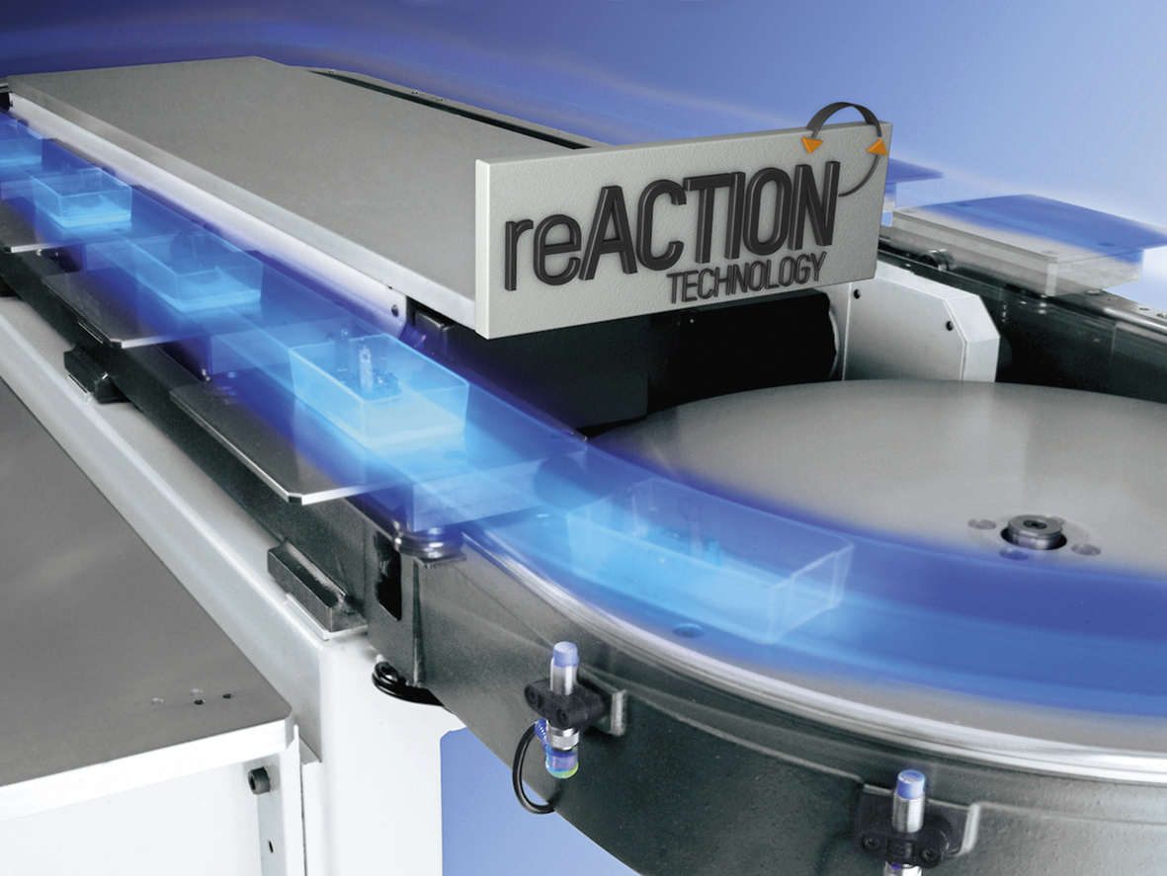
B&R reACTION technology increases the performance of high-speed packaging machines.

B&R Hakkında
ABB Grubunun bir bölümü olan B&R, merkezi Avusturya'da bulunan endüstriyel otomasyon alanında global bir liderdir. B&R, neredeyse her sektördeki müşterilere makine ve fabrika otomasyonu, hareket kontrolü, HMI ve entegre güvenlik teknolojisi için eksiksiz çözümler sunmak üzere en son teknolojiyi ileri mühendislikle birleştiriyor. OPC UA, POWERLINK ve openSAFETY gibi Endüstriyel IoT iletişim standartlarının yanı sıra Automation Studio yazılımıyla B&R, otomasyon mühendisliğinin geleceğini sürekli olarak yeniden tanımlıyor. B&R'ı endüstriyel otomasyonun ön saflarında tutan yenilikçi ruh, süreçleri basitleştirme ve müşteri beklentilerini aşma taahhüdünden kaynaklanmaktadır.
Daha fazla bilgi için www.br-automation.com adresini ziyaret edin.

