"Industry 4.0 offers excellent opportunities"

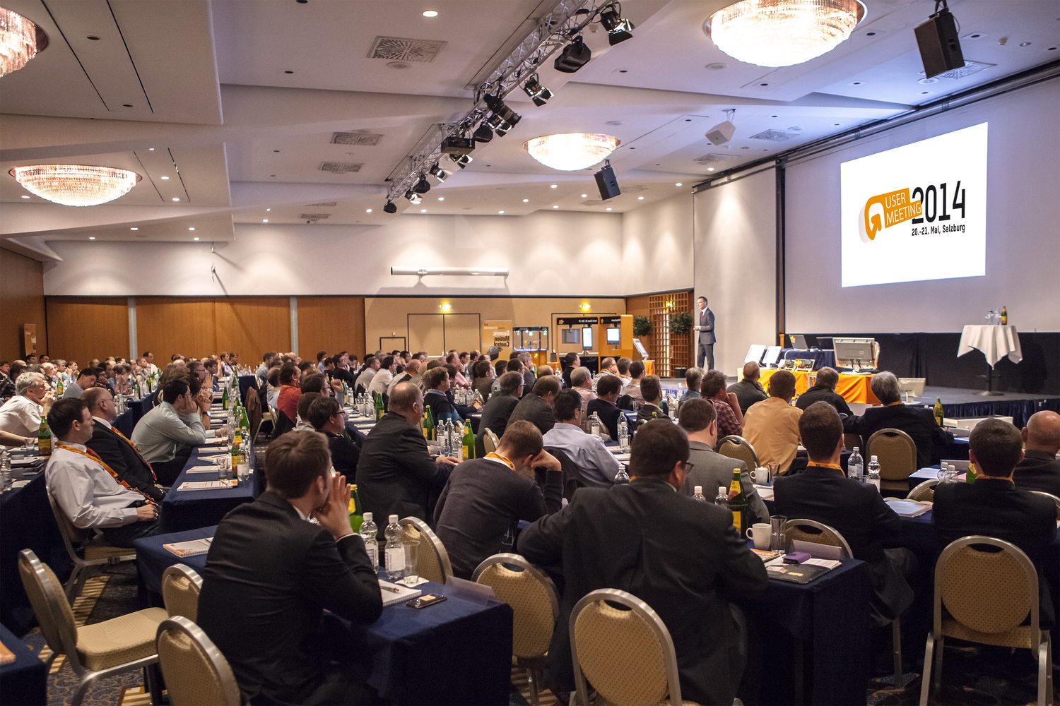
280 participants traveled to the B&R User Meeting in Salzburg to find out the latest information first-hand.

280 participants at the B&R USER Meeting in Salzburg
The B&R User Meeting in Salzburg was met with great interest. Around 280 visitors from the machine and system manufacturing industry took the opportunity to learn about the latest developments in the field of automation technology. Special attention was given this year to Industry 4.0 as well as the opportunities and challenges presented by factory- and department-wide automation concepts.
At the two-day event, B&R showcased a mix of corporate speakers, independent experts and case studies from B&R customers. "The consistently high attendance figures prove that this mix works well," said Hermann Obermair, Sales manager for B&R Austria, with satisfaction after the event. "Our customers know that we are not just presenting a product show, but are also offering interesting information and real examples of our solutions."
After successive merging of "mechanics" and "electronics" into "mechatronics", Industry 4.0 is now making yet another step necessary – merging mechatronics and IT. "Here, open source communication standards such as POWERLINK and openSafety play an important role."
New business models
Dr. Herbert Jodlbauer – from the FH Upper Austria – added that the transition to Industry 4.0 would trigger significant change to business models. "Digital services will be added to physical products, or even replace them," says Dr. Jodlbauer referring to his vision of the future. If recognized early enough, machine and system manufacturers, automation suppliers and IT service providers could greatly benefit from this change.
There was also great interest in the many other lectures and live presentations, such as the presentation of a portable antenna surveying system for the European Space Agency (ESA) that uses B&R technology or intelligent networking of machines (M2M) using mobile phone technology. During breaks, participants took the opportunity to deepen understanding of the topics and network with colleagues.

