B&R User Meeting in Shanghai a huge success
Open automation – The inevitable future
More than 100 machine manufacturers, end users and partners from the People's Republic of China and Taiwan took part in the B&R User Meeting in Shanghai. The meeting focused on open automation technologies and how the manufacturing industry can respond to future challenges in a flexible manner.
A pioneer on the path to Industry 4.0
Dr. Xiao Weirong, managing director of B&R China, stressed how important open automation is for manufacturers of industrial production systems. During his presentation, Weirong highlighted five major advantages offered by open automation: open integration, long-lasting technology, interchangeability, the possibility for further development and flexibility. "Open automation promises machine and system manufacturers exciting opportunities on the market," he summarized. Franz Enhuber, director of the B&R Automation Academy, then presented an in-depth analysis of Industry 4.0. In addition to pointing out that the requirements of end users have changed, Enhuber also spoke about the opportunities and challenges that have resulted from advances in information technology. "B&R has taken over a leadership role when it comes to supporting machine manufacturers wishing to take on the challenges of Industry 4.0."
Candid perspectives from business executives
Executives from various industries also spoke of the importance of knowledge management, training, project management, company operations and energy efficiency. They also touched on current difficulties and challenges they are confronting. The candid exchanges between these managers was considered an extremely positive aspect by the audience. "Increasing the openness of automation technology could bring about great opportunities," said Weirong. It is therefore important to not lose sight of the big picture and to create the conditions for continuous innovation, he concluded.

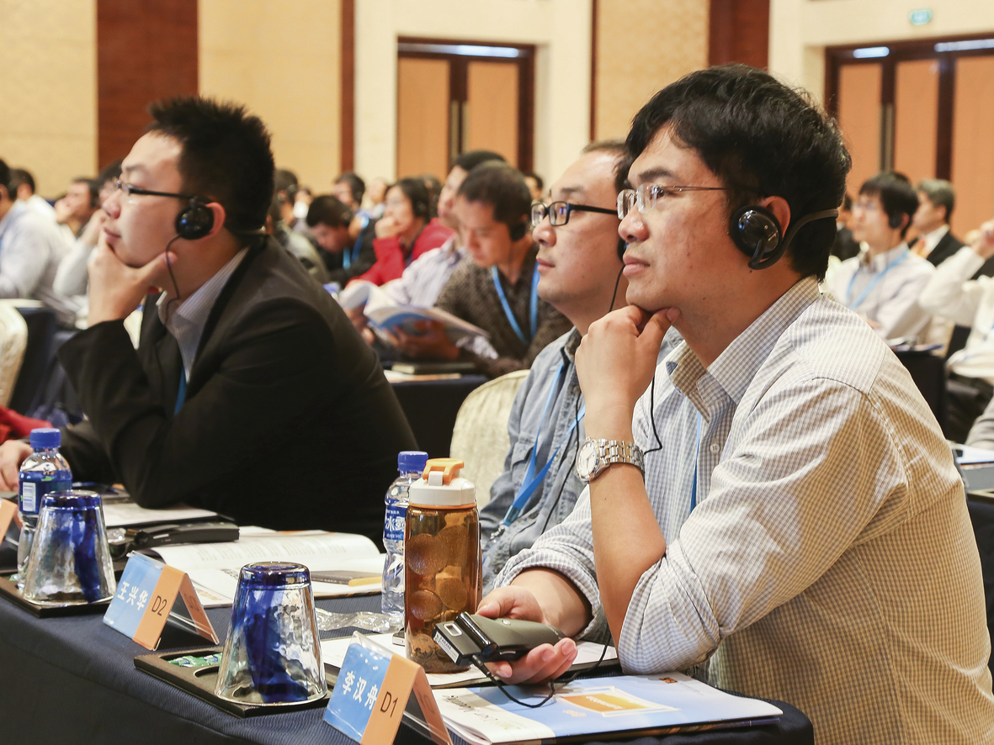
More than 100 machine manufacturers, end users and partners from the People's Republic of China and Taiwan took part in the B&R User Meeting on the topic of open automation.

B&R Hakkında
ABB Grubunun bir bölümü olan B&R, merkezi Avusturya'da bulunan endüstriyel otomasyon alanında global bir liderdir. B&R, neredeyse her sektördeki müşterilere makine ve fabrika otomasyonu, hareket kontrolü, HMI ve entegre güvenlik teknolojisi için eksiksiz çözümler sunmak üzere en son teknolojiyi ileri mühendislikle birleştiriyor. OPC UA, POWERLINK ve openSAFETY gibi Endüstriyel IoT iletişim standartlarının yanı sıra Automation Studio yazılımıyla B&R, otomasyon mühendisliğinin geleceğini sürekli olarak yeniden tanımlıyor. B&R'ı endüstriyel otomasyonun ön saflarında tutan yenilikçi ruh, süreçleri basitleştirme ve müşteri beklentilerini aşma taahhüdünden kaynaklanmaktadır.
Daha fazla bilgi için www.br-automation.com adresini ziyaret edin.

