Additions to the X20 I/O family
B&R presents their new temperature and power measurement modules
B&R is extending the X20 I/O system to include 2 additional modules: A temperature measurement module with 4-wire resistance measurement and an energy metering module with 4 current inputs for connecting external transformers with a 333 mV output.
Up to 4 platinum PT100 temperature sensors that are complaint with IEC 60751 can be connected to the X20ATB312 temperature measurement module using 4-wire connection technology. Wiring the compact 4-channel X20 module, which has a width of only 12.5 mm, is done using an X20TB1F 16-pin terminal block. In addition to resistance temperature measurement using PT100 sensors that have a constant current supply for the 4-wire connections and a resolution of 0.01°C, the module also allows direct resistance measurement and offers the possibility to individually set the filter time.
Measuring energy consumption
The X20AP3161 extends B&R's range of energy metering modules. It is equipped with 3 voltage inputs for a maximum of 3x 480 VAC and 4 current inputs for connecting external current transformers with s 333 mV output. The module measures effective, reactive and apparent power individually for each of the 3 phases and for all of them collectively. The power consumption of each phase and the total sum is also recorded.
The module measures current and voltage up to the 31st harmonic, so it is highly precise. Due to its high sensitivity and having a fourth channel, it is perfectly suited for measuring leakage current on neutral lines. The signals are pre-processed before being passed on in the form of digital variables, which reduces the load on the controller.

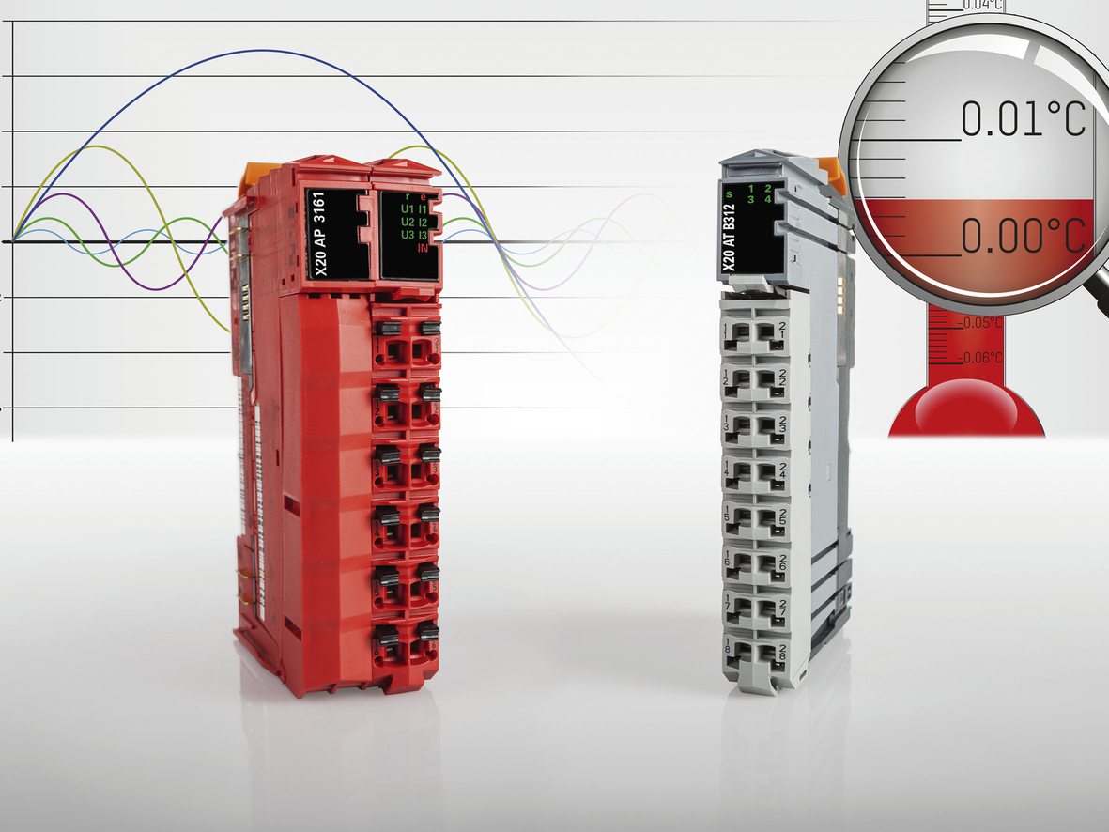
Extremely precise temperature or electrical energy measurements are not a problem with the newest members to B&R's X20 product family.

About B&R
B&R, a division of ABB Group, is a global leader in industrial automation headquartered in Austria. B&R combines state-of-the-art technology with advanced engineering to provide customers in virtually every industry with complete solutions for machine and factory automation, motion control, HMI and integrated safety technology. With Industrial IoT communication standards including OPC UA, POWERLINK and openSAFETY as well as its Automation Studio software, B&R is constantly redefining the future of automation engineering. The innovative spirit that keeps B&R at the forefront of industrial automation is driven by a commitment to simplifying processes and exceeding customer expectations.
For more information, visit www.br-automation.com.

