Additions to the X20 I/O family
B&R presents their new temperature and power measurement modules
B&R is extending the X20 I/O system to include 2 additional modules: A temperature measurement module with 4-wire resistance measurement and an energy metering module with 4 current inputs for connecting external transformers with a 333 mV output.
Up to 4 platinum PT100 temperature sensors that are complaint with IEC 60751 can be connected to the X20ATB312 temperature measurement module using 4-wire connection technology. Wiring the compact 4-channel X20 module, which has a width of only 12.5 mm, is done using an X20TB1F 16-pin terminal block. In addition to resistance temperature measurement using PT100 sensors that have a constant current supply for the 4-wire connections and a resolution of 0.01°C, the module also allows direct resistance measurement and offers the possibility to individually set the filter time.
Measuring energy consumption
The X20AP3161 extends B&R's range of energy metering modules. It is equipped with 3 voltage inputs for a maximum of 3x 480 VAC and 4 current inputs for connecting external current transformers with s 333 mV output. The module measures effective, reactive and apparent power individually for each of the 3 phases and for all of them collectively. The power consumption of each phase and the total sum is also recorded.
The module measures current and voltage up to the 31st harmonic, so it is highly precise. Due to its high sensitivity and having a fourth channel, it is perfectly suited for measuring leakage current on neutral lines. The signals are pre-processed before being passed on in the form of digital variables, which reduces the load on the controller.

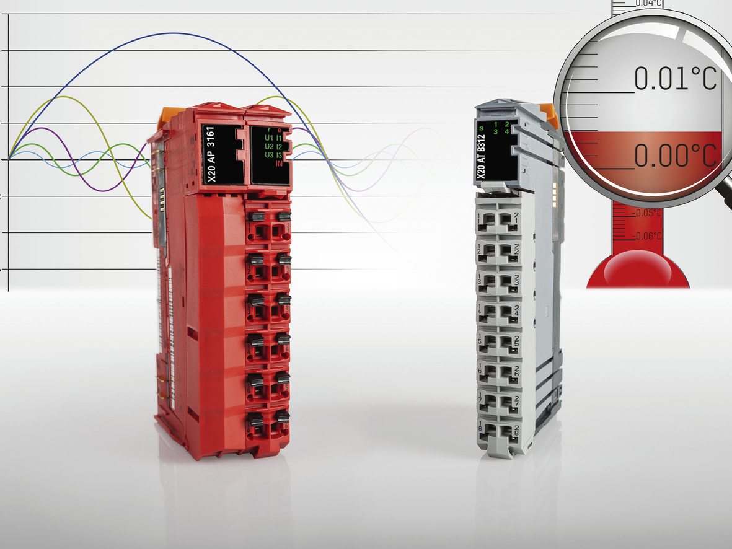
Extremely precise temperature or electrical energy measurements are not a problem with the newest members to B&R's X20 product family.

B&R Hakkında
ABB Grubunun bir bölümü olan B&R, merkezi Avusturya'da bulunan endüstriyel otomasyon alanında global bir liderdir. B&R, neredeyse her sektördeki müşterilere makine ve fabrika otomasyonu, hareket kontrolü, HMI ve entegre güvenlik teknolojisi için eksiksiz çözümler sunmak üzere en son teknolojiyi ileri mühendislikle birleştiriyor. OPC UA, POWERLINK ve openSAFETY gibi Endüstriyel IoT iletişim standartlarının yanı sıra Automation Studio yazılımıyla B&R, otomasyon mühendisliğinin geleceğini sürekli olarak yeniden tanımlıyor. B&R'ı endüstriyel otomasyonun ön saflarında tutan yenilikçi ruh, süreçleri basitleştirme ve müşteri beklentilerini aşma taahhüdünden kaynaklanmaktadır.
Daha fazla bilgi için www.br-automation.com adresini ziyaret edin.

