Protection against moisture and corrosive environments
X20 controllers and modules handle all environmental conditions
With the X20c series, B&R is setting new standards for protection against harsh environmental conditions. The "coated" variants of the compact controller and I/O modules are protected against condensation and corrosive gases by a special coating on the electronics module. This makes these modules suitable for use in corrosive environmental conditions.
The coating on the electronics module protects the components and circuit board from the effects of condensation and corrosive gases. The effectiveness of protection against condensation is checked using the test specified in BMW GS 95011-4, and protection against corrosive gases using the 4-part corrosive gas tests specified in EN 60068-2-60, test method 4. The tests are carried out in a fully accredited in-house testing laboratory and in certified external testing facilities. B&R places even higher demands on the modules than what is specified in the standards and also subjects equipment to additional, more stringent testing.
At sea and in icy temperatures
The X20 modules with coated circuit boards are completely compatible with existing models with respect to functionality. Their introduction represents the third time that B&R has extended the range of applications in which the X20 system can be used. The operating temperature range for all X20 modules was recently expanded to -25°C to +60°C. The X20 System has also received certification for maritime applications from Germanischer Lloyd (GL), which is particularly demanding.

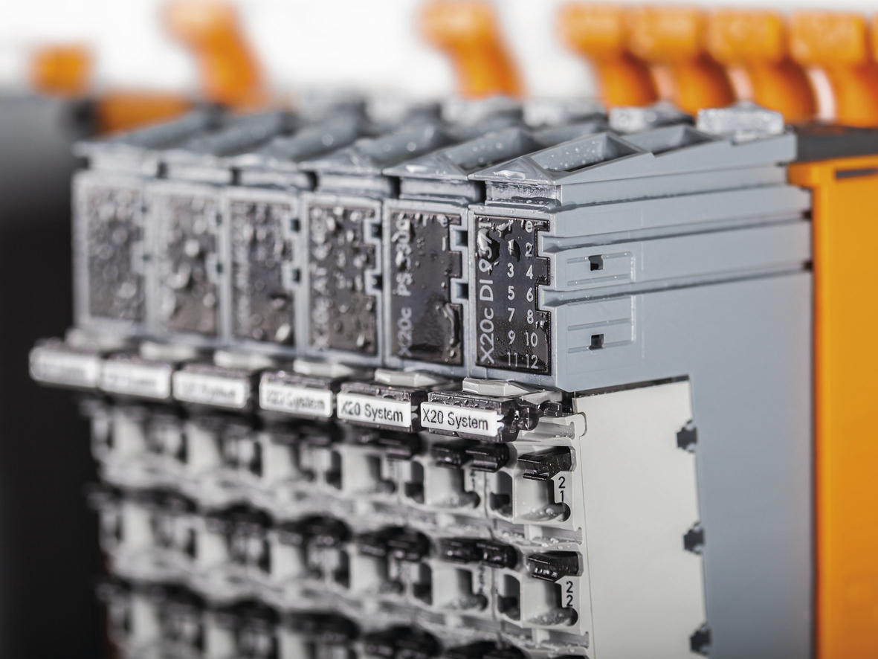
Condensation is also no problem for the "coated" X20 models.

About B&R
B&R, a division of ABB Group, is a global leader in industrial automation headquartered in Austria. B&R combines state-of-the-art technology with advanced engineering to provide customers in virtually every industry with complete solutions for machine and factory automation, motion control, HMI and integrated safety technology. With Industrial IoT communication standards including OPC UA, POWERLINK and openSAFETY as well as its Automation Studio software, B&R is constantly redefining the future of automation engineering. The innovative spirit that keeps B&R at the forefront of industrial automation is driven by a commitment to simplifying processes and exceeding customer expectations.
For more information, visit www.br-automation.com.

