Password-protected FTP access management for B&R systems
Highly secure direct access to the controller
All B&R controllers have an FTP server on board as a standard feature. A protection mechanism with integrated username and password management now makes accessing this server even more secure – without sacrificing ease of operation.
Whether it's to perform maintenance, supply a machine with new recipes or load a new function module, direct access to the controller is becoming increasingly important throughout the entire life cycle of production equipment. Developers of automation applications must maintain a high level of security when preparing the functions involved, while also ensuring that they are simple to learn and easy to operate.
Bringing IT functionality to automation
B&R draws on methods that have proven themselves in the realm of IT to help machine and system developers implement access security. User authentication is managed with usernames and passwords. Management of user data and assigned rights is integrated in Automation Studio. This data is stored on the runtime system in encrypted form to ensure seamless security. User management for FTP access to B&R systems allows an unlimited number of users to be assigned access rights. At runtime, up to eight different users can access the controller at the same time via FTP.
FTP access that is as secure as it is versatile is one of the many ways that B&R systems allow machine and system operators to react quickly and flexibly to new requirements.

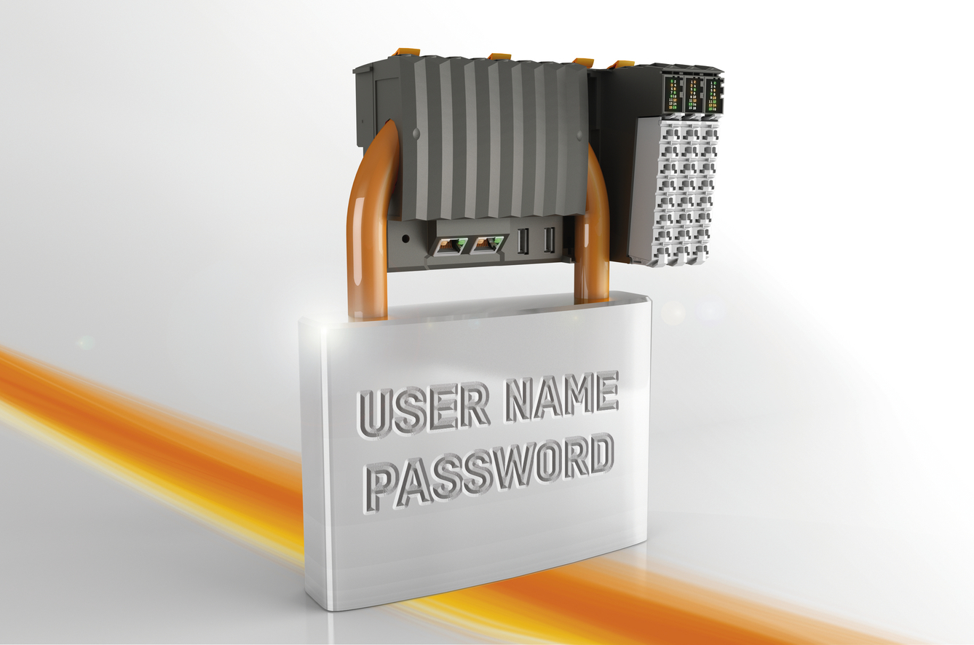
Secure FTP access using usernames and passwords begins with encrypted storage of the passwords on the controller.

About B&R
B&R, a division of ABB Group, is a global leader in industrial automation headquartered in Austria. B&R combines state-of-the-art technology with advanced engineering to provide customers in virtually every industry with complete solutions for machine and factory automation, motion control, HMI and integrated safety technology. With Industrial IoT communication standards including OPC UA, POWERLINK and openSAFETY as well as its Automation Studio software, B&R is constantly redefining the future of automation engineering. The innovative spirit that keeps B&R at the forefront of industrial automation is driven by a commitment to simplifying processes and exceeding customer expectations.
For more information, visit www.br-automation.com.

