Password-protected FTP access management for B&R systems
Highly secure direct access to the controller
All B&R controllers have an FTP server on board as a standard feature. A protection mechanism with integrated username and password management now makes accessing this server even more secure – without sacrificing ease of operation.
Whether it's to perform maintenance, supply a machine with new recipes or load a new function module, direct access to the controller is becoming increasingly important throughout the entire life cycle of production equipment. Developers of automation applications must maintain a high level of security when preparing the functions involved, while also ensuring that they are simple to learn and easy to operate.
Bringing IT functionality to automation
B&R draws on methods that have proven themselves in the realm of IT to help machine and system developers implement access security. User authentication is managed with usernames and passwords. Management of user data and assigned rights is integrated in Automation Studio. This data is stored on the runtime system in encrypted form to ensure seamless security. User management for FTP access to B&R systems allows an unlimited number of users to be assigned access rights. At runtime, up to eight different users can access the controller at the same time via FTP.
FTP access that is as secure as it is versatile is one of the many ways that B&R systems allow machine and system operators to react quickly and flexibly to new requirements.

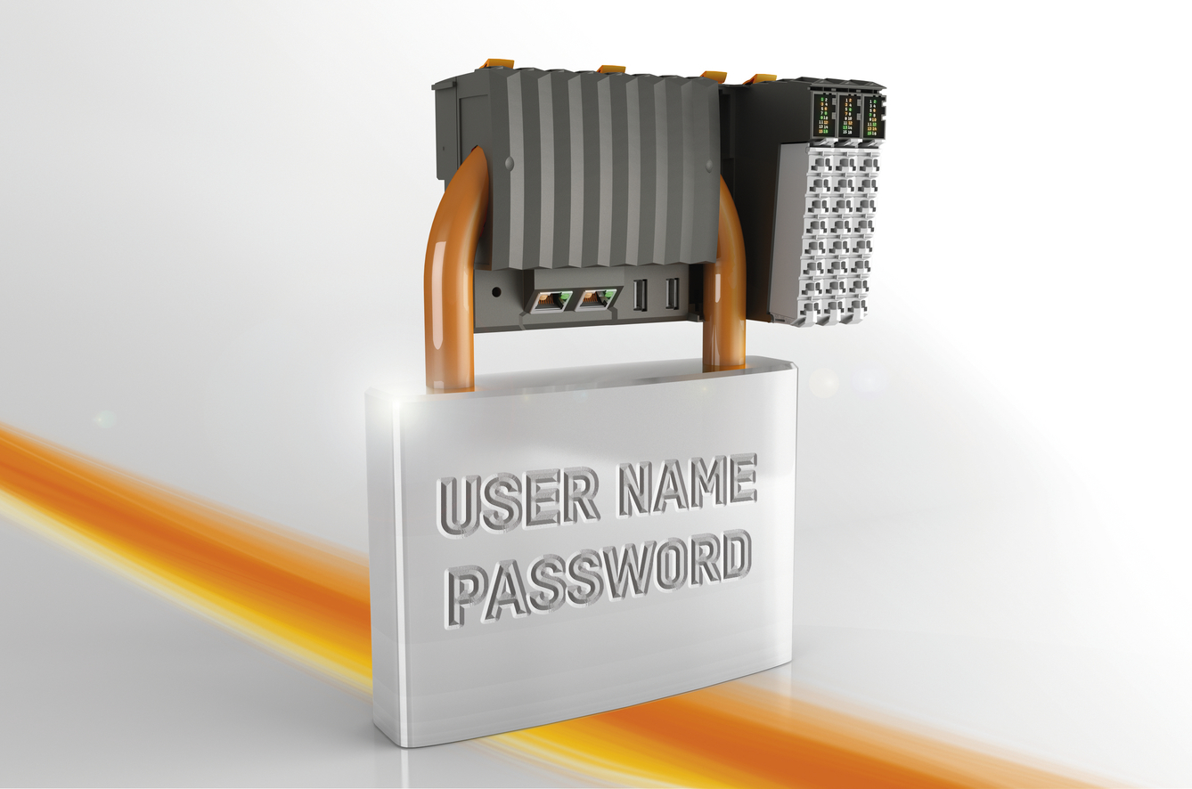
Secure FTP access using usernames and passwords begins with encrypted storage of the passwords on the controller.

B&R Hakkında
ABB Grubunun bir bölümü olan B&R, merkezi Avusturya'da bulunan endüstriyel otomasyon alanında global bir liderdir. B&R, neredeyse her sektördeki müşterilere makine ve fabrika otomasyonu, hareket kontrolü, HMI ve entegre güvenlik teknolojisi için eksiksiz çözümler sunmak üzere en son teknolojiyi ileri mühendislikle birleştiriyor. OPC UA, POWERLINK ve openSAFETY gibi Endüstriyel IoT iletişim standartlarının yanı sıra Automation Studio yazılımıyla B&R, otomasyon mühendisliğinin geleceğini sürekli olarak yeniden tanımlıyor. B&R'ı endüstriyel otomasyonun ön saflarında tutan yenilikçi ruh, süreçleri basitleştirme ve müşteri beklentilerini aşma taahhüdünden kaynaklanmaktadır.
Daha fazla bilgi için www.br-automation.com adresini ziyaret edin.

