Modular mechatronic systems gaining momentum
ACOPOSmotor sets new standards for decentralized motion control
With the ACOPOSmotor, B&R combines a servo motor and drive in one compact unit. Safety technology can also be integrated as an option. This gives developers more freedom when designing a machine and can save valuable space in the control cabinet.
The ACOPOSmotor is connected to the drive network using a hybrid cable. This cable includes all necessary power and signal lines and establishes the connection to the POWERLINK network. ACOPOSmotor modules come in three sizes with torque ranging from 1.8 to 12 Nm. If needed, an optional fan assembly can provide a performance boost of up to 100%.
Safety included
In addition to the proven wired safety functions STO (Safe Torque Off) and SS1 (Safe Operational Stop 1), a network-based ACOPOSmotor module variant will also be available in the future. This will allow users to access the following functions (as with the ACOPOSmulti): STO, SOS, SS1, SS2, SLS, SMS, SLI and SDI.
The ACOPOSmotor is fully compatible with the ACOPOSmulti drive system. This makes it possible for users to select the best-suited servo drive for each machine without having to do any additional engineering work.

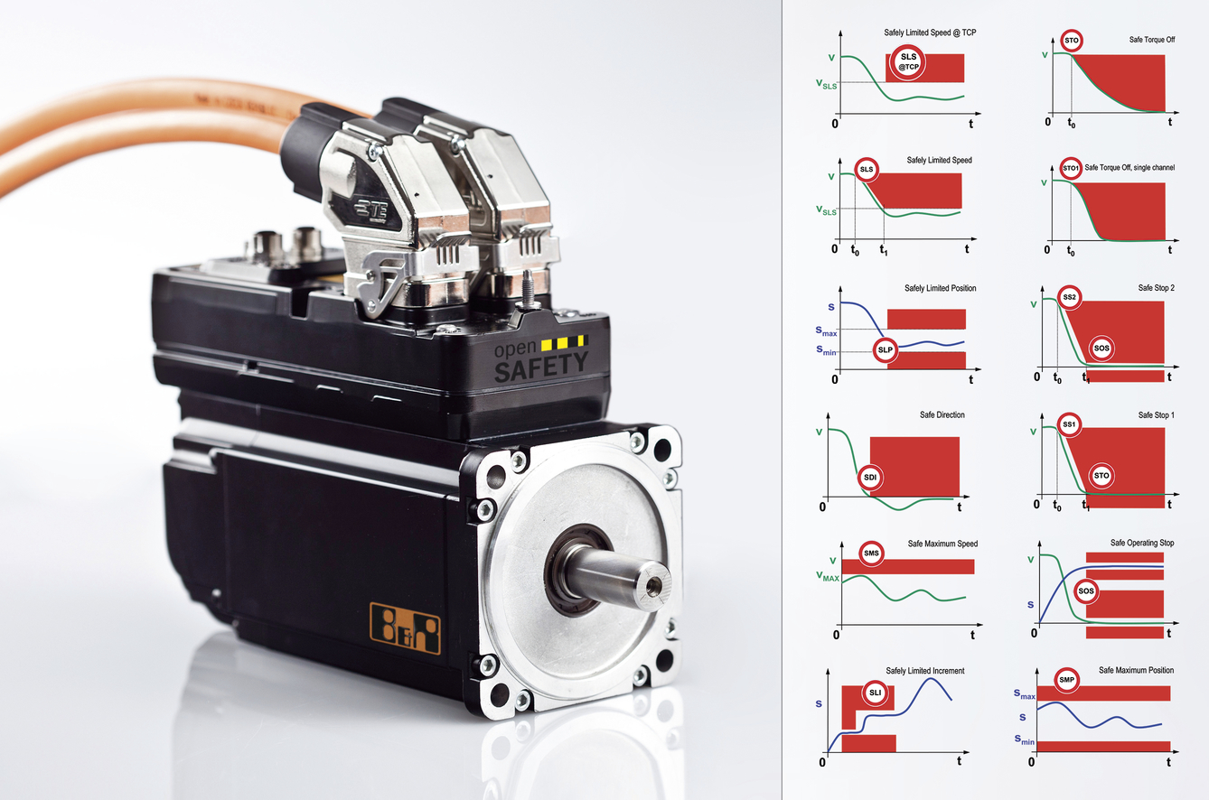
An ACOPOSmotor combines the motor, drive and safety technology in a single unit.

About B&R
B&R, a division of ABB Group, is a global leader in industrial automation headquartered in Austria. B&R combines state-of-the-art technology with advanced engineering to provide customers in virtually every industry with complete solutions for machine and factory automation, motion control, HMI and integrated safety technology. With Industrial IoT communication standards including OPC UA, POWERLINK and openSAFETY as well as its Automation Studio software, B&R is constantly redefining the future of automation engineering. The innovative spirit that keeps B&R at the forefront of industrial automation is driven by a commitment to simplifying processes and exceeding customer expectations.
For more information, visit www.br-automation.com.

