A large number of applicants for internships
More than 200 summer interns working at Bernecker + Rainer
More than 200 students will take part in internships at B&R's HQ in Eggelsberg this summer. They work in many different departments such as development, production, logistics, marketing and administration.
"As in past years, there was enormous interest in the intern jobs available," says Nicole Rainer, manager of the personnel department. "In the district of Braunau, we are one of the most popular employers. At B&R, interns are provided assistance and trained to handle their new responsibilities.
Individual assistance and supervision
"Providing comprehensive assistance to each trainee is important to us," says Rainer. On the first day at the company, there is an introductory event for all interns before being introduced to the respective area of responsibility by their supervisors.
B&R works closely with HTL Braunau, as well as other educational institutes, in order to provide the best possible support to young people getting started in their profession. Each year, two interns can each use their theoretical knowledge in practical situations at the "summer school".

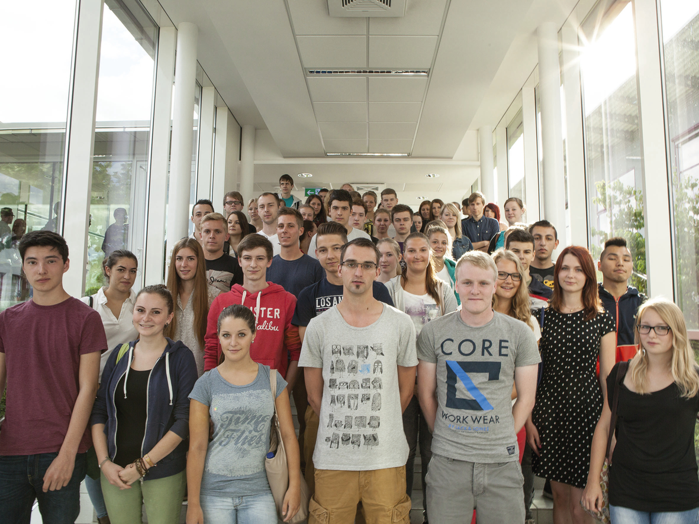
The first interns have been working at B&R since the beginning of July. Last Monday, there was a introductory event for all summer interns.

About B&R
B&R, a division of ABB Group, is a global leader in industrial automation headquartered in Austria. B&R combines state-of-the-art technology with advanced engineering to provide customers in virtually every industry with complete solutions for machine and factory automation, motion control, HMI and integrated safety technology. With Industrial IoT communication standards including OPC UA, POWERLINK and openSAFETY as well as its Automation Studio software, B&R is constantly redefining the future of automation engineering. The innovative spirit that keeps B&R at the forefront of industrial automation is driven by a commitment to simplifying processes and exceeding customer expectations.
For more information, visit www.br-automation.com.

