A large number of applicants for internships
More than 200 summer interns working at Bernecker + Rainer
More than 200 students will take part in internships at B&R's HQ in Eggelsberg this summer. They work in many different departments such as development, production, logistics, marketing and administration.
"As in past years, there was enormous interest in the intern jobs available," says Nicole Rainer, manager of the personnel department. "In the district of Braunau, we are one of the most popular employers. At B&R, interns are provided assistance and trained to handle their new responsibilities.
Individual assistance and supervision
"Providing comprehensive assistance to each trainee is important to us," says Rainer. On the first day at the company, there is an introductory event for all interns before being introduced to the respective area of responsibility by their supervisors.
B&R works closely with HTL Braunau, as well as other educational institutes, in order to provide the best possible support to young people getting started in their profession. Each year, two interns can each use their theoretical knowledge in practical situations at the "summer school".

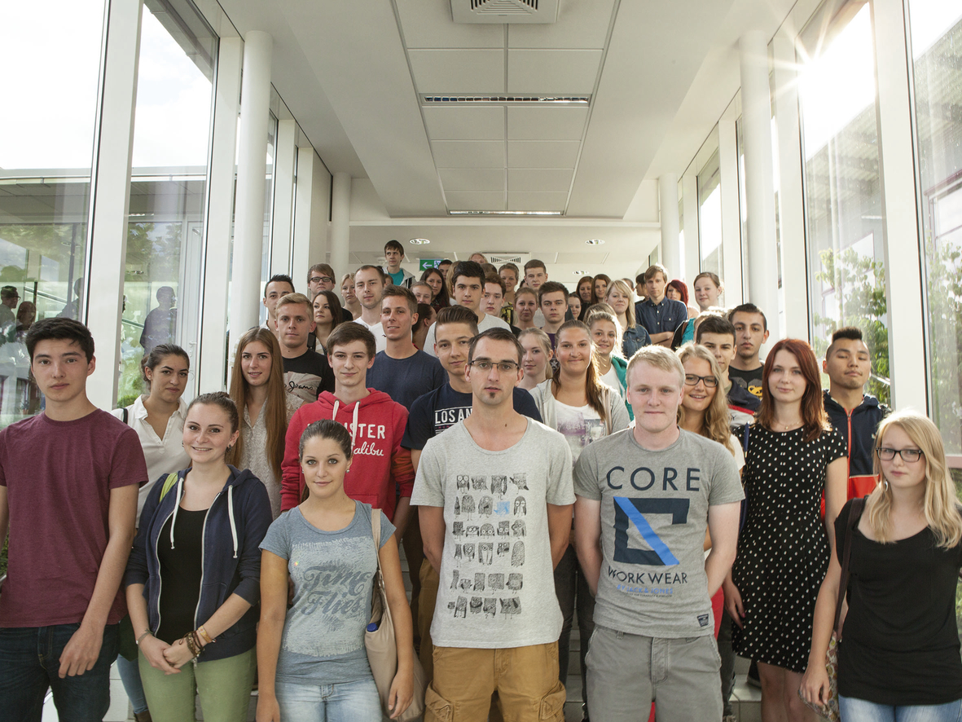
The first interns have been working at B&R since the beginning of July. Last Monday, there was a introductory event for all summer interns.

B&R Hakkında
ABB Grubunun bir bölümü olan B&R, merkezi Avusturya'da bulunan endüstriyel otomasyon alanında global bir liderdir. B&R, neredeyse her sektördeki müşterilere makine ve fabrika otomasyonu, hareket kontrolü, HMI ve entegre güvenlik teknolojisi için eksiksiz çözümler sunmak üzere en son teknolojiyi ileri mühendislikle birleştiriyor. OPC UA, POWERLINK ve openSAFETY gibi Endüstriyel IoT iletişim standartlarının yanı sıra Automation Studio yazılımıyla B&R, otomasyon mühendisliğinin geleceğini sürekli olarak yeniden tanımlıyor. B&R'ı endüstriyel otomasyonun ön saflarında tutan yenilikçi ruh, süreçleri basitleştirme ve müşteri beklentilerini aşma taahhüdünden kaynaklanmaktadır.
Daha fazla bilgi için www.br-automation.com adresini ziyaret edin.

