Cutting-edge technology for renewable energy sources
For the Energy Data Manager, juwi relies on products from B&R.
With its Energy Data Manager, juwi is making a big impression in the area of remote monitoring for wind power, photovoltaics and biogas facilities. This cutting-edge concept expands and optimizes existing remote monitoring systems by providing RE system operators real-time power generation data. juwi implemented this system with the aid of automation products from B&R.
"Our goal in developing the juwi Energy Data Manager was to design a system tailored to customers' individual needs and the unique requirements of their specific systems," states Alrik Schiede, department manager for service engineering and technical operations at juwi. "With regard to hardware, we were searching for an internationally well-respected partner that is a step ahead of the rest technologically and has a company structure that can flexibly meet the needs of its customers." After intensive market research, juwi found the strong partner they were looking for in B&R.
Close partnership
When it comes to software, juwi and B&R also work closely together: "The Plant Control Room series of the juwi Energy Data Manager is based on the proven APROL process control system from B&R," explains Schiede. juwi's many years of experience in the area of renewable energy made it possible to optimize the individual Energy Data Manager products.
"With international experience in project engineering and EE plant management, we have a close relationship with customers and energy suppliers. This helps us to continually offer optimized solutions that are tailored to customers' requirements," continues Schiede. With the juwi Energy Data Manager, the Wörrstadt-based company has fused the expertise of two leading companies into a unique product that will help facilitate the transition to renewable energy sources.

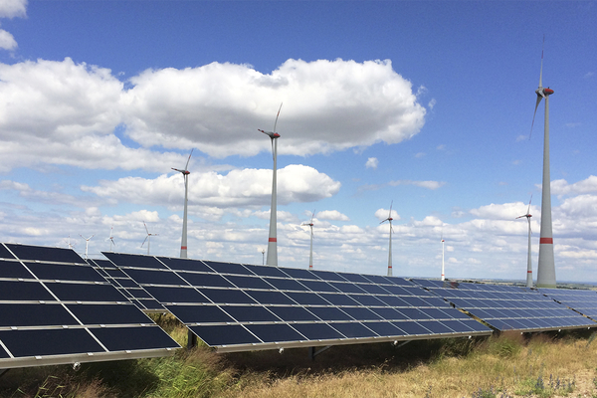
In the area of remote monitoring for wind power, photovoltaics and biogas facilities, juwi and B&R are ringing in a new era.

About B&R
B&R, a division of ABB Group, is a global leader in industrial automation headquartered in Austria. B&R combines state-of-the-art technology with advanced engineering to provide customers in virtually every industry with complete solutions for machine and factory automation, motion control, HMI and integrated safety technology. With Industrial IoT communication standards including OPC UA, POWERLINK and openSAFETY as well as its Automation Studio software, B&R is constantly redefining the future of automation engineering. The innovative spirit that keeps B&R at the forefront of industrial automation is driven by a commitment to simplifying processes and exceeding customer expectations.
For more information, visit www.br-automation.com.

