Cutting-edge technology for renewable energy sources
For the Energy Data Manager, juwi relies on products from B&R.
With its Energy Data Manager, juwi is making a big impression in the area of remote monitoring for wind power, photovoltaics and biogas facilities. This cutting-edge concept expands and optimizes existing remote monitoring systems by providing RE system operators real-time power generation data. juwi implemented this system with the aid of automation products from B&R.
"Our goal in developing the juwi Energy Data Manager was to design a system tailored to customers' individual needs and the unique requirements of their specific systems," states Alrik Schiede, department manager for service engineering and technical operations at juwi. "With regard to hardware, we were searching for an internationally well-respected partner that is a step ahead of the rest technologically and has a company structure that can flexibly meet the needs of its customers." After intensive market research, juwi found the strong partner they were looking for in B&R.
Close partnership
When it comes to software, juwi and B&R also work closely together: "The Plant Control Room series of the juwi Energy Data Manager is based on the proven APROL process control system from B&R," explains Schiede. juwi's many years of experience in the area of renewable energy made it possible to optimize the individual Energy Data Manager products.
"With international experience in project engineering and EE plant management, we have a close relationship with customers and energy suppliers. This helps us to continually offer optimized solutions that are tailored to customers' requirements," continues Schiede. With the juwi Energy Data Manager, the Wörrstadt-based company has fused the expertise of two leading companies into a unique product that will help facilitate the transition to renewable energy sources.

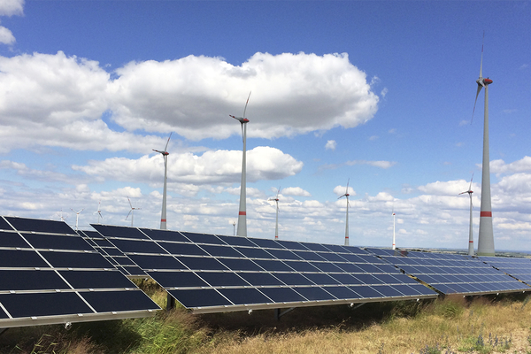
In the area of remote monitoring for wind power, photovoltaics and biogas facilities, juwi and B&R are ringing in a new era.

B&R Hakkında
ABB Grubunun bir bölümü olan B&R, merkezi Avusturya'da bulunan endüstriyel otomasyon alanında global bir liderdir. B&R, neredeyse her sektördeki müşterilere makine ve fabrika otomasyonu, hareket kontrolü, HMI ve entegre güvenlik teknolojisi için eksiksiz çözümler sunmak üzere en son teknolojiyi ileri mühendislikle birleştiriyor. OPC UA, POWERLINK ve openSAFETY gibi Endüstriyel IoT iletişim standartlarının yanı sıra Automation Studio yazılımıyla B&R, otomasyon mühendisliğinin geleceğini sürekli olarak yeniden tanımlıyor. B&R'ı endüstriyel otomasyonun ön saflarında tutan yenilikçi ruh, süreçleri basitleştirme ve müşteri beklentilerini aşma taahhüdünden kaynaklanmaktadır.
Daha fazla bilgi için www.br-automation.com adresini ziyaret edin.

