CHINAPLAS 2014 showcases B&R's leadership in plastics
Sixty-nine leading OEMs introduce machines featuring B&R control
Sixty-nine leading plastic machinery manufacturers introduced new machines based on B&R control technology at CHINAPLAS 2014, the world’s second largest plastics industry event. Once again, the B&R booth was the exhibition's de facto hub for plastics machinery control solutions. Particularly in the area of fully electric injection molding, B&R is the only automation provider in China with a complete solution – based on POWERLINK that meets the key industry requirements of higher precision and efficiency.
"We feel that local companies are eager for new technology and appreciate the benefits of a complete solution – from more efficient, fully electric injection molding to cluster management and plant-wide optimization," says Zhang Zhe, plastics industry sales manager at B&R China. "B&R always leads the way with innovation, which is why B&R is always so popular at events like CHINAPLAS." Many European machine builders with local engineering or production also appreciate and benefit from the highly skilled team at B&R China.
Open architecture
The topic of robotics was strongly represented at the event that took place in Shanghai. The open architecture of B&R systems makes it easy to integrate robotics technology in plastic machinery and auxiliary equipment. As machines become more and more integrated, B&R – with its open platform and many years of experience in plastics – is an obvious choice with a low investment risk.
Further exhibition highlights were B&R's APROL EnMon and cluster management solutions. Faced with enormous cost pressure, end users are seeking solutions for reducing energy consumption. For OEMs, these solutions mean higher added value and strengthened core competencies.

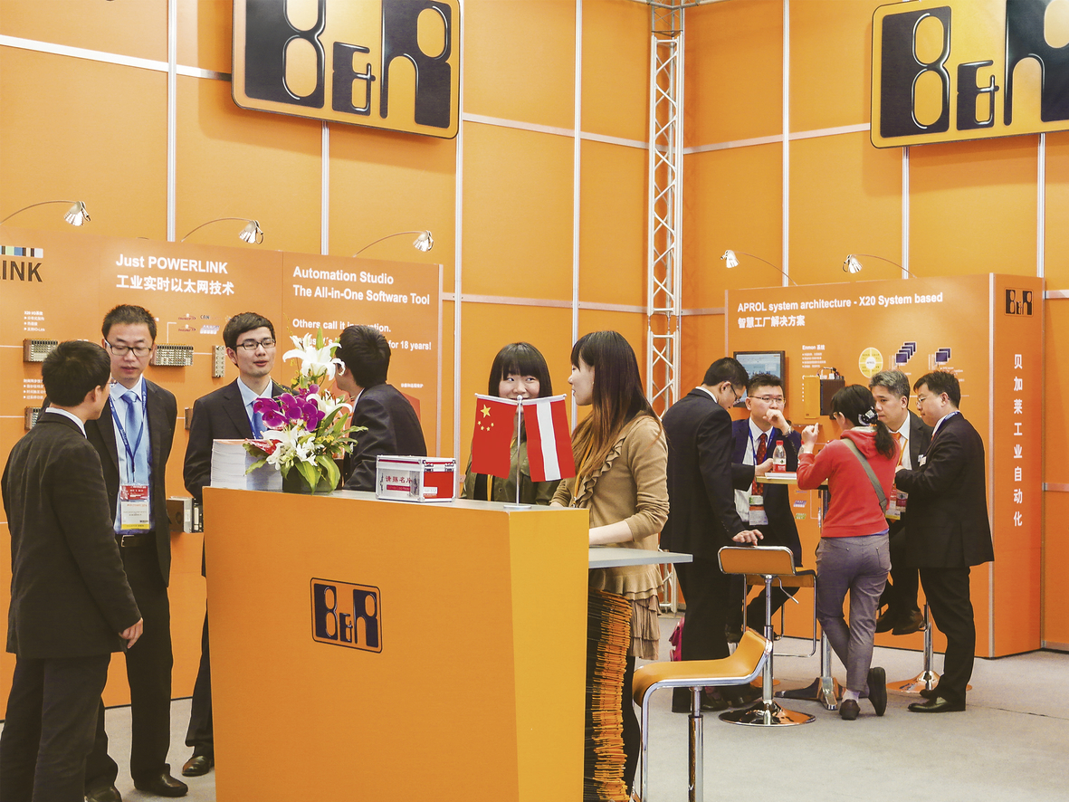
The B&R booth was the de facto hub for plastics machinery control solutions at CHINAPLAS 2014.

About B&R
B&R, a division of ABB Group, is a global leader in industrial automation headquartered in Austria. B&R combines state-of-the-art technology with advanced engineering to provide customers in virtually every industry with complete solutions for machine and factory automation, motion control, HMI and integrated safety technology. With Industrial IoT communication standards including OPC UA, POWERLINK and openSAFETY as well as its Automation Studio software, B&R is constantly redefining the future of automation engineering. The innovative spirit that keeps B&R at the forefront of industrial automation is driven by a commitment to simplifying processes and exceeding customer expectations.
For more information, visit www.br-automation.com.

