B&R shines a spotlight on 3 expo highlights at WindEnergy Hamburg
Perfect automation for on- and offshore wind turbines
One of the highlights being presented this year by B&R at booth B5.440 of the WindEnergy Hamburg expo is the latest release of the APROL process control system. Version 4.0 is the perfect platform for linking together all kinds of energy-related technologies, including wind and solar power systems, energy storage and software for electricity exchanges, just to name a few.
Robust hardware for extreme environments
Today's wind turbines require a high-performance automation solution and place high demands on safety and system availability, especially when located offshore. Harsh operating conditions are a real challenge for the components themselves as well. In Hamburg, B&R will be presenting solutions that meet these challenges, including the new Automation PC 2100 industrial PC. This innovative PC design is based on Intel Bay Trail architecture, whose single-, dual- and quad-core processor technology represents a milestone for embedded systems.
Ultrafast response times using standard hardware
For extremely time-critical applications, B&R has developed a groundbreaking new solution that achieves response times of 1 µs – reACTION technology. What's also impressive about this development is the fact that the solution can be implemented in standard hardware, making it possible to boost performance enormously without increasing costs. And because B&R's reACTION technology is integrated directly in the I/O modules, manufacturers are free to choose centralized controllers from the middle performance class, further reducing overall hardware expenditures.

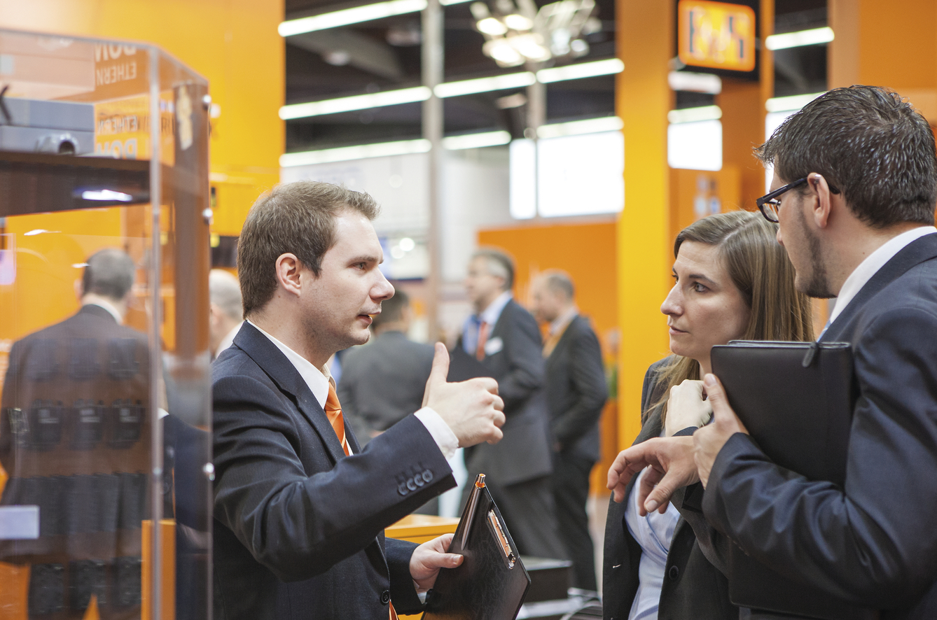
Along with other exciting innovations, the B&R expo booth in Hamburg (B5.440) will be presenting the APROL process control system, the efficient solution for automating entire wind farms.

About B&R
B&R, a division of ABB Group, is a global leader in industrial automation headquartered in Austria. B&R combines state-of-the-art technology with advanced engineering to provide customers in virtually every industry with complete solutions for machine and factory automation, motion control, HMI and integrated safety technology. With Industrial IoT communication standards including OPC UA, POWERLINK and openSAFETY as well as its Automation Studio software, B&R is constantly redefining the future of automation engineering. The innovative spirit that keeps B&R at the forefront of industrial automation is driven by a commitment to simplifying processes and exceeding customer expectations.
For more information, visit www.br-automation.com.

