B&R shines a spotlight on 3 expo highlights at WindEnergy Hamburg
Perfect automation for on- and offshore wind turbines
One of the highlights being presented this year by B&R at booth B5.440 of the WindEnergy Hamburg expo is the latest release of the APROL process control system. Version 4.0 is the perfect platform for linking together all kinds of energy-related technologies, including wind and solar power systems, energy storage and software for electricity exchanges, just to name a few.
Robust hardware for extreme environments
Today's wind turbines require a high-performance automation solution and place high demands on safety and system availability, especially when located offshore. Harsh operating conditions are a real challenge for the components themselves as well. In Hamburg, B&R will be presenting solutions that meet these challenges, including the new Automation PC 2100 industrial PC. This innovative PC design is based on Intel Bay Trail architecture, whose single-, dual- and quad-core processor technology represents a milestone for embedded systems.
Ultrafast response times using standard hardware
For extremely time-critical applications, B&R has developed a groundbreaking new solution that achieves response times of 1 µs – reACTION technology. What's also impressive about this development is the fact that the solution can be implemented in standard hardware, making it possible to boost performance enormously without increasing costs. And because B&R's reACTION technology is integrated directly in the I/O modules, manufacturers are free to choose centralized controllers from the middle performance class, further reducing overall hardware expenditures.

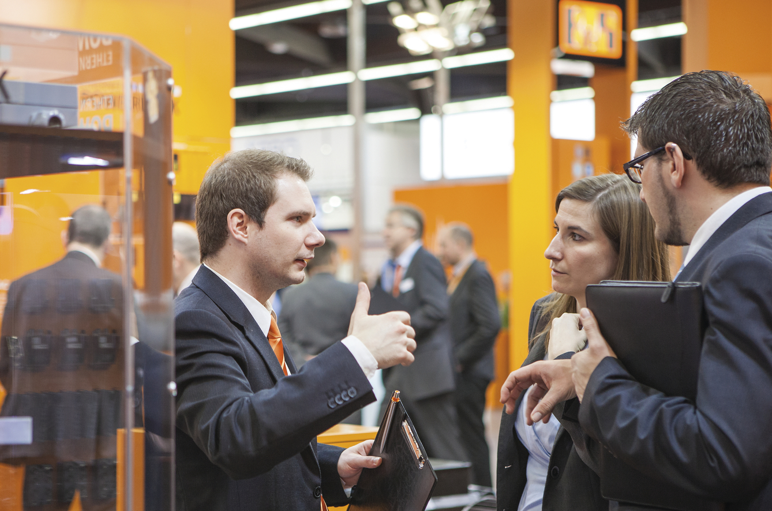
Along with other exciting innovations, the B&R expo booth in Hamburg (B5.440) will be presenting the APROL process control system, the efficient solution for automating entire wind farms.

B&R Hakkında
ABB Grubunun bir bölümü olan B&R, merkezi Avusturya'da bulunan endüstriyel otomasyon alanında global bir liderdir. B&R, neredeyse her sektördeki müşterilere makine ve fabrika otomasyonu, hareket kontrolü, HMI ve entegre güvenlik teknolojisi için eksiksiz çözümler sunmak üzere en son teknolojiyi ileri mühendislikle birleştiriyor. OPC UA, POWERLINK ve openSAFETY gibi Endüstriyel IoT iletişim standartlarının yanı sıra Automation Studio yazılımıyla B&R, otomasyon mühendisliğinin geleceğini sürekli olarak yeniden tanımlıyor. B&R'ı endüstriyel otomasyonun ön saflarında tutan yenilikçi ruh, süreçleri basitleştirme ve müşteri beklentilerini aşma taahhüdünden kaynaklanmaktadır.
Daha fazla bilgi için www.br-automation.com adresini ziyaret edin.

